OALCF Task Cover Sheet for the Deaf Stream
Task Title: Set up and use an e-mail account
Learner Name:

Date Started: Date Completed:

Successful Completion: Yes___ No___
Goal Path: Employment Apprenticeship___ Secondary School Post Secondary Independence
Task Description:
In this task learners will demonstrate how to set up and use a new e-mail account.
Competency:  A: Find and Use Information  B: Communicate ideas and information  D: Use Digital technology (optional) | Task Group(s):  A1: Read continuous text  A2: Interpret documents  A3. Extract info from films, broadcasts, and presentations  B1. Interact with others  D. N/A
Level Indicators:

A1.1: Read brief texts to locate specific details
A1.2: Read text to locate and connect ideas and information
A2.1: Interpret very simple documents to locate specific details
A3. Extract info from films, broadcasts, and presentations
B1.2 Initiate and maintain interactions with one or more persons to discuss , explain or exchange information
D1: Perform simple digital tasks according to a set procedure
D2: Perform well-defined, multistep digital tasks
Performance Descriptors: see chart on last page
Materials required:
- “Set up and use an email account” ASL video
https://youtu.be/E6dd899MmJY
- Smartboard
- Intervenor (based on client’s needs)
- Deaf Instructor (if available)
- Assistive technology or ACC if applicable
- Computer
- Internet connection

Support Materials Included:
- An “Optional Video outline for Instructor and Learner reference” with instructions for this Task Set in both English and ASL
Skill Building Activities: Click here to go to Skill Building Activities

Please find the following skill building activities at the end of this task set:

- Skill Building Activity # 1: video example of setting up and using an email account with ASL instructions
- An “Optional Video outline for Instructor and Learner reference” for Skill Building Activity # 1, in both English and ASL
- Skill Building Activity # 2: Setting up and using an e-mail account (instructions and screen shots)

Task Title: Set up and use an e-mail account
Learner Information and Task:
Most people nowadays contact people through e-mail. It’s a very important tool to communicate with family, friends, co-workers, and new people. You may need to use e-mails for: sending a resume or talking to your boss, replying to an ad, buying a present online, sending a note to your family, etc. E-mail is instant, fast, and free.
Before doing this task, it is recommended that you watch the two ASL videos that show examples of setting up and using an e-mail account. You may pause and replay the videos as many times as needed.

Setting up an email account:
Task 1: Why is it a good idea to use your real first and last name as your email user name?

Task 2: Pretend you forget your password. Which two items do you need to get a new password?

Task 3: If you can’t read the verification picture, how do you get a new picture?

Task 4: Set up an e-mail account.

Task 5: Sign or show the Instructor how to set up an e-mail account.

Using email:

Task 6: What button do you click to begin a new email?

Task 7: Give one example of how you can change the look of your email text.

Task 8: What does the icon look like to delete an email?

Optional Video outline for Instructor and Learner reference (English):

Set up email: Questions
Now you can answer questions for Tasks one to three.

Task 1: Why is it a good idea to use your real first and last name as your email user name?
Note: this graphic indicates a place where you can pause the video to allow time to learners to or prepare for reflect on the task.

Task 2: Pretend you forget your password. Which two items do you need to get a new password?

Task 3: If you can’t read the verification picture, how do you get a new picture?

Demonstrate
Task 4: Set up an e-mail account.

Task 5: Sign or show the Instructor how to set up an e-mail account.

Use email: Questions
Task 6: What button do you click to begin a new email?

Task 7: Give one example of how you can change the look of your email text.

Task 8: What does the icon look like to delete an email?
Optional Video outline for Instructor and Learner reference (ASL):

Set up email: Questions
NOW YOU ANSWER QUESTIONS(2h.) TASK ONE-TO-THREE
TASK NUMBER 1: WHEN IMPORTANT SUGGESTION USE YOUR REAL FIRST LAST NAME AS YOUR U-S-E-R NAME WHAT Q

TASK NUMBER TWO: WHAT TWO THINGS IMPORTANT CONTACT INFORMATION YOU CAN PUT THAT HELP IF NEED FORMAT IF YOU FORGOT PASSWORD Q

TASK NUMBER THREE: IF YOU CAN’T READ INFORMATION THAT IN V-E- R-I-F-I-C-A-T-I-O-N PROOF PICTURE WHAT HOW CAN YOU MAKE NEW PICTURE LOOK-AT WHAT Q

Demonstrate
TASK NUMBER FOUR: NOW YOU SET-UP E-M-A-I-L ACCOUNT

TASK NUMBER FIVE: SIGN / EXPLAIN YOUR TEACHER HOW SET-UP E-M-A-I-L ACCOUNT

Use email: Questions
TASK NUMBER SIX: WHAT SQUARE ICON NAME START WITH NEW E-M-A-I-L WHAT Q

TASK NUMBER SEVEN: GIVE ME ONE EXAMPLE HOW YOU CHANGE SUCH F-O-N-T / S-T-Y-L-E / LARGE / SMALL-CASE YOUR E-M-A-I-L TYPE-OVER WRITTEN PARAGRAPH WHAT Q

TASK NUMBER EIGHT: WHAT LOOK-LIKE SQUARE ICON TO-CLICK DELETE E-M-A-I-L WHAT Q Task Title: Set up and use an e-mail account

Answer Key

Task 1: Why is it a good idea to use your real first and last name as your email user name?
It is more professional, especially for job searching
Task 2: Gmail can contact you 2 ways if you forget your email password. What are they?
Using another email address or through your mobile phone (text)
Task 3: If you cannot read the information in the verification picture, how can you get a new one?
You can click “get a new challenge” and a new picture will appear
Task 4: Set up an e-mail account.
The learner will have successfully completed this Task if they are able to create an email account
Task 5: Sign or show the Instructor how to set up an e-mail account.
The learner will have successfully completed this task if they can communicate the instructions for setting up an email account to you in their preferred mode of communication (ex. sign language, fingerspelling, through demonstration)
Task 6: What button do you click to begin a new email?
Compose

Task 7: Give me one example of how you can change the look of your email text
Any one of the following: Change the font, the font size or colour, add/remove highlighting, etc. If the learner suggests other ways to change the look of their email text that don’t appear on this list but are correct, they have successfully completed this task.
Task 8: What does the icon look like to delete an email?
It looks like a trash can.

Task Title: Set up and use an e-mail account

Performance Descriptors |  | Needs Work | Completes Task with Support of Practitioner | Completes  Task Independently
A1.1 | - Reads short texts to locate a single piece of information
A1.2 | - Follows the main events of descriptive, narrative, and informational texts or video
 | - Begins to identify sources and evaluate information
A3 | - tasks in this group are not rated for complexity
B1.2 | - Signs clearly in a focused and organized way
 | - Rephrases to confirm understanding
D1.1 | - Follows simple prompts
 | - Follows apparent steps to complete tasks
 | - Interprets brief texts and icons
 | - Locates specific functions and information
 | - Begins to perform simple searches
D.2 | - Locates and recognizes functions and commands
 | - Selects and follows appropriate steps to complete tasks

This task: was successfully completed _____
needs to be tried again________
Learner Comments:

_______________________ __________________________
Instructor (print) Learner Signature
SKILL BUILDING ACTIVITY # 1: video example of setting up and using an email account, with ASL instructions
https://youtu.be/LGXsTlH-xkM
Optional Video outline for Instructor and Learner reference (English)
- Find the internet browser icon (Internet Explorer, Google Chrome) from your computer window and open it

- Type http://mail.google.com/ inside the Address Bar edit box and then press the ENTER keyboard key

- Click on “Create an account”

- Add your first name, last name

- When choosing your new “username” please think of professionalism & manners. When looking for employment you should include your first name and last name

- Add your password and repeat your password to confirm. A strong password is strongly recommended

- Enter your real birthday. It is important so you can gain access to your email account if you forget your password

- Click your gender. If you do not want to disclose, you can click “other”

- Type in your mobile phone number. If you forget your password, Google can send you an access code through text message

- Add any other e-mail address you already have. It can be used if you have to reset your password

- Google needs to be sure that you are a real person. They need to prove that you are not a robot for security reasons.
(Optional) click on “Skip this verification” if you prefer to use the process through your cell phone number (text)
Type-in one or two pieces of the text as you see them on the screen (picture). They can be difficult to read and not accessible so you might need help. There are several different ways.
- Reset the picture by clicking to get a new challenge (next to the text box)
- Guess and try it again if it failed
- Click “?” for help

- Please make sure the “Location” drop-down menu setting is set to your Country to benefit from using the correct language and Google services. If it already says “Canada” you can leave it alone.

- Make sure you that you put a check mark next to the setting called “I AGREE TO THE GOOGLE TERMS OF SERVICE AND PRIVACY POLICY” before clicking on the “Next Step” button. For more information click on both words. If you do not click and/or agree, you cannot continue the application and Google will not accept you as account holder.

- Click “Next Step” button

- Google asks you if you want to create your Profile. You can do this later in settings. Click “No Thanks”

- This screen is welcoming you to Google! Click “Continue to Gmail”

Note: You can add a profile picture at any time. To see the instructions and screen shots of adding a profile picture, please look at the Skill Building Activity handout called “Setting up an email account”.
To send email:

- Click on the “compose” icon

- Type an e-mail address

- Under subject, add the reason you are sending an e-mail. For example, if you want to meet that person on Saturday, type “Saturday”

- Type your message

- If you want to change the look of the text, you need to highlight your message and decide what you want to change. You can change the style and size of the font.

- When you finish typing your message. Click SEND.

To delete email:

- Go to inbox

- Left click on the box beside the message you want to delete

- Look for the trash icon and left click

To sign out:

- Click on the username or look for your profile picture on the top right.

- Click Sign out.

SKILL BUILDING ACTIVITY # 1: video example of setting up and using an email account with ASL instructions
https://youtu.be/LGXsTlH-xkM
Optional Video outline for Instructor and Learner reference (ASL)
- COMPUTER INTERNET LOOK-FOR INTERNET EXPLORER (or) GOOGLE BROWSER (or) FIREFOX (or) SAFARI (index finger double click) IN

- TYPE-IN h-t-t-p://mail.google.com/ INSIDE BOX ADDRESS B-A-R TYPE-IN PERFECT-FINISH CLICK (keyboard)ENTER

- OPENWINDOW (new screen)CLICK-ON “Create an account”

- FIRST NAME PUT, LAST NAME PUT

- U-S-E-R-N-A-M-E YOU PICK FOR++ EMAIL PLEASE THINK TWICE YOUR FUTURE USE FOR ANY PROFESSIONAL JOB LOOK GOOD POLITE SUGGEST YOU SHOULD INCLUDE YOUR FIRST DOT (.) LAST NAME @ G-M-A-I-L.C-O-M

- PUT-IN YOUR PASSWORD / AGAIN MAKE SURE SECOND TIME SAME. MAKE SURE YOUR PASSWORD GREEN (light) PASS THUMBS-UP

- BIRTHDAY MAKE SURE REAL PUT-DOWN WHY Q IF YOU FORGET PASSWORD THEY (google) WILL ASK YOUR BIRTHDAY!

- G-E-N-D-E-R MAN / WOMAN YOU Q UP-TO-YOU (mm) BUT IF YOU WANT PRIVACY CLICK “OTHER”

- TEXT PHONE INFORMATION OPTIONAL PUT-DOWN WILL HELP-YOU IF INCASE YOU FORGET PASSWORD WILL SEND INFORM TEXT PHONE

- PUT-DOWN IF HAVE ANY EMAIL / OTHER / OLD LIKE STILL USE Q WILL HELP IF LOST OR FORGOT PASSWORD

- GOOGLE COMPANY WANT MAKE SURE YOU REAL AGENT NOT ROBOT OR FAKE PERSON (so) NEED PROOF FOR SECURITY REASON PROCEDURE

NUMBER ONE OPTIONAL IF YOU DECIDE YES “SKIP THIS V-E-R-I-F-I-C-A-T-I-O-N CHECK-MARK YOU CAN DO WITH YOUR TEXT PHONE NUMBER

NUMBER TWO YOU TYPE IN ONE (or) TWO WORD PARAPHRASE YOU SEE FROM-PICTURE. SOMETIME DIFFICULT SEE NOT-GOOD ACCESSIBLE MAYBE HELP NEED. SEVERAL DIFFERENT WAYS DEPENDING THREE-THING-POINT-HERE

  - CLICK REPEAT TRY AGAIN SEE “NEW CHALLENGE” NEXT-TO TYPE-IN BOX
  - CONTINUE AGAIN THINK GOOD GUESS OTHER WORD YOU MAY REMEMBER IF FAIL
  - Click “?” for help

- LOCATION ASK YOU IF YOU HERE IN CANADA (or) OTHER COUNTRY. MAKE SURE TYPE-IN CANADA HERE MAKE SURE RIGHT WHY LANGUAGE FAMILIAR CANADA WAY FOR++ GOOGLE SERVICE IF NEED.

- check Please make sure you FINISH check-mark “I AGREE GOOGLE T-E-R-M-S (LIST POINTS) OF SERVICE AND PRIVACY POLICY” before YOU click “NEXT STEP”. If you not agree you cannot continue FILL-OUT application. Google will not accept you AS NEW G-M-A-I-L ACCOUNT

- PROCEED / Click “Next step” box (CLICK)

- Google ask-you if you want ABOUT YOU(AGENT) P-r-o-f-i-l-e SET-UP q You can do-DO later settings. YOU PROCEED / Click “No Thanks”

- OPEN-SCREEN WELCOME YOU TO GOOGLE! Click “Continue to Gmail”
YOU CAN ADD P-R-O-F-I-L-E DROP-YOU PICTURE YOUR G-M-A-I-L ACCOUNT. EXPLANATIONS THERE “SETTING UP EMAIL” LOOK PAPER SKILL BUILDING ACTIVITY HANDOUT PAPER

SEND E-M-A-I-L

- LOOK-FOR C-O-M-P-O-S-E ICON (CLICK)

- TYPE-IN EMAIL ADDRESS

- MAKE SURE PUT-IN SUBJECT – TOPIC Q / REASON WHY YOU SEND EMAIL MESSAGE / EXAMPLE / IF YOU WANT MEET THAT PERSON ON SATURDAY / SUBJECT CAN TYPE-IN “SATURDAY”

- TYPE-IN ANY YOUR MESSAGE HERE REGARDS SUBJECT

- SUPPOSE HIGHLIGHT TEXT WORD / YOU CAN CHANGE FONT STYLE / PREFERENCE

- ALSO YOU CAN CHANGE SIZE FONT SMALL / BIG

- WHEN YOU TYPE-IN FINISH / MAKE SURE (CLICK) “SEND” IF YOU WANT SEND YOUR E-M-A-I-L

DELETE EMAIL

- DELETE EMAIL / FIRST GO YOUR I-N-B-O-X

- CLICK SQUARE-BOX CHECKMARK RIGHT-NEXT YOUR EMAIL YOU WANT REMOVE

- CLICK TRASH CAN I-C-O-N PICTURE

SIGN-OUT
SIGN-OUT / CLICK ON U-S-E-R-N-A-M-E (or) PICTURE YOU P-R-O-F-I-L-E CLICK / FINISH / CLICK “SIGN-OUT” SQUARE

Skill Building Activity # 2: Setting up and using an e-mail account (instructions and screen shots)

Type http://mail.google.com/ inside the Address Bar edit box and then press the ENTER keyboard key
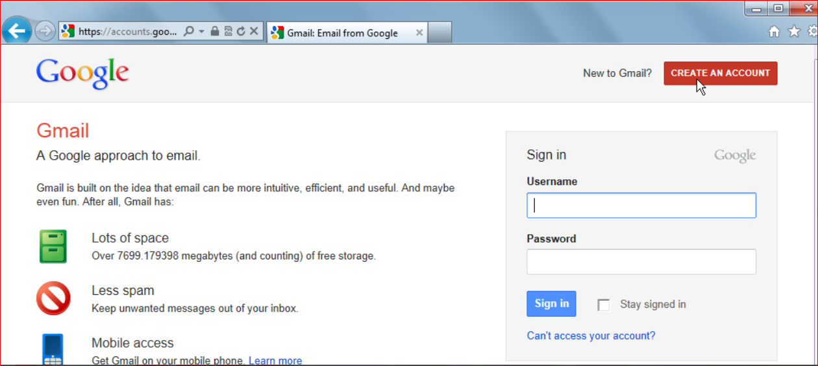

Click on CREATE AN ACCOUNT
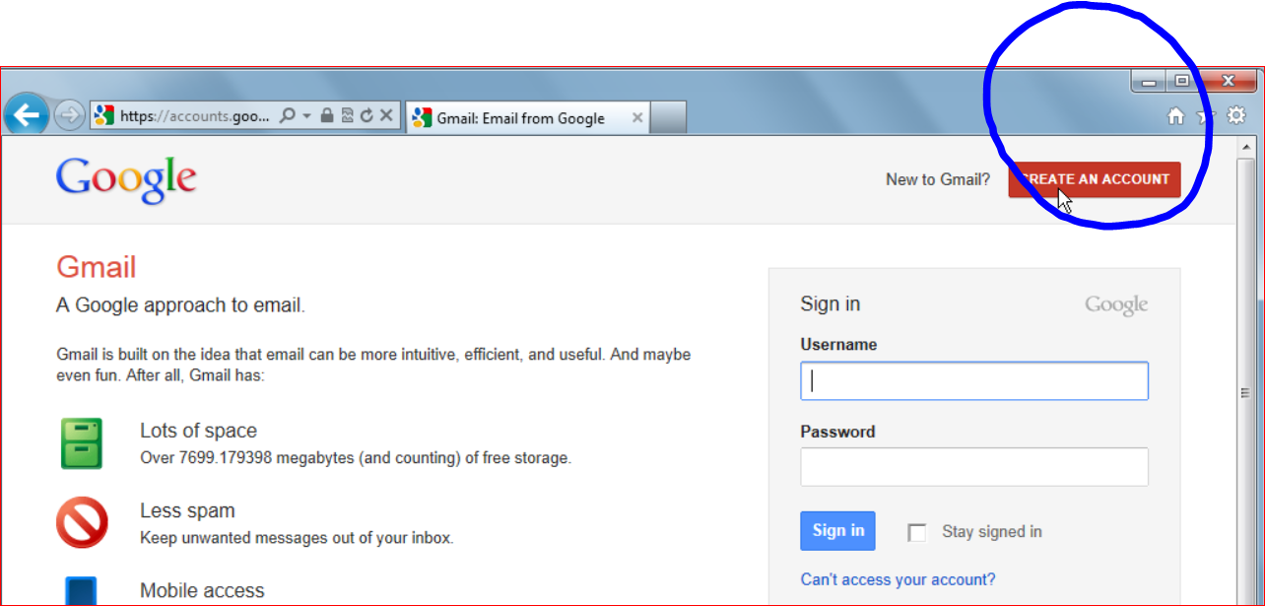
Then:
- Add your first name and last name
- Choose a user name. If you are looking for employment, including your first name and last name looks more professional
- Create a password
- Confirm the password

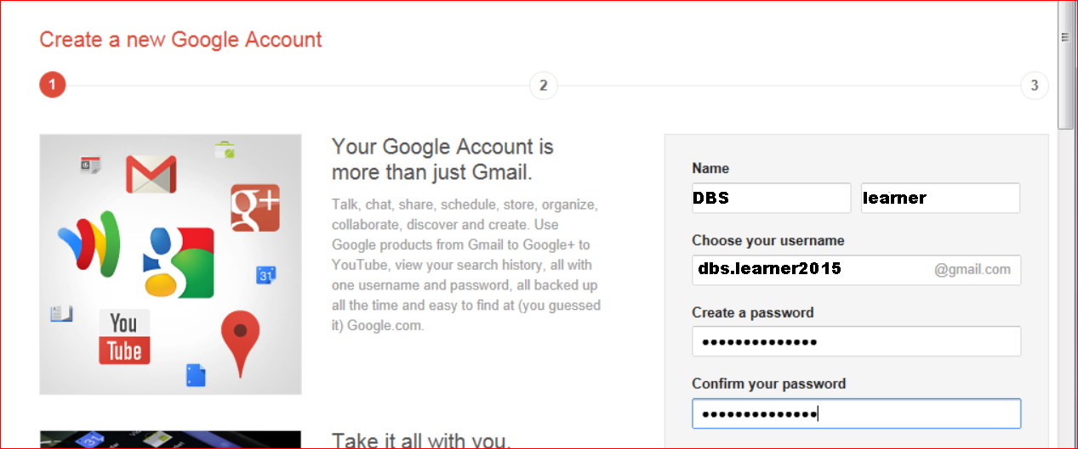

Next:
- Enter your birthday
- Gender
- A Mobile phone
- Any other e-mail address you have, which would be used to reset your password
- Default homepage means that that’s the first page you see when you open a window. If you do not want www.google.com to be your web browser's default homepage simply don’t click on the box.
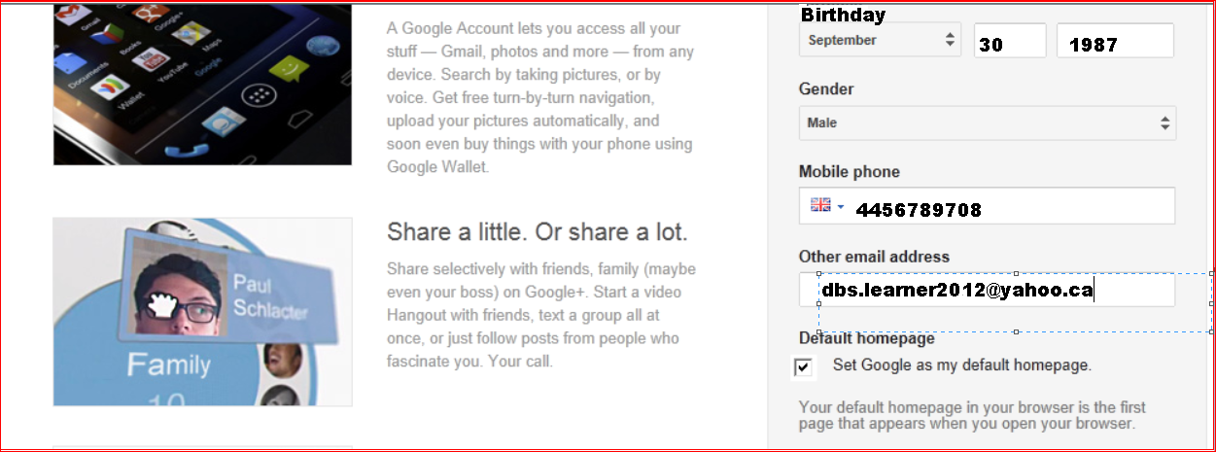
Prove you are not a robot. This feature is used for security measures; type the two pieces of the text as you see them on the screen. They may be difficult to read and not accessible, so you might need help.
The rest of the application form requires you to agree to the Terms & Conditions and Privacy Policy of the Google Terms of Service. Make sure you put a tick next to the setting called I AGREE TO THE GOOGLE TERMS OF SERVICE AND PRIVACY POLICY before clicking on the NEXT STEP button.
You also need to make sure the LOCATION drop-down menu setting is set to your Country in order to benefit from using the correct language and Google services.
Clicking on the NEXT STEP button. You have the option to add a photograph to your profile. You can skip this step by clicking on the NEXT STEP button. If you want to add a photograph, click on ADD PROFILE PHOTO button to continue.
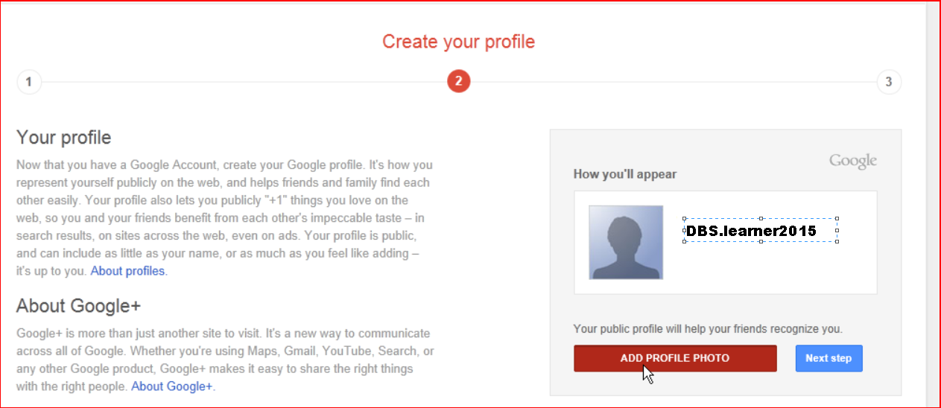

Click SELECT A PHOTO FROM YOUR COMPUTER
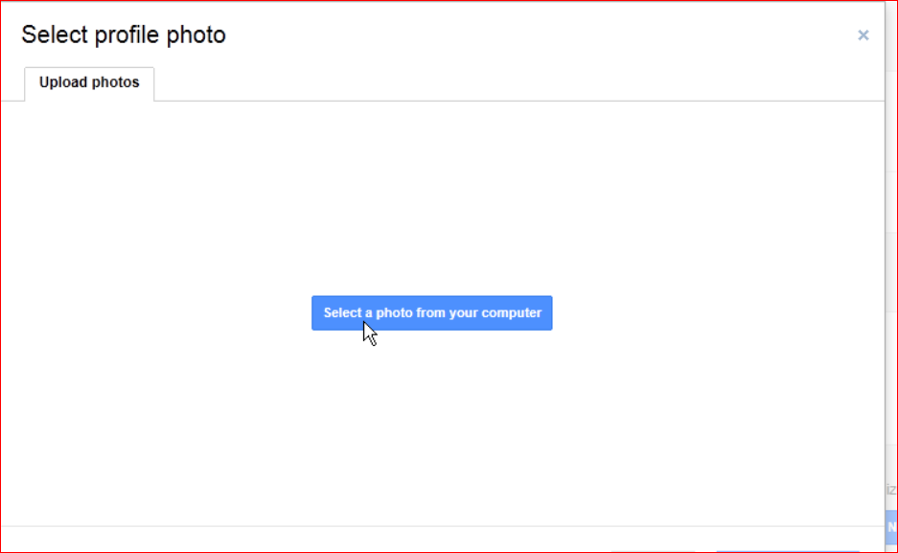
Find the picture you want to use and click OPEN
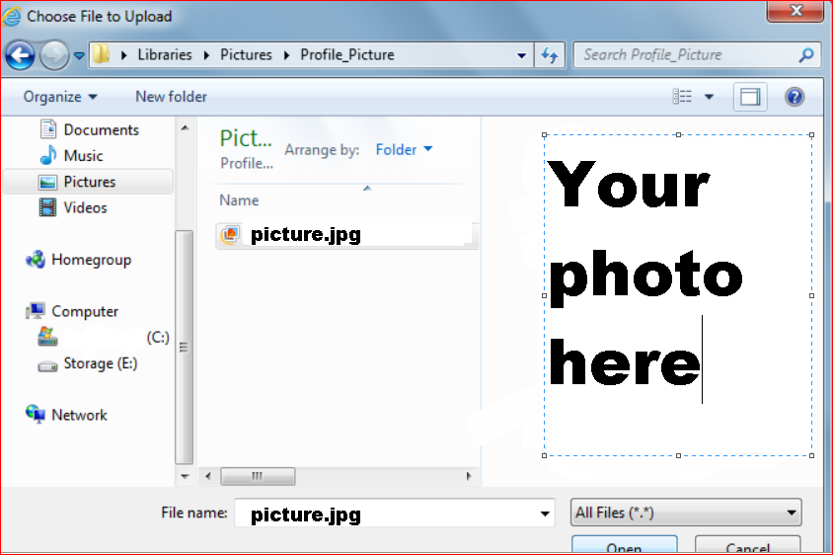
Crop or rotate your photo, then click SET AS PROFILE PHOTO
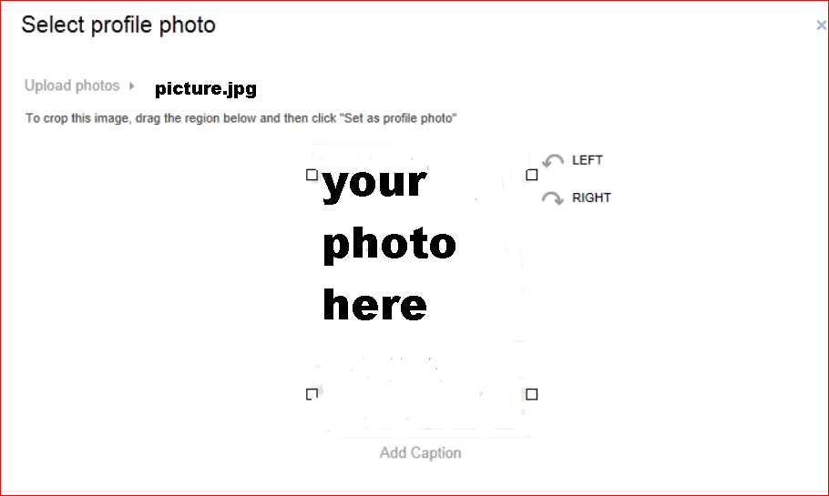
Click NEXT STEP when you are done adding your photo
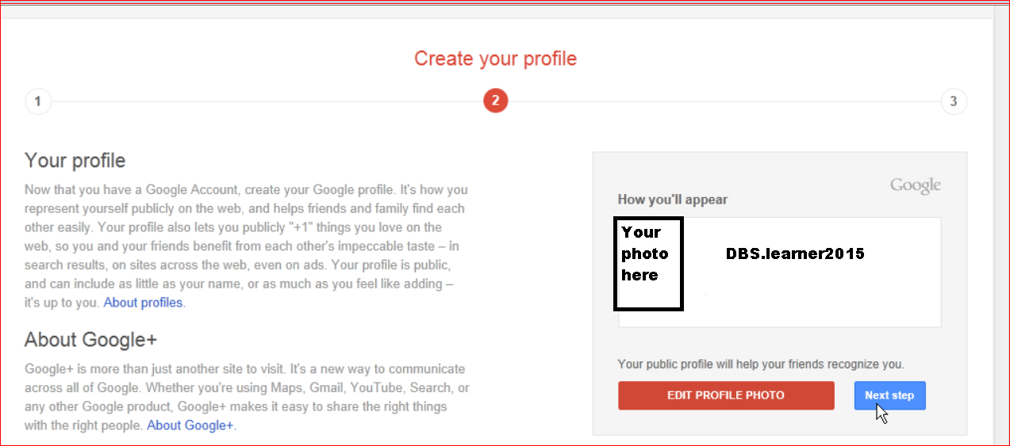

Click on CONTINUE TO GMAIL
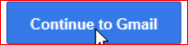

You will be in your new e-mail box
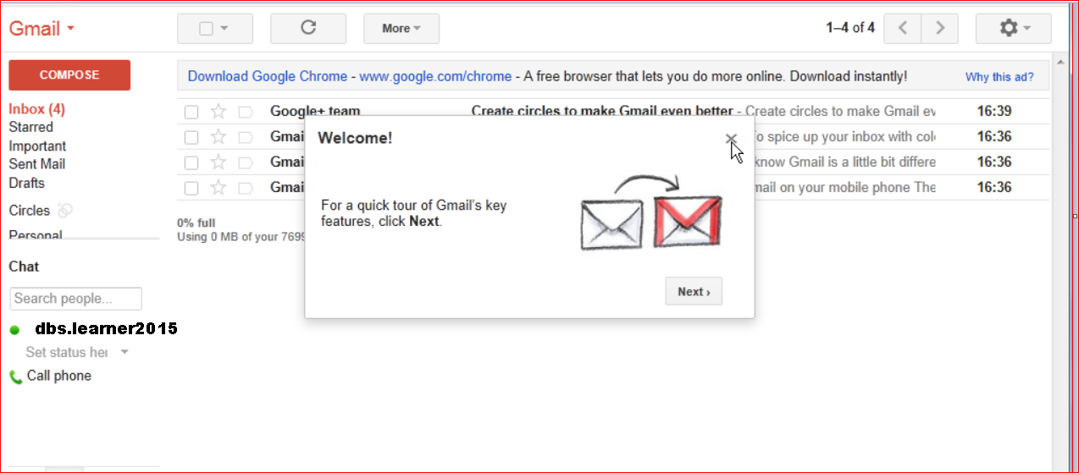

To begin a new email, click COMPOSE
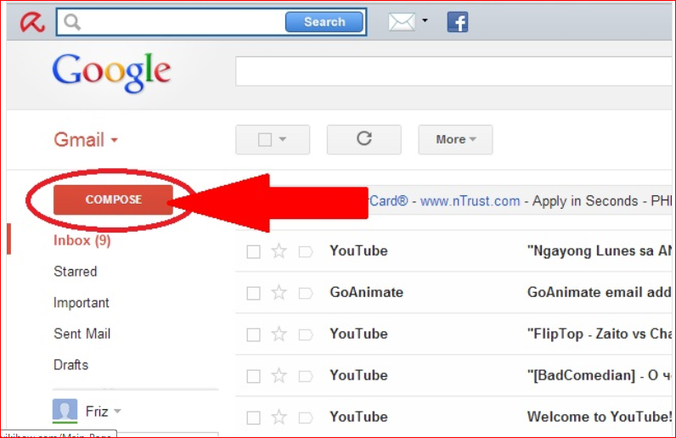
Type an e-mail address. It could be a friend, family, teacher, etc.
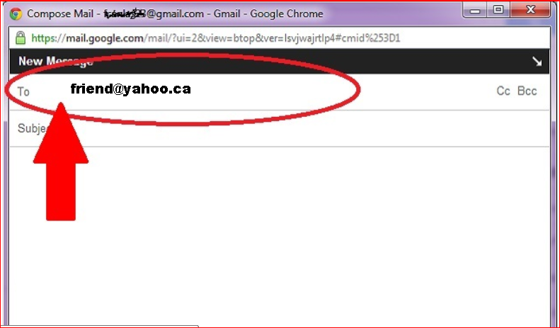
Add a subject: the reason you are sending a message. For example, if you want to meet with a person on Saturday the subject could be “Saturday”
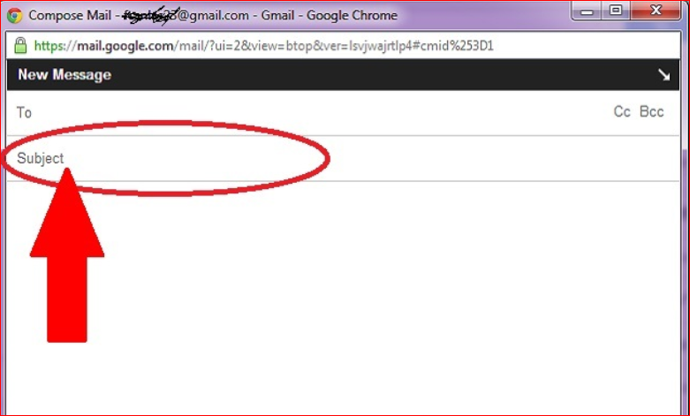
Type your message
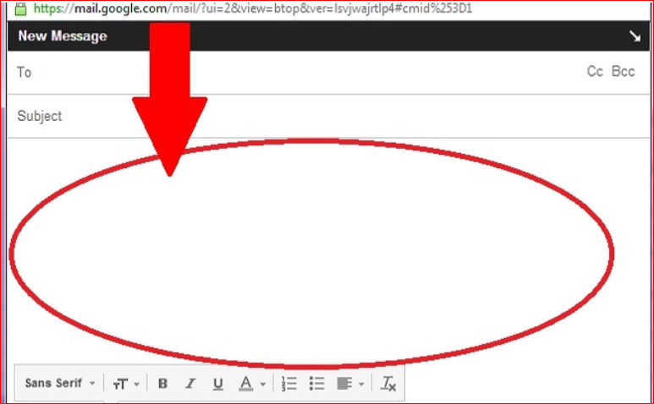
You can change the font
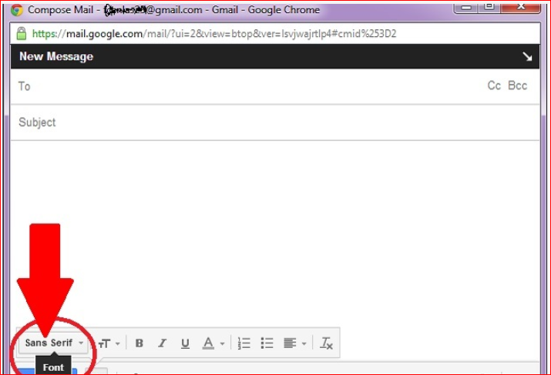
And change the size of your font
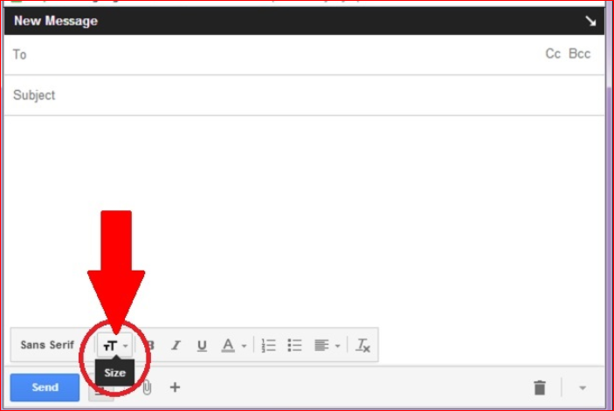
When you are done typing, click SEND to send your email
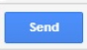

To delete an email, go to your INBOX
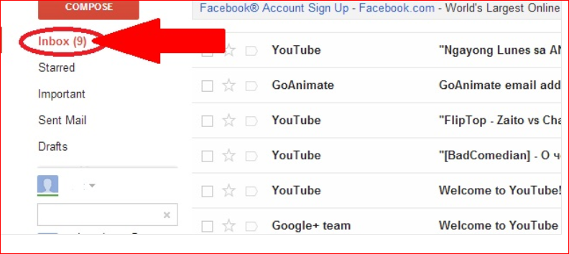
And put a check in the box next to the email you want to delete
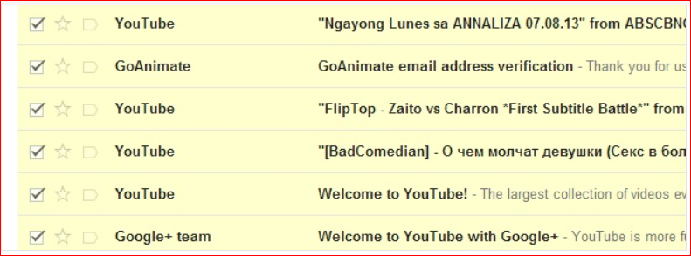

Then click the DELETE button (trash can icon)
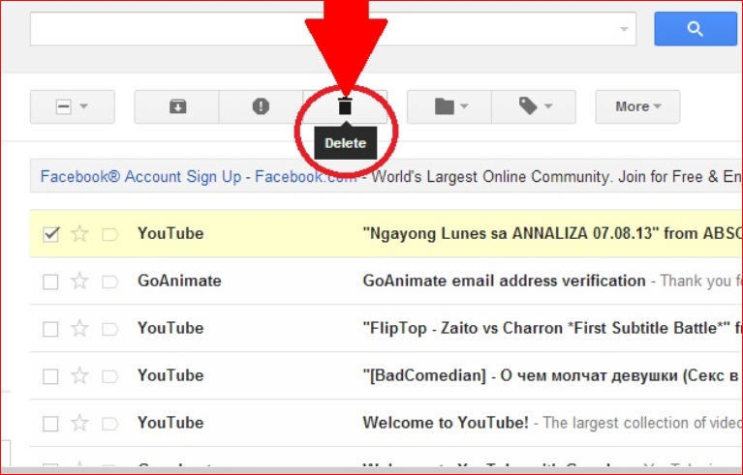

To sign out of your email account, click on your profile photo or username, and then click on the SIGN OUT button.

