OALCF Task Cover Sheet
Task Title: Information on an Adult Learning Centre Brochure
Learner Name:

Date Started: Date Completed:

Successful Completion: Yes___ No___
Goal Path: Employment___ Apprenticeship___ Secondary School Post Secondary Independence___
Task Description:
Read a brochure to get necessary information to apply for upgrading at an Adult Learning Centre
Competency:  A: Find and Use Information  C: Understand and Use Numbers | Task Group(s):  A1.1: Read continuous text  A1.2: Read continuous text  A2.1: Interpret documents  A2.2 Interpret documents  C2.1: Manage time
Level Indicators:
A1.1: Read brief texts to locate specific details
A1.2: Read texts to locate and connect ideas and information
A2.1: Interpret very simple documents to locate specific details
A2.2: Interpret simple documents to locate and connect information
C2.1: Measure time and make simple calculations
Performance Descriptors: see chart on last page
Materials Required:
- Task set questions
- Pen or pencil, highlighter

Task Title: Information on an Adult Learning Centre Brochure
Learner Information and Tasks:
You are presently going to a community-based adult learning centre. You are now ready to move on towards your goal of completing your Grade 12 education. First you must register in a program that will help you upgrade your literacy skills before enrolling in credit courses. To get more information, look at a brochure from a local Adult Learning and Continuing Education Centre.

Task 1: What is the name of the program?

Task 2: Circle all the skills this program will help you to upgrade.

Task 3: There are two campuses. What is the address for each one?
- Kitchener Main Campus:

- Cambridge Campus:

Task 4: When are the classes?
- Days of the week:

- Class time:

Task 5: When is registration available?

Task 6: How can you register?

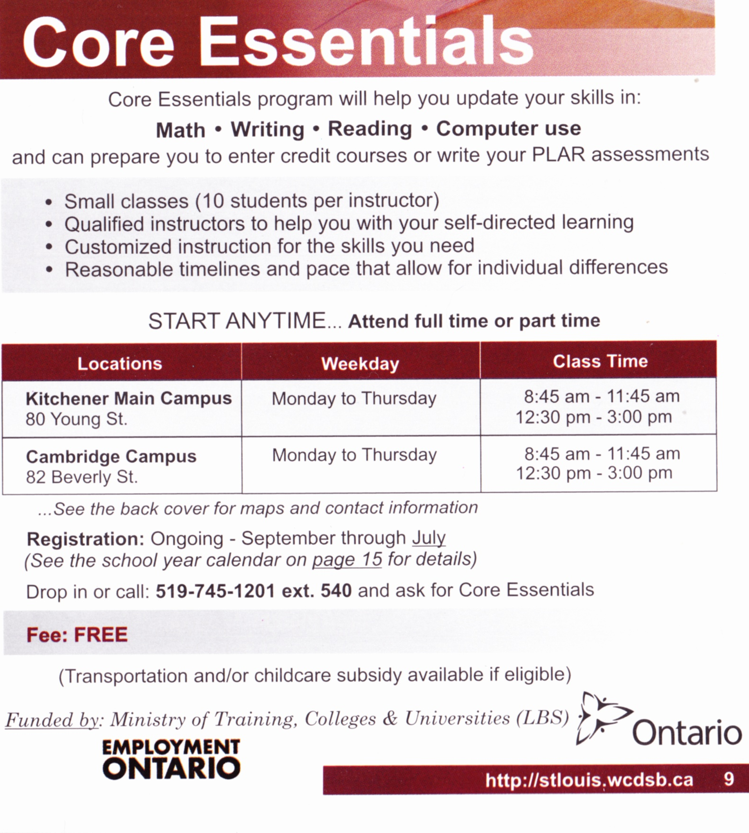

Task Title: Information on an Adult Learning Centre Brochure
Answer Key
Task 1: What is the name of the program? Core Essentials
Task 2: Circle all the skills this program will help you and others upgrade.
Task 3: There are two campuses. What is the address for each one?
a. Kitchener Main Campus: 80 Young St.
b. Cambridge Campus: 82 Beverly St.
Task 4: When are the classes held?
a. Days of the week: Monday to Thursday
b. Class time: 8:45 am – 11:45 am and 12:30 pm – 3:00 pm
Task 5: When is registration available?
Ongoing – September through July
Task 6: How can you register? Give details.
Drop in or call: 519-745-1201 ext. 540 and ask for Core Essentials

Task Title: Information on an Adult Learning Centre Brochure
Performance Descriptors |  | Needs Work | Completes task with support from practitioner | Completes task independently
A1.1 | - Reads short texts to locate a single piece of information
A1.2 | - Scans text to locate information
A2.1 | - Scans to locate specific details
A2.2 | - Extracts information from tables and forms
C2.1 | - Represents dates and times using standard conventions

This task: was successfully completed___ needs to be tried again___

Learner Comments

____________________________ _________________________

Instructor (print) Learner Signature

