Task Title: Compare Store Prices Step-by-Step Activity
Learner Name: ______________________ Date: _______________
Goal Path: Independence
Competency A: Find and Use Information
Task Group: A2: Interpret Documents
Level: A2.1 Interpret very simple documents to locate a specific details

Competency C: Understand and Use Numbers
Task Group: C1: Manage Money
Level: C1.1 Compare costs and make simple calculations

Milestone: #37
Milestone Name: Use flyers and price lists to compare and calculate

Successful: Yes □ No □
Task Description: Learner will compare the total cost of two items at two grocery stores.
Documents related to this task:
- Step-by-Step Activity
- ESKARGO (Skills Set)
- Performance Descriptors Checklist
- Links to Skill Building Activities
Materials Needed:
- Learner Information and Task Sheet
- Two in-store sales flyers (preferably printed in colour)
- Pencil
- Calculator
Supports Allowed: | Questions given in ASL (if needed).

Task Title: Compare Store Prices

Shoppers often compare the cost of grocery items at different stores, to decide where they can get the best deals. Look at the grocery store flyers for “Bargain Barnie’s” and “Fab Foods”.

Activity:

- Calculate how much money a shopper would pay for a bag of oranges and a loaf of whole wheat bread at Bargain Barnie’s.

- Calculate how much money a shopper would pay for a bag of oranges and a loaf of whole wheat bread at Fab Foods.

- At which store could a shopper buy the oranges and bread at the lowest cost?

- Calculate the price difference between a carton of eggs at each store.

BARGAIN BARNIE’S
Sale Prices—September 18-25
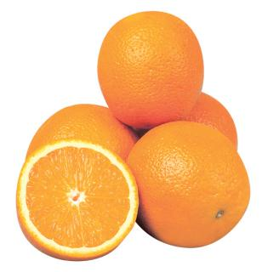
Oranges - $5.99 /5 lb. bag Dish soap - $2.79 /bottle

Whole wheat bread - $2.39 /loaf Toilet paper - $5.79 /24 rolls

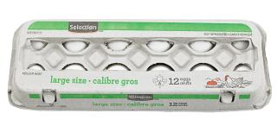
Carrots - $2.79 /5 lb. bag Eggs - $2.39 /dozen
FAB FOODS
Sale Prices—September 18-27
Whole wheat bread - $2.85 / loaf Grapes - 89¢ /lb.

Chicken breasts - $4.88 /lb Oranges - $6.49 /5 lb. bag 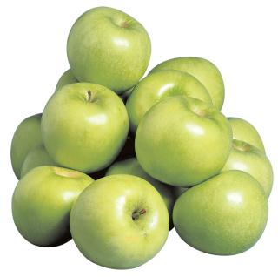
Apples - $4.99 /5 lb. bag Eggs - $2.85 /dozen

Task Title: Compare Store Prices

Answer Key

- Calculate how much money a shopper would pay for a bag of oranges and a loaf of whole wheat bread at Bargain Barnie’s.
$5.99 + $2.39 = $8.38
- Calculate how much money a shopper would pay for a bag of oranges and a loaf of whole wheat bread at Fab Foods.
$6.49 + $2.85 = $9.34
- At which store could a shopper buy the oranges and bread at the lowest cost?
Bargain Barnie’s
- Calculate the price difference between a carton of eggs at each store.
$2.85 - $2.39 = $0.46

ESKARGO
Competency A: Find and Use Information
Task Group: A2: Interpret Documents
Level: A2.1 Interpret very simple documents to locate a specific details

Competency C: Understand and Use Numbers
Task Group: C1: Manage Money
Level: C1.1 Compare costs and make simple calculations

A2.1:

Reading Strategies – Decoding and Comprehension Enhancement

- Uses phonics and knowledge of word parts to decode words
- Uses context cues and personal experience to draw meaning from signs, labels, lists and simple forms
- Uses knowledge of basic abbreviations to gather meaning from text
- Uses background knowledge on common uses and purposes of signs, lists, labels and
- forms to gather meaning
- Uses pictures and illustrations to determine meaning of unfamiliar words and gather information

Forms and Conventions – Find Information/Research/Understand Types of Texts

- Scans to locate a single piece of information or specific details

Comprehension – Read to Understand/Retell

- Reads signs, symbols and common sight words from everyday life
- Locates specific details in simple documents, such as labels and signs

Interpretation – Read and Apply Understanding

- Begins to identify sources and to evaluate and integrate information

C1.1:
Skills and Knowledge Required for Successful Task Performance
- Adds, subtracts, multiplies, and divides whole numbers and decimals
Addition & Subtraction:
- Writes and solves simple addition and subtraction sentences (e.g. 5 + 6 = 11)
- Adds whole numbers by carrying
- Subtracts whole numbers by borrowing
- Adds and subtracts multi-digit whole numbers with and without regrouping
- Identifies and performs required 1-step operations

- Interprets and represents costs using monetary symbols and decimals:
- Adds and subtracts money amounts and represents the answer in decimal notation (e.g. 5 dollars and 75 cents plus 10 cents is 5 dollars and 85 cents, which is $5.85
- Follows apparent steps to reach solutions
- Uses strategies to check accuracy (e.g. estimating, using a calculator, repeating a calculation, using the reverse operation)
Attitudes:

Practitioner,
We encourage you to talk with the learner about attitudes required to complete this task set. The context of the task has to be considered when identifying attitudes. With your learner, please check one of the following:

- Attitude is not important
- Attitude is somewhat important
- Attitude is very important

Competency A: Find and Use Information
Task Group: A2: Interpret Documents
Level: A2.1 Interpret very simple documents to locate a specific details

Competency C: Understand and Use Numbers
Task Group: C1: Manage Money
Level: C1.1 Compare costs and make simple calculations

Performance Descriptors |  | Can’t do | Received help from the teacher | Can do independently
A2.1 | - Scans to locate specific details
 | - Interprets brief text and common symbols
 | - Locates specific details in simple documents, such as labels and signs
 | - Requires support to identify sources and to evaluate and integrate information
C1.1 | - Adds, subtracts, multiplies, and divides whole numbers and decimals
 | - Recognizes values in number and word format
 | - Understands numerical order
 | - Identifies and performs required operation
 | - Follows apparent steps to reach solutions
 | - Interprets and represents costs using monetary symbols and decimals
 | - Uses strategies to check accuracy (e.g. estimating, using a calculator, repeating a calculation, using the reverse operation)

This task:
was successfully completed _____needs to be tried again_____
Learner Comments:

______________ _______________________
Instructor (print) Learner Signature
List of Online Resources:

- Adding & Subtracting - https://www.khanacademy.org/math/early-math/cc-early-math-add-sub-topic
- Counting Money (US Coins) - https://www.khanacademy.org/math/early-math/cc-early-math-measure-data-topic/cc-early-math-time-money-topic/e/counting-money--us-
- Counting Money (Canadian) - http://ca.ixl.com/math/grade-3/count-coins-and-bills-up-to-5-dollar-bill
- Making Change (Choose Canadian) - http://www.mathsisfun.com/money/money-master.html

