OALCF Task Cover Sheet
Task Title: Explore the Plumbing Trade
Learner Name:

Date Started: Date Completed:

Successful Completion: Yes___ No___
Goal Path: Employment___ Apprenticeship ✓ Secondary School Post Secondary Independence___
Task Description: Learners will read about the trade and then try out some plumbing skills.
Competency:  A: Find and Use Information  B: Communicate Ideas and Information  C: Understand and Use Numbers  D: Use Digital Technology | Task Group(s):  A1: Read continuous text  A2: Interpret documents  B2: Write continuous text  C1: Manage money  C2: Manage time  C3: Use measures  D: Use digital technology
Level Indicators:
A1.3: Read longer texts to connect, evaluate and integrate ideas and information
A2.2: Interpret simple documents to locate and connect information
B2.1: Write brief texts to convey simple ideas and factual information
C1.1: Compare costs and make simple calculations
C2.1: Make low-level inferences to calculate using time
C3.1: Measure and make simple comparisons and calculations
D.2: Perform well-defined, multi-step digital tasks
Performance Descriptors: see chart on last page
Materials Required:
- Instruction sheet
- Handout “On the Job with a Plumber
- Handout “Do you have the essential skills to be a plumber?”
- Pen or pencil
- Access to the Internet

Task Title: Explore the Plumbing Trade
The Canadian government provides information for persons interested in entering the skilled trades. Here is an opportunity to learn about being a plumber.

Learner Information and Tasks:
Task 1: Look at the entire handout “On the Job with a Plumber”. List the essential skills used by a plumber.

Tasks 2-5: Look at the handout “Do you have the Essential skills to be a Plumber?” Try the questions. Keep in mind that these are questions that a journeyperson (who has had about 4-5 years of training on the job and in a classroom) should be able to answer.

Using Essential Skills: On the Job with a Plumber
Are you starting an apprenticeship in plumbing or are you thinking about a career in this trade? Pursuing a career as a plumber requires strong Essential Skills such as reading continuous text, interpreting documents, using measures and critical thinking.
Use this booklet to:
- learn how plumbers use essential skills;
- follow the daily routine of a plumber; and
- find out how your essential skills compare to those of a journeyperson in plumbing.

How plumbers use Essential Skills
Plumbers use essential skills to perform a variety of job-related tasks, for example:
- interpret documents to read assembly drawings and instructions on how to install plumbing fixtures and appliances;
- interact with others to discuss scheduling, system failures or alterations to previously installed fixtures with other tradespeople on a job site; and
- problem solving to solve water flow problems.
Plumbers install, repair and maintain pipes, plumbing fixtures and other plumbing equipment used for water distribution and waste water disposal. They work in homes, businesses and industrial buildings. Plumbers may be employed by plumbing contractors or by the maintenance departments of institutions or organizations; they may also be self employed.
A day in the life of a plumber: James' story

Reviewing the job
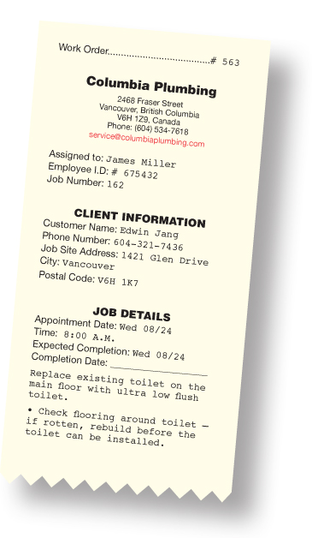
James is a plumber who works for a private company that specializes in home plumbing. His manager tells him that his next job is to install a new toilet for a customer. While the manager gives him detailed instructions, James writes a few notes on the work order (write continuous text, interact with others).
Tomorrow morning you will be replacing an old large flush toilet with an ultra low flush for a customer, Edwin Jang. It is an old house, so don’t forget to inspect the floor where the toilet was. If the floor has rotted, it will have to be rebuilt before the toilet can be installed. Depending on how bad the damage is, the rebuilding may involve the floor, the subfloor and even the joists. Inspect the flange and if it is damaged, replace it and replace the T-bolts. Also, before you leave to do the job tomorrow morning, you might want to research some information about different types of toilets in case the customer wants more information. There is a toilet replacement rebate application form and you should explain how to apply. It will save the customer some money.

Setting up the job
After picking up the tools and supplies he needs from the warehouse and loading up his van, James checks his map and heads out to the customer's house. When he gets there, James discusses the toilet installation with the customer. He explains that since the new toilet is a little smaller than the old one, there may be some spacing adjustments to make between the wall and the new toilet tank. He says that he will present a few options on how to do this after he checks the rough-in distance (interact with others, use measures).
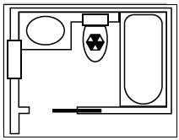

Discussing options
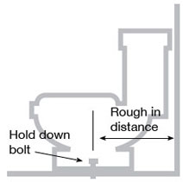
James measures from the wall to the centre of the hold-down bolts and discovers that the distance is 14 inches. The new toilet requires only 12 inches (use measures).
He chats with the customer about this situation and about what the options are to solve it. Some options will be more expensive than others (interact with others).
The first and probably most expensive option is to re-work the existing pipes to make a 12-inch rough-in. A second option is to replace the existing closet ring with an offset closet ring. The third and least expensive option is to place a spacer of some sort (like a wood block) between the tank and the wall. James explains that the spacer does not need to be large or visible, but that there will be a gap between the tank and the wall (thinking skills – decision making).
The customer is not happy with the gap option and decides to go with option two, using an offset closet ring; James agrees.

Preparing for the new fixture
James starts by shutting off the water supply to the toilet tank and removing all the water from the tank and bowl. He then removes the hold-down bolts so he can remove the tank from the wall and the bowl from the floor, to inspect the uncovered drain in the floor.
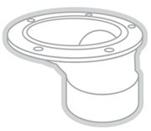
An offset closet ring allows the opening of pipe to be altered and alignment with the pipe already in place.
James also inspects the tile and subfloor where the toilet was; he finds the floor in great shape. However, he will have to make a wood block filler to fit the new offset closet ring. The cut-out of the floor and the wood block filler has complicated angles because the back corners of the new toilet will not cover a square cut-out. James cuts a ¾-inch-thick piece of treated lumber to fit in the tile cut-out and drills in a 4½-inch hole in the wood block filler to connect the flange to the pipe (use measures, thinking skills – problem solving).

Securing the flange
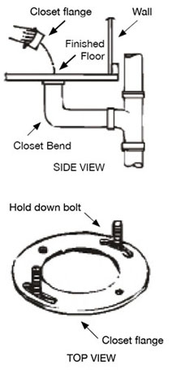
James applies an adhesive to the drainpipe and the fitting, then lifts the drainpipe and fixes it in place with a temporary support. He then joins the drainpipe and the fitting with PVC cement, removes the pipe support and uses deck screws to secure the flange to the floor. He uses caulking to fill the gaps between the wood block filler and the tile floor to minimize water damage if the toilet ever overflows.
Once the flange is in place, the rest of the toilet installation is easy.
James installs a new sealer ring on the opening of the water outlet, on the bottom of the new bowl; he also applies an even layer of setting compound around the edge of the bowl, at the base (about 2 inches thick) (use measures). He turns the bowl right side up and places it down over the flange, guiding the bolts into place. James then levels the bowl and secures the toilet to the flange. Finally, he reconnects the water-supply inlet pipe and makes sure the ballcock assembly is properly attached. He turns the water back on and tests the operation of the toilet.
James finishes the job by reviewing the work he did with the customer (interact with others). He also reminds the customer about filling in the rebate application to get a refund for part of the cost.

Do you have the Essential Skills to be a Plumber?
Complete the following questions to see how your skills compare to those of a journeyperson in plumbing.

2. Internet research
Residential plumbers have to be up to date with the latest products to be able to give their customers current information. Do some research on the Internet to find out more about low-flush toilets so you can answer the following questions:
- A customer would like to replace a 13-litre toilet with an ultra-low-flush toilet.
  - Which search words should you use to find this information?
  - How much water does an ultra-low-flush toilet use?
- Find out if there is a municipal rebate available for a toilet replacement in the community where you live. Write down the steps you took to find this information.

3. Calculating distances
The odometer in the plumber's service truck records travel to and from service calls during the day. The plumber can charge 53 cents per kilometre. Calculate the kilometres and the charge if the odometer has the following readings:
Start of shift: 82781.6 km
End of shift: 82817.9 km

4. Designing a wood block filler
A plumber drills a 4½-inch hole into a square wood block filler to connect the flange to the drainpipe. If the seat of the flange is 1¼ inches wide, what is the minimum width of the wood block filler?
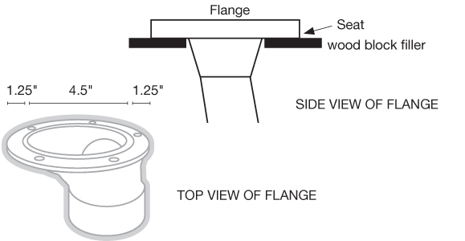

5. Applying caulking
After applying caulking to the wood block filler and to the tile floor, a plumber spends one hour to complete the toilet assembly. He reviews the directions on the caulking and takes note of the following key points:
- Be sure the area is clean and dry before beginning caulking.
- Cut the tip of the caulking gun at a 45° angle.
- To release the caulk, squeeze the trigger of the gun and slowly pull it away from the bead.
- Allow the caulking to dry for a minimum of two hours.
Based on this information, how much longer must the plumber wait before turning on the water to fill the tank and perform a flush test for leaks?

Adapted from Using Essential Skills: On the Job with a Plumber
http://www.edsc.gc.ca/eng/jobs/les/tools/awareness/plumber_story.shtml

Task Title: Explore the Plumbing Trade
Answer Key
Task 1: read continuous text
interpret documents
use measures
critical thinking
interact with others
problem solving
decision making (thinking skills)

Task 2: 1) a. ultra-low-flush toilet
b. The old standard size of a toilet is 13 litres (or 7 gallons); new ultra low flush toilets use as
little as 3 litres (or .8 gallons) of water.
2) Answers will vary. You can enter search words such as "toilet rebate program" along with the
name of the city in which you live.

Task 3: 82817.9km – 82781.6km = 36.3km
36.3km x .53 = $19.24 for travel charges

Task 4: 1¼" + 4½" + 1¼" = 7" is the minimum width of the wood block filler

Task 5: 2 hours for total drying – 1 hour to complete the assembly = 1 hour more waiting time

Task Title: Explore the Plumbing Trade
Performance Descriptors |  | Needs Work | Completes task with support from practitioner | Completes task independently
A1.3 | - integrates several pieces of information from texts
 | - manages unfamiliar elements (e.g. vocabulary, context, topic) to complete tasks
 | - identifies the purpose and relevance of texts
 | - infers meaning which is not explicit in texts
 | - uses organizational features, such as headings, to locate information
 | - follows the main events of descriptive, narrative, informational and persuasive texts
 | - obtains information from detailed reading
A2.2 | - performs limited searches using one or two search criteria
 | - extracts information from tables and forms
 | - uses layout to locate information
 | - makes low-level inferences
B2.1 | - writes simple texts to request, remind or inform
 | - conveys simple ideas and factual information
 | - demonstrates a limited understanding of sequence
 | - uses highly familiar vocabulary
C1.1 | - adds, subtracts, multiplies and divides whole numbers and decimals
 | - follows apparent steps to reach solutions
 | - interprets and represents costs using monetary symbols and decimals
 | - recognizes values in number and word format
 | - identifies and performs required operation
C2.1 | - adds, subtracts, multiplies and divides whole numbers and decimals
 | - understands chronological order
 | - identifies and performs required operation
 | - represents dates and times using standard conventions
 | - follows apparent steps to reach solutions
C3.1 | - adds and subtracts whole number measurements
 | - recognizes values in number and word format
 | - measures distance, length, width, height, weight, liquid volume, angles and temperature
 | - uses common measuring tools, such as rulers, scales and thermometers
 | - chooses appropriate units (e.g. metres, inches) and non-standard units (e.g. paces, cupfuls, scoops)
 | - identifies and performs required operation
 | - interprets and represents measures using whole numbers, decimals and simple, common fractions (e.g. ½, ¼)
 | - interprets and represents measures using symbols and abbreviations (e.g. inches as “, centimeters as cm, pounds as lbs, kilograms as kilos or kg)
 | - follows apparent steps to reach solutions
D2 | - selects and follows appropriate steps to complete tasks
 | - locates and recognizes functions and commands
 | - makes low-level inferences to interpret icons and text
 | - begins to identify sources and evaluate information
 | - performs simple searches using keywords (e.g. internet, software help menu)

This task: was successfully completed___ needs to be tried again___

Learner Comments

____________________________ _________________________

Instructor (print) Learner Signature

