OALCF Task Cover Sheet
Task Title: Use a Floor Plan to Design a Room
Learner Name:

Date Started: Date Completed:

Successful Completion: Yes___ No___
Goal Path: Employment___ Apprenticeship___ Secondary School___ Post-Secondary___ Independence
Task Description:
Learners must select furniture from various print and online sources to furnish a single room in their home,
and then create a floor plan for the room
Competency:  A: Find and Use Information  B: Communicate Ideas and Information  C: Understand and Use Numbers | Task Group(s):  A2: Interpret Documents  B3: Complete and create documents  C3: Use measures
Level Indicators:
A2.2: Interpret simple documents to locate and connect information
B3.2b: Create simple documents to sort, display, and organize information
C3.1: Measures and make simple comparisons and calculations
Performance Descriptors: see chart on last page
Materials Required:
- “Room design” handout
- List of furniture items with dimensions
- Floor Plan of a living room
- Ruler, pencil, eraser

Task Title: Use a Floor Plan to Design a Room
Learner Information and Tasks
A floor plan is a great way to see if your furniture will fit in the room. On a separate piece of paper create a floor plan of a room or use the floor plan provided. Indicate where you would place the furniture items. Remember to leave enough room for doors to open.

Task Title: Use a Floor Plan to Design a Room
Task 1: Use the floor plan to design your living room. The total dimension of the living room is 11 feet 8 inches x 17 feet 7 inches. Your living room needs to have the following items:
- two couches
- two chairs
- coffee and end tables
- three floor lamps
- bookshelf
- television with stand
- two plants
- dog bed

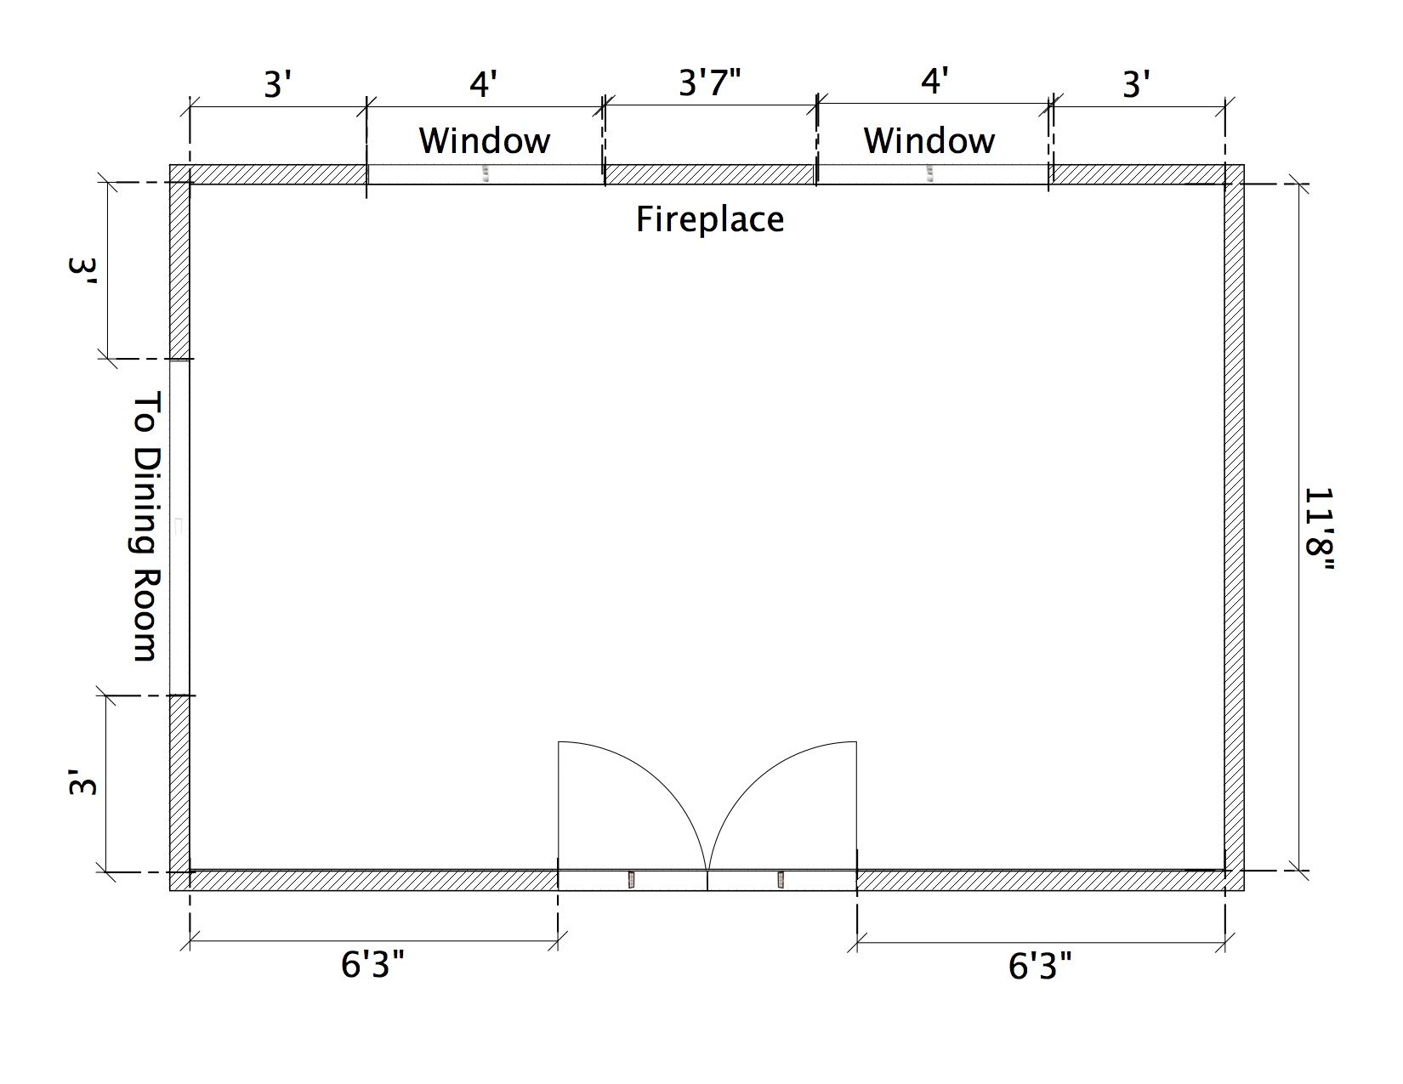

Task Title: Use a Floor Plan to Design a Room
Category | Furniture Item and Footprint Dimensions
Couch | 6 feet x 3 feet
Chair | 3 feet x 3 feet
Coffee and end tables | 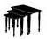 2 feet x 2 feet 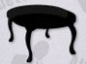 2 feet x 3 feet
Television | 3 feet wide x 1 foot deep
Television stand | 3 feet x 2 feet
Bookshelf | 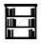 2 feet wide x 1 foot deep
Floor lamp | All floor lamps have a 1 foot diameter base
Dog bed | 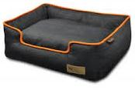 2 feet x 2 feet
Plants | 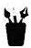 All plants have a 1 foot diameter base

Task Title: Use a Floor Plan to Design a Room
Performance Descriptors |  | Needs Work | Completes task with support from practitioner | Completes task independently
A2.2 | - locates information in simple graphs and maps
 | - uses layout to locate information
B3.2b | - follows conventions to display information in simple documents (e.g. use of font, colour, shading, bulleted lists)
 | - identifies parts of documents using titles, row and column heading, and labels
C3.1 | - adds and subtracts whole number measurements
 | - recognizes value in number and word format
 | - measures distance, length, width, height, weight, liquid volume, angles, and temperature
 | - uses common measuring tools, such as rulers, scales, and thermometer
 | - makes simple estimates

This task: was successfully completed___ needs to be tried again___

Learner Comments

____________________________ _________________________

Instructor (print) Learner Signature

