OALCF Task Cover Sheet
Task Title: Understanding the Syllabus
Learner Name:

Date Started: Date Completed:

Successful Completion: Yes___ No___
Goal Path: Employment___ Apprenticeship ✓ Secondary School Post Secondary ✓ Independence___
Task Description:
Read and understand a college course syllabus.
Competency:  A: Find and Use Information  B: Communicate Ideas and Information  D: Use Digital Technology | Task Group(s):  A1: Read Continuous Text  A2: Interpret Documents  B2: Write Continuous Text  D: Not Applicable
Level Indicators:
A1.2: Read texts to locate and connect ideas and information
A2.2: Interpret simple documents to locate and connect information.
B2.2: Write texts to explain and describe information and ideas.
D.2: Perform well-defined, multi-step digital tasks
Performance Descriptors: see chart on last page
Materials Required:
- Task Document and Questions
- Pen and paper
- A computer with Internet access
- Alternative: Consider using a syllabus for a course your learner is interested in. The Ontario North website (http://www.ontariolearn.com/en/) has a search engine for online College courses across Ontario and many of the syllabi are available on college websites.

Task Title: Understanding the Syllabus
Learner Information and Tasks:
Many college and university professors provide information to students through a syllabus. A syllabus is a document that explains course material, deadlines, important details about the class, and other information so that the professor does not have to repeat information during class time. Look at the “CMM125 College Communications I” syllabus.
Task 1: How many credits do you receive for completing the CMM125 course?

Task 2: Which managing time outcomes can you expect to meet at the end of this course?

Task 3: Which department would you see if you needed accommodations for a disability?

Task 4: Which prerequisites are required to take this course?

Task 5: Most syllabi have more information than the CMM125 syllabus includes. What other information would be useful to you if you were taking this course? (Note: the word “syllabi” is the plural form of “syllabus.”)

Task 6: PLAR is an acronym that is used in the syllabus. Use the Internet to search for the PLAR program in Ontario colleges. What is a PLAR and what does it do?

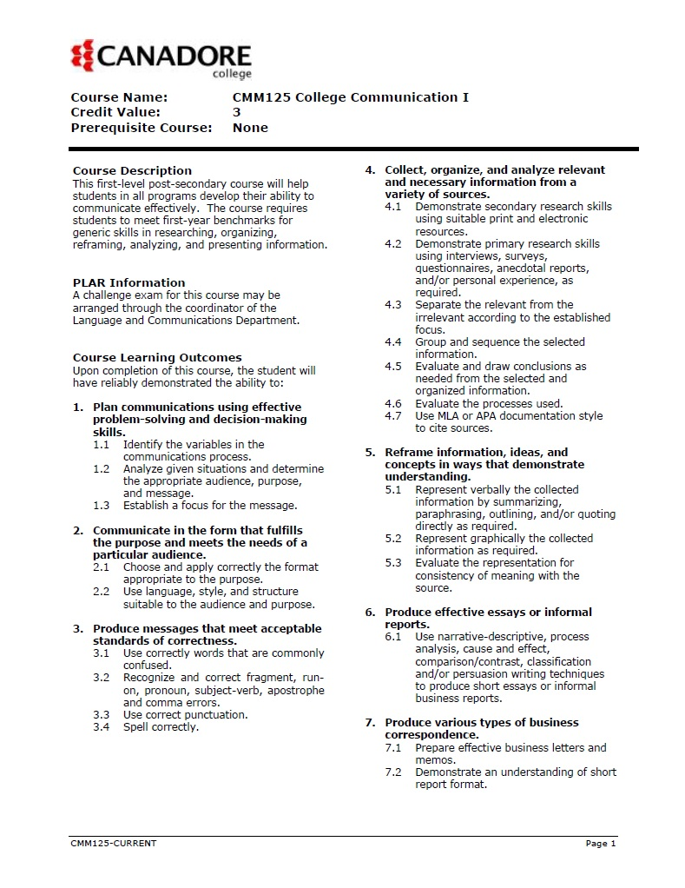
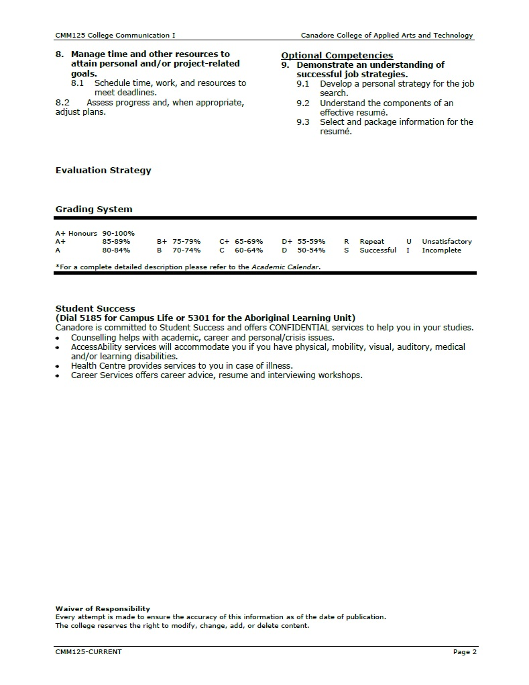
Task Title: Understanding the Syllabus
Answer Key
Task 1: How many credits do you receive for completing the CMM125 course?
You receive 3 credits for completing the CMM125 course.
Task 2: Which managing time outcomes can you expect to meet at the end of this course?
The managing time outcomes that you can expect to meet at the end of this course are the ability to schedule time, work, and resources to meet deadlines, and assess progress and, when appropriate, adjust plans.
Task 3: Which department would you contact if you needed accommodations for a disability?
You would see the Accessibility Services department if you needed accommodations for a disability.
Task 4: Which prerequisites are required to take this course?
There are no prerequisites required to take this course.
Task 5: Most syllabi have more information than the CMM125 syllabus includes. What other information would be useful to you if you were taking this course? Note: the word “syllabi” is the plural form of “syllabus.”
Answers will vary but here is an example: If I was taking this course, I would want to know what assignments I was responsible for and a week-by-week schedule of course material. Other answers may include a breakdown of the course mark, information about the professor or course meeting time, or other related information that would typically be included on a syllabus.
Task 6: PLAR is an acronym that is used in the syllabus. What does the acronym stand for? Use the Internet to search for the PLAR program in Ontario colleges. Write at least 2 pieces of information that you learned about PLAR from your search.
PLAR stands for Prior Learning Assessment and Recognition. The PLAR program allows students to get course credit for life experience. Each college has its own policy PLAR policy. Other answers may include that you can demonstrate prior knowledge through tests, interviews, or demonstrations, or PLAR portfolios; that you may contact the Coordinator of the Language and Communications Department for more information about using PLAR with this course; or other related facts found when researching PLAR at local colleges or the Ontario Colleges website.
Task Title: Understanding the Syllabus
Performance Descriptors |  | Needs Work | Completes task with support from practitioner | Completes task independently
A1.2 | - scans text to locate information
 | - locates multiple pieces of information in simple texts
 | - makes low-level inferences
A2.2 | - performs limited searches using one or two search criteria
 | - extracts information from tables and forms
 | - locates information in simple graphs and maps
 | - uses layout to locate information
 | - makes connections between parts of documents
 | - makes low-level inferences
B2.2 | - writes texts to explain and describe
 | - conveys intended meaning on familiar topics for a limited range of purposes and audiences
D.2 | - selects and follows appropriate steps to complete tasks
 | - locates and recognizes functions and commands
 | - makes low-level inferences to interpret icons and text
 | - performs simple searches using keywords (e.g. internet, software help menu)

This task: was successfully completed___ needs to be tried again___

Learner Comments

____________________________ _________________________

Instructor (print) Learner Signature

