Task Title: Assessing Computer Skills

OALCF Cover Sheet – Practitioner Copy

Learner Name:
Date Started (m/d/yyyy):
Date Completed (m/d/yyyy):
Successful Completion: Yes No
Goal Path: | Employment | Apprenticeship
Secondary School | Post Secondary | Independence
Task Description: Many jobs require knowledge of computers and the internet. In this task the learner will assess their computer skills through an online test and determine whether they would benefit from computer skills upgrading.
Competency: A: Find and Use Information, D: Use Digital Technology, E: Manage Learning
Task Groups: A1: Read continuous text, A2: Interpret documents
Level Indicators:
A1.1: Read brief texts to locate specific details
A1.2: Read continuous text
A2.3: Interpret somewhat complex documents to connect, evaluate and integrate information
D.3: Experiment and problem solve to perform multi-step digital tasks
E.1: Set short-term goals, begin to use limited learning strategies, and begin to monitor own learning
Performance Descriptors: See chart on last page
Materials Required:
- Computer with internet access
- A minimum of 30 minutes to take the test and review results.
Instructor preparation: Ensure the learner is set up on a computer with the internet connection open. Depending on the reading level of the learner you may have to assist them with some of the questions. Help the learner review the results and decide about taking a computer class.

Work Sheet:
Many jobs require knowledge of computers and the internet.

Task 1: Make sure the computer’s internet connection is on. In the web browser, enter the website:
https://www.wiseowl.co.uk/basic-it/skill/basic-it-test/

Task 2: Read the instructions on the page for taking the online basic computing skills assessment.

Task 3: Once you have read and understand the instructions click on the “Start this test” button on the bottom left corner of the screen.

Task 4: Read and follow the answer instructions for the first of 20 questions in the assessment. You can skip a question at any time by clicking the ‘Leave this question for now’ button at the bottom of the screen. The test will come back to this question later.

Task 5: Once you select your answer, the next question will appear. Repeat task 4 until all 20 questions have been answered. You have about 20 minutes to complete the quiz. Your remaining time will appear right above the questions.

Task 6: Once you have answered all 20 questions a screen will appear that says you have finished the quiz. Enter your first name only and click on the button that says “Mark My Test”.
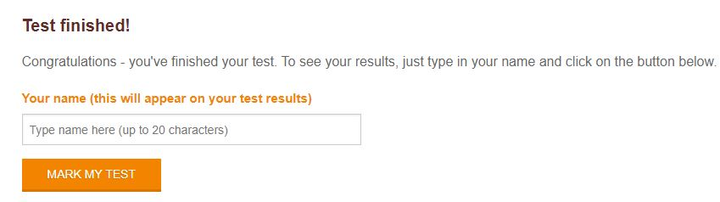

Task 7: Review the results of your test as shown. See what your total score is. See how you compare to others taking this quiz. Check the correct answers for questions you got wrong or didn’t know.
Task 8: Based on your results decide if you would benefit from taking a computer class.

Performance Descriptors
Levels | Performance Descriptors | Needs Work | Completes task with support from practitioner | Completes task independently
A1.1 | Reads short texts to locate a single piece of information
A1.1 | Decodes words and makes meaning of sentences in a single text
A1.1 | Follows the sequence of events in straightforward chronological texts
A1.1 | Follows simple, straightforward instructional texts
A1.1 | Identifies the main idea in brief texts
A1.2 | Scans text to locate information
A1.2 | Locates multiple pieces of information in simple texts
A1.2 | Obtains information from detailed reading
A1.2 | Makes low-level inferences

Levels | Performance Descriptors | Needs Work | Completes task with support from practitioner | Completes task independently
A2.3 | Manages unfamiliar elements (e.g. vocabulary, context, topic) to complete tasks
A2.3 | Uses layout to locate information
A2.3 | Identifies the purpose and relevance of documents
A2.3 | Begins to recognize bias in displays, such as graphs
A2.3 | Makes inferences and draws conclusions from information displays
A2.3 | Identifies sources, evaluates and integrates information
D.3 | Manages unfamiliar elements (e.g. vocabulary, context, topic) to complete tasks
D.3 | Makes inferences to interpret icons and text
D.3 | Identifies sources, evaluates and integrates information

Levels | Performance Descriptors | Needs Work | Completes task with support from practitioner | Completes task independently
E.1 | Sets short-term goals
E.1 | Identifies steps required to achieve goals
E.1 | Begins to identify barriers to achieving goals
E.1 | Begins to monitor own learning
E.1 | Uses feedback to improve performance

This task: Was successfully completed Needs to be tried again
Learner Comments:

Instructor (print): Learner (print):

