OALCF Tasks for the Apprenticeship Goal Path: Prepared for the Project, Developing Best Practices for Increasing, Supporting and Retaining Apprentices in Northern Ontario (2014) - Updated 2023 as part of CLO’s Skills for Success Initiative

Task Title: Automotive Repair Invoice

OALCF Cover Sheet – Practitioner Copy

Learner Name:
Date Started (m/d/yyyy):
Date Completed (m/d/yyyy):
Successful Completion: Yes No

Goal Path: | Employment | Apprenticeship
Secondary School | Post Secondary | Independence
Task Description: Use an automotive service invoice to calculate costs for repair work.
Competency: A: Find and Use Information, C: Understand and Use Numbers
Task Groups: A2: Interpret documents, C1: Manage money
Level Indicators:
- A2.1: Interpret very simple documents to locate specific details
- A2.2: Interpret simple documents to locate and connect information
- C1.1: Compare costs and make simple calculations
- C1.2: Make low-level inferences to calculate costs and expenses that may include rates such as taxes and discounts

Embedded Skills for Success: | Digital
Adaptability | Numeracy
Collaboration | Problem Solving
Communication | Reading
Creativity and Innovation | Writing
Performance Descriptors: See chart on last page
Materials Required:
- Automotive service invoice – attached
- Calculator - optional

Learner Information

Automotive service technicians calculate the cost of repair jobs. The total cost of a repair job may include taxes, labour rates, and parts. Look at the “ABC Auto Repair” invoice and complete the tasks that follow.
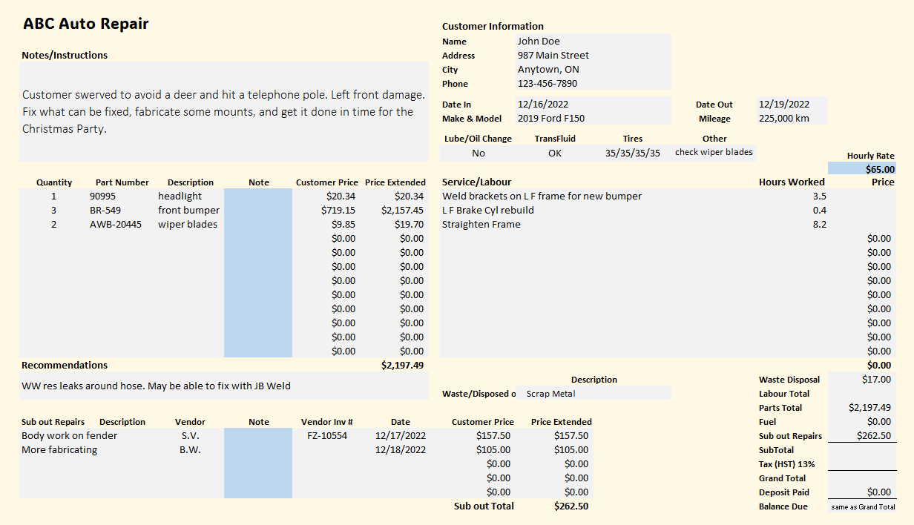

Work Sheet
Task 1: On the invoice, highlight, underline or circle the notes/instructions for this job. If doing this task online, write the notes/instructions below.
Answer:

Task 2: Calculate the cost for the repair shop to “weld brackets on L F for new bumper”. Enter the answer into the invoice.

Task 3: Calculate the cost for the repair shop to “L F brake Cyl rebuild”. Enter the answer into the invoice.

Task 4: Calculate the cost for the repair shop to “Straighten Frame”. Enter the answer into the invoice.

Task 5: Calculate the Labour total. Enter the answer into the invoice.

Task 6: Calculate the subtotal for waste disposal, labour total, parts total, fuel, and sub out for repairs. Enter the answer into the invoice.

Task 7: Calculate the amount of tax (HST) that will be added to the subtotal. Enter the answer into the invoice.

Task 8: Calculate the final total the customer will pay for this repair work. Enter the answer into the invoice.

Answers
Note: Individual answers/images are provided for each task. Additionally, an image of the entire invoice correctly completed is also provided at the end.
Task 1: On the invoice, highlight, underline or circle the notes/instructions for this job. If doing this task online, write the notes/instructions below.
Learner will circle the instruction box in the top-left corner of the invoice or write: “Customer swerved to avoid a deer and hit a telephone pole. Left front damage. Fix what can be fixed, fabricate some mounts, and get it done in time for the Christmas Party.”
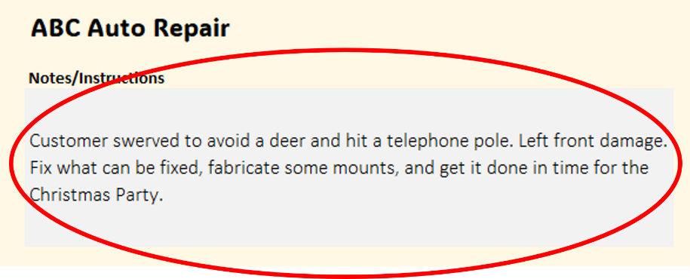
Task 2: Calculate the cost for the repair shop to “weld brackets on L F for new bumper”. Enter the answer into the invoice.
$65/hour x 3.5 hours = $227.50
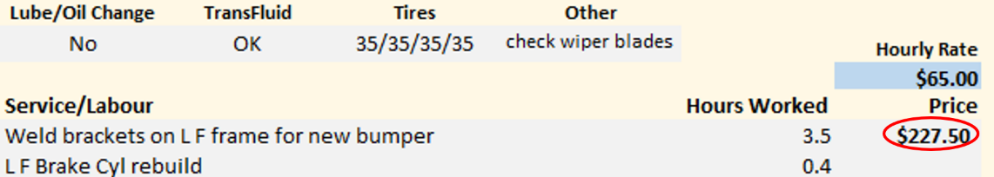
Task 3: Calculate the cost for the repair shop to “L F brake Cyl rebuild”. Enter the answer into the invoice.
$65/hour x 0.4 hours = $26.00
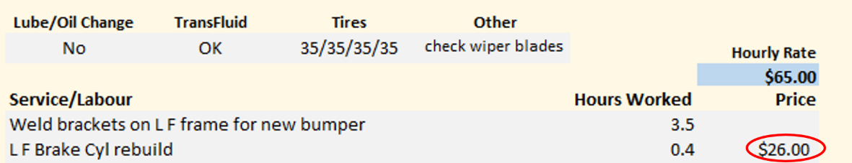
Task 4: Calculate the cost for the repair shop to “Straighten Frame”. Enter the answer into the invoice.
$65/hour x 8.2 = $533.00
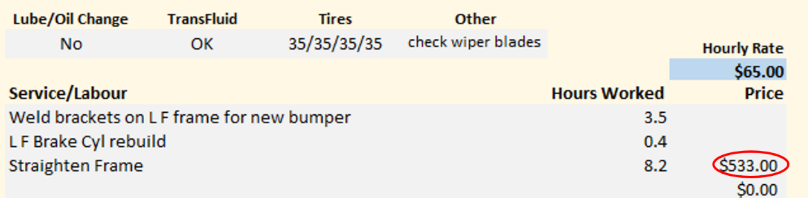

Task 5: Calculate the Labour total. Enter the answer into the invoice.
Add the total hours and multiply by the hourly rate: (3.5 + 0.4 + 8.2) x $65 = $786.50 OR
Add the answers to Tasks 2, 3 and 4 ($227.50 + $26.00 + $533.00) = $786.50

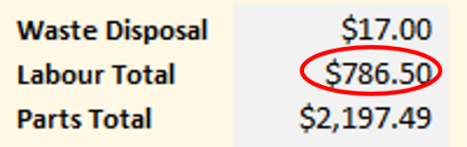

Task 6: Calculate the subtotal for waste disposal, labour total, parts total, fuel, and sub out for repairs. Enter the answer into the invoice.
Cal

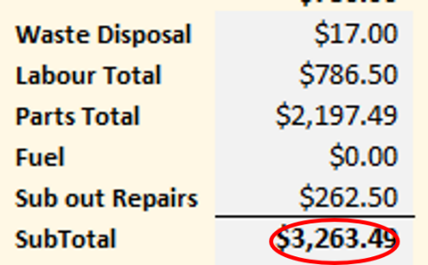

Task 7: Calculate the amount of tax (HST) that will be added to the subtotal. Enter the answer into the invoice.
Multiply the subtotal (calculated in Task 6) by 13% (.13):
$3,263.49 x 0.13 = $424.2537
Round down to $424.25
$424.25
Task 8: Calculate the final total the customer will pay for this repair work. Enter the answer into the invoice.
Add the subtotal and the tax total together: $3,263.49 + $424.25 = $3,687.74
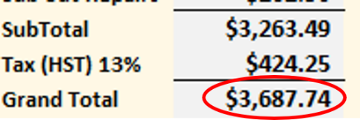
Correctly Completed Invoice
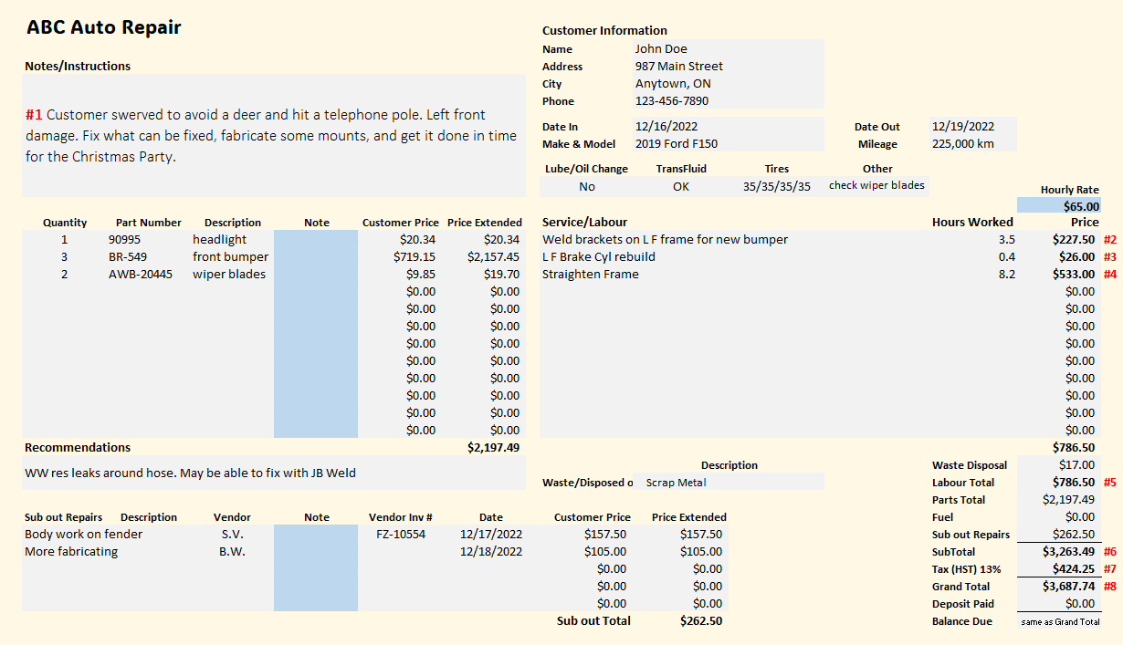

Performance Descriptors 1
Levels | Performance Descriptors | Needs Work | Completes task with support from practitioner | Completes task independently
A2.1 | Scans to locate specific details
A2.1 | Locates specific details in simple documents, such as labels and signs
A2.1 | Identifies how lists are organized (e.g. sequential, chronological, alphabetical)
A2.1 | Requires support to identify sources and to evaluate and integrate information
A2.2 | Performs limited searches using one or two search criteria
A2.2 | Extracts information from tables and forms
A2.2 | Uses layout to locate information
A2.2 | Makes connections between parts of documents
A2.2 | Makes low-level inferences

Performance Descriptors 2
Levels | Performance Descriptors | Needs Work | Completes task with support from practitioner | Completes task independently
C1.1 | Adds, subtracts, multiplies and divides whole numbers and decimals
C1.1 | Understands numerical order
C1.1 | Identifies and performs required operation
C1.1 | Follows apparent steps to reach solutions
C1.1 | Interprets and represents costs using monetary symbols and decimals
C1.1 | Uses strategies to check accuracy (e.g. estimating, using a calculator, repeating a calculation, using the reverse operation)
C1.2 | Calculates using numbers expressed as whole numbers, fractions, decimals, percentages and integers
C1.2 | Calculates percentages
C1.2 | Interprets and applies rates (e.g. $/kg, $/1)

Performance Descriptors 3
Levels | Performance Descriptors | Needs Work | Completes task with support from practitioner | Completes task independently
C1.2 | Chooses and performs required operation(s); may make inferences to identify required operation(s)
C1.2 | Selects appropriate steps to reach solutions
C1.2 | Represents costs and rates using monetary symbols, decimals and percentages
C1.2 | Interprets, represents and converts amounts using whole numbers, decimals, percentages, ratios and simple, common fractions (e.g. ½, ¼ )
C1.2 | Uses strategies to check accuracy (e.g. estimating, using a calculator, repeating a calculation, using the reverse operation)

This task: Was successfully completed Needs to be tried again

Performance Descriptors 4
Learner Comments:

Instructor (print): Learner (print):

