Task-based Activity Cover Sheet
Task Title: Browse classified listings online and in newspapers to search for used furniture
Learner Name:

Date Started: Date Completed:

Successful Completion: Yes___ No___
Goal Path: Employment___ Apprenticeship___ Secondary School Post Secondary Independence ✓
Task Description:
The learner will browse through classified advertisements to search for a used couch.
Competency:  A: Find and Use Information | Task Group(s):  A2:Interpret documents
Level Indicators:
A2.3: Interpret somewhat complex documents to connect, evaluate, and integrate informaiton
Performance Descriptors: see chart or click here
Skill Building Activities: see last page or click here
Materials Required:
- Pen, paper
- Attached classified listings
ESKARGO:
Skills and Knowledge Required for Successful Task Performance
Reading Strategies – Decoding and Comprehension Enhancement :
- Uses a variety of strategies to decode and determine the meaning of unfamiliar words
- Uses context cues and personal experience to gather meaning from a document
- Manages unfamiliar elements (vocabulary, context, topic) to complete tasks
- Uses knowledge of vocabulary and sight words related to specific forms, tables, graphs,
maps and flow charts to obtain meaning
- Navigates various displays of information to locate information
Forms and Conventions – Find Information/Research/Understand Types of Texts :
- Uses layout to locate information
- Uses various conventions of more complex forms, tables, graphs, maps and flow charts to obtain meaning; i.e., layout, rows and columns, titles, headings and sub-headings, to comprehend and interpret data
- Uses organizational features, such as headings, to locate information
- Performs complex searches using multiple search criteria
Comprehension – Read to Understand/Retell :
- Follows list of complex written instructions
- Compares or contrasts information between two or more documents
- Identifies the purpose and relevance of documents
- Reads graphs made with concrete materials, and demonstrates understanding (e.g.,
reads Canada Food guide icons for number of recommended daily portions)
Interpretation – Read and Apply Understanding
- Integrates several pieces of information from documents
- Identifies and describes trend in graphed data using informal language
- Makes inferences and draws conclusions based on the analysis of tables, charts and
graphs
- Identifies sources, evaluates and integrates information
- Evaluates arguments that are based on data analysis
Attitudes:
Practitioner,
We encourage you to talk with the learner about attitudes required to complete this task set. The context of the task has to be considered when identifying attitudes. With your learner, please check one of the following:
□ Attitude is not important □ Attitude is somewhat important □ Attitude is very important

Task Title: Browse classified listings online and in newspapers to search for used furniture
Classified advertisements are a great place to find used furniture at a reasonable cost. Look at the classified advertisements from Kijiji.
Learner Information and Tasks:

Task 1: List five similarities among the advertisements.

Task 2: List two reasons mentioned by these Kijiji sellers as to why they are selling their couches.

Task 3: What may dissuade some people from purchasing the faux-leather couch?

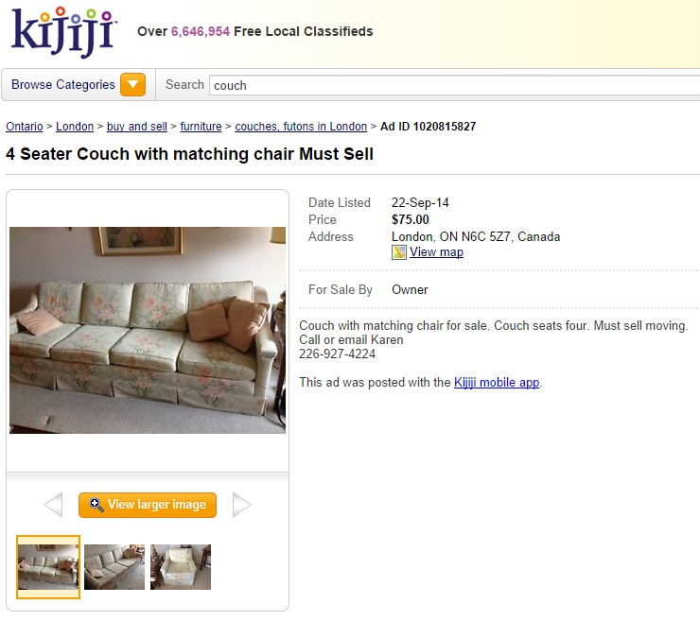
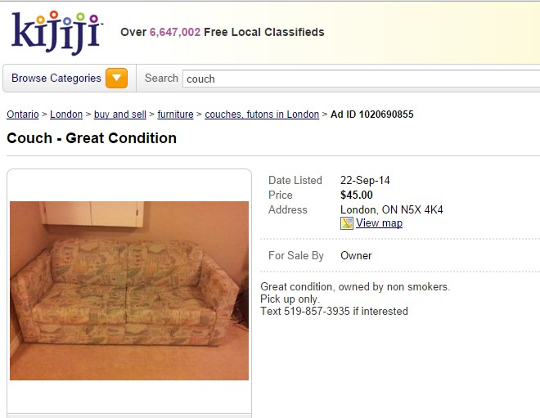
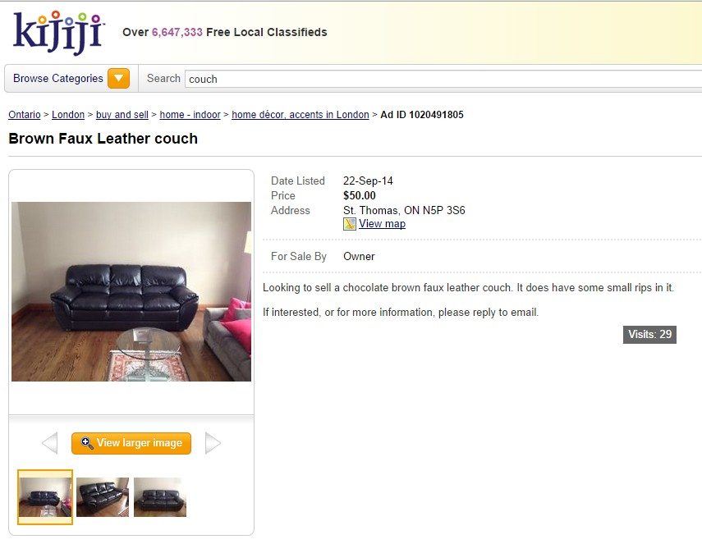
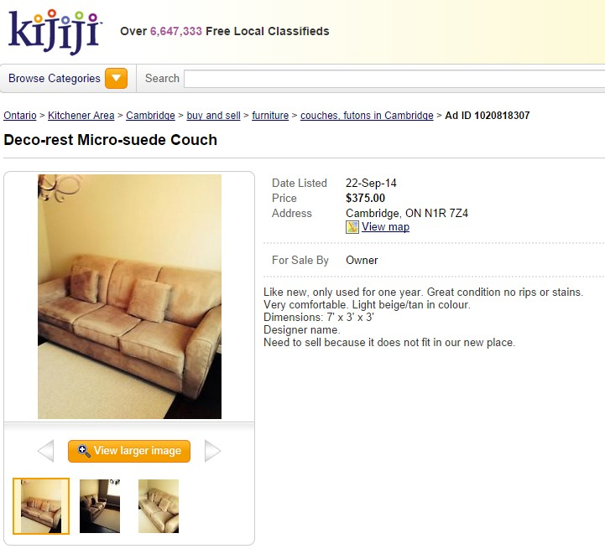
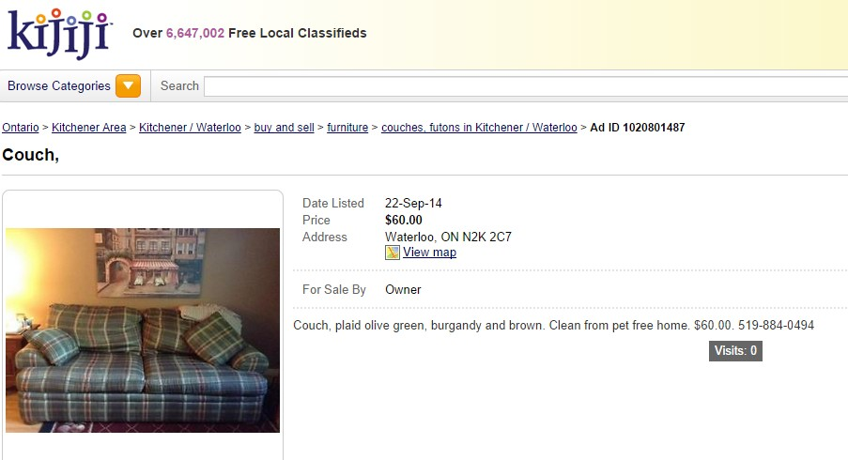
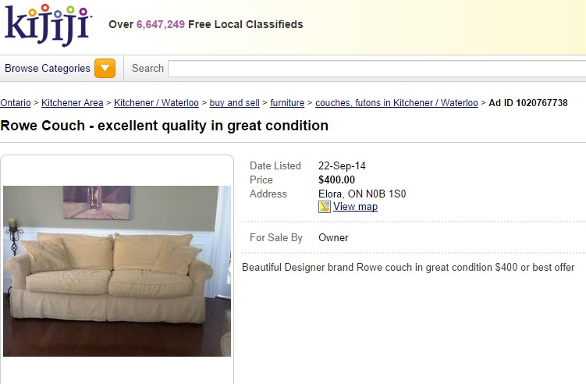

Task Title: Browse classified listings online and in newspapers to search for used furniture
Answer Key
Task 1: List five similarities among the advertisements
- All being sold on Kijiji
- All have a price listed
- all selling couches
- all have pictures of the couch
- all have a listed location
- all have contact information for seller
- all listed on September 22, 2014
- all are sold by the owner
Task 2: List two specific reasons individuals who have posted classified advertisements listed are selling their couches
Does not fit in our place
Must sell: moving

Task 3: What may dissuade some people from purchasing the faux-leather couch?
It does have some small rips in it

Task Title: Browse classified listings online and in newspapers to search for used furniture
Performance Descriptors |  | Needs Work | Completes task with support from practitioner | Completes task independently
A2.3 | - performs complex searches using multiple search criteria
A2.3 | - manages unfamiliar elements (e.g. vocabulary, context, topic) to complete tasks
A2.3 | - integrates several pieces of information from documents
A2.3 | - compares or contrasts information between two or more documents
A2.3 | - uses layout to locate information
A2.3 | - identifies the purpose and relevance of documents
A2.3 | - begins to recognize bias in displays, such as graphs
A2.3 | - makes inferences and draws conclusions from information displays
A2.3 | - identifies sources, evaluates and integrates information

This task: was successfully completed___ needs to be tried again___

Learner Comments

____________________________ _________________________

Instructor (print) Learner Signature

Skill Building Activities
Links to Online Resources:
BBC Skillswise – “Skimming and Scanning” – http://www.bbc.co.uk/skillswise/topic/skimming-and-scanning - learn principles of scanning documents, such as using clue words, headings and titles to direct the eye, and knowing in advance what type of information is being sought
eSpark Learning – “Compare & Contrast Reading Strategy” - https://www.youtube.com/watch?v=eGCzB9VoGLc&list=PLHsgU465oaDRMEwEUqx7dQAi3lnSP9Gq3&index=11 – video describes the compare and contrast reading strategy, and explains its use when evaluating various criteria

Skill Plan - “Measure Up” - http://www.skillplan.ca/measure-up , (select “English”, “Choice of Activities”, “Practice”, “Document Use”, and “Lists and Tables”) – practise locating and comparing multiple pieces of information in documents
GCF LearnFree – “Everyday Life - http://www.gcflearnfree.org/everydaylife/edlall – play games (“Classifieds”, “Phone Numbers”) to practise using layout in documents to locate information
LearningHUB online courses available:

- Reading & Writing, Independent Study (assigned by practitioner after assessment)
  - Reading Level 2, Assignment 1
  - Reading Level 3 Assignment
  - Ready for College Reading, Assignment 3
*all assignments teach strategies for managing unfamiliar elements in texts, using layout to locate details, using pictures to aid comprehension, making inferences, and asking and answer questions while reading

- Essential Skills Independent Study (assigned by practitioner after assessment)
  - Document Use Level 2, Assignment 1 (locating details in reference material)

- Essential Skills Independent Study (assigned by practitioner after assessment)
  - Basic Skills for the Real World, Assignment 4 - interpret simple documents to locate and connect ideas and information related to meeting the daily challenges of life

- Live Classes (SABA) – Reading Comprehension (scanning to locate details)

*To access LearningHUB courses, learners must register for the LearningHUB e-Channel program by completing the registration form on their website and completing the course selection (page 2 of the registration form): https://www.learninghub.ca/get_registered.aspx

*To Access LearningHUB Course Catalogue:
http://www.learninghub.ca/Files/PDF-files/HUBcoursecatalogue,%20December%2023,%202014%20revision.pdf

