OALCF Task Cover Sheet
Task Title: Cancelling and rescheduling a workshop
Learner Name:

Date Started: Date Completed:

Successful Completion: Yes___ No___
Goal Path: Employment Apprenticeship___ Secondary School___ Post Secondary___ Independence___
Task Description:
Use proper phone etiquette to cancel and reschedule a workshop. Use a calendar to reschedule and understand appointment times
Competency:  A: Find and Use Information  B: Communicate Ideas and Information  C: Understand and Use Numbers | Task Group(s):  A1: Read continuous text  A2: Interpret documents  B1: Interact with others  B2: Write continuous text  B3: Complete and create documents  C2: Manage Time
Level Indicators:
A1.1: Read brief texts to locate specific details
A2.2: Interpret simple documents to locate and connect information
B1.2: Initiate and maintain interactions with one or more persons to discuss, explain or exchange information and opinions
B2.2: Write texts to explain and describe information and ideas
B3.2a: Use layout to determine where to make entries in simple documents
C2.1: Measure time and make simple calculations

Performance Descriptors: see chart on last page
Materials Required:
- Pen and Paper
- Attached document "June Calendar"
- Conduct conversation orally with instructor

Task Title: Cancelling and rescheduling a workshop
Learner Instructions and Task Set
You are unable to attend a workshop because of illness.
In this task you will learn proper telephone etiquette for cancelling an appointment.
Remember to be pleasant and patient with the receptionist.
You cannot attend a resume workshop because you are sick. You will need to contact the organization that is hosting the resume workshop to let them know and to reschedule for the next available resume workshop.
When you contact the organization with the information use the calendar provided to choose a date to reschedule. It is not appropriate to text the organization. Be sure to ask the time and length of the workshop. This is important for working into your schedule.
You will have the conversation with your instructor or a fellow student acting as the Receptionist. You will also need to refer to the calendar at some point in the conversation.
Use the June calendar that has been provided.
Task 1: You have dialed the number and the receptionist has answered.
Receptionist: Good Morning, Employment Services, May I help you?
You:
Receptionist: May I have your name please?
You:
Receptionist: Thank you for calling. Is there anything else I can do for you?
You:
Receptionist: The next available dates for the workshop are
June 2nd, June 10th, June 18th and June 26th
Each workshop is 1 1/2 hours long
Which one would you like to be scheduled for?
You:
Receptionist: June 2nd and June 18th the workshop is at 9:30 am. and June 10th and 26th the workshop is at 1:30 pm.

You:
Receptionist: I apologize; I should have let you know that one is full. It looks like the 18th and 26th are not full.
You:
Receptionist: Okay. Is there anything else I can do for you?
You:
Receptionist: Hope you feel better.
You:

Task 2: Enter the rescheduled workshop date and time into the calendar provided.

Task 3: Why would you not get upset with the receptionist when she tells you that the workshop you wanted is full?

Task 4: a) A workshop is scheduled for 9:30 am on Monday and you have a dentist appointment at 8:45 am. The dentist appointment will take 45 minutes and it will take 25 minutes to get to the workshop. What time will you arrive at the workshop?

- Explain your reasons for not attending the workshop.

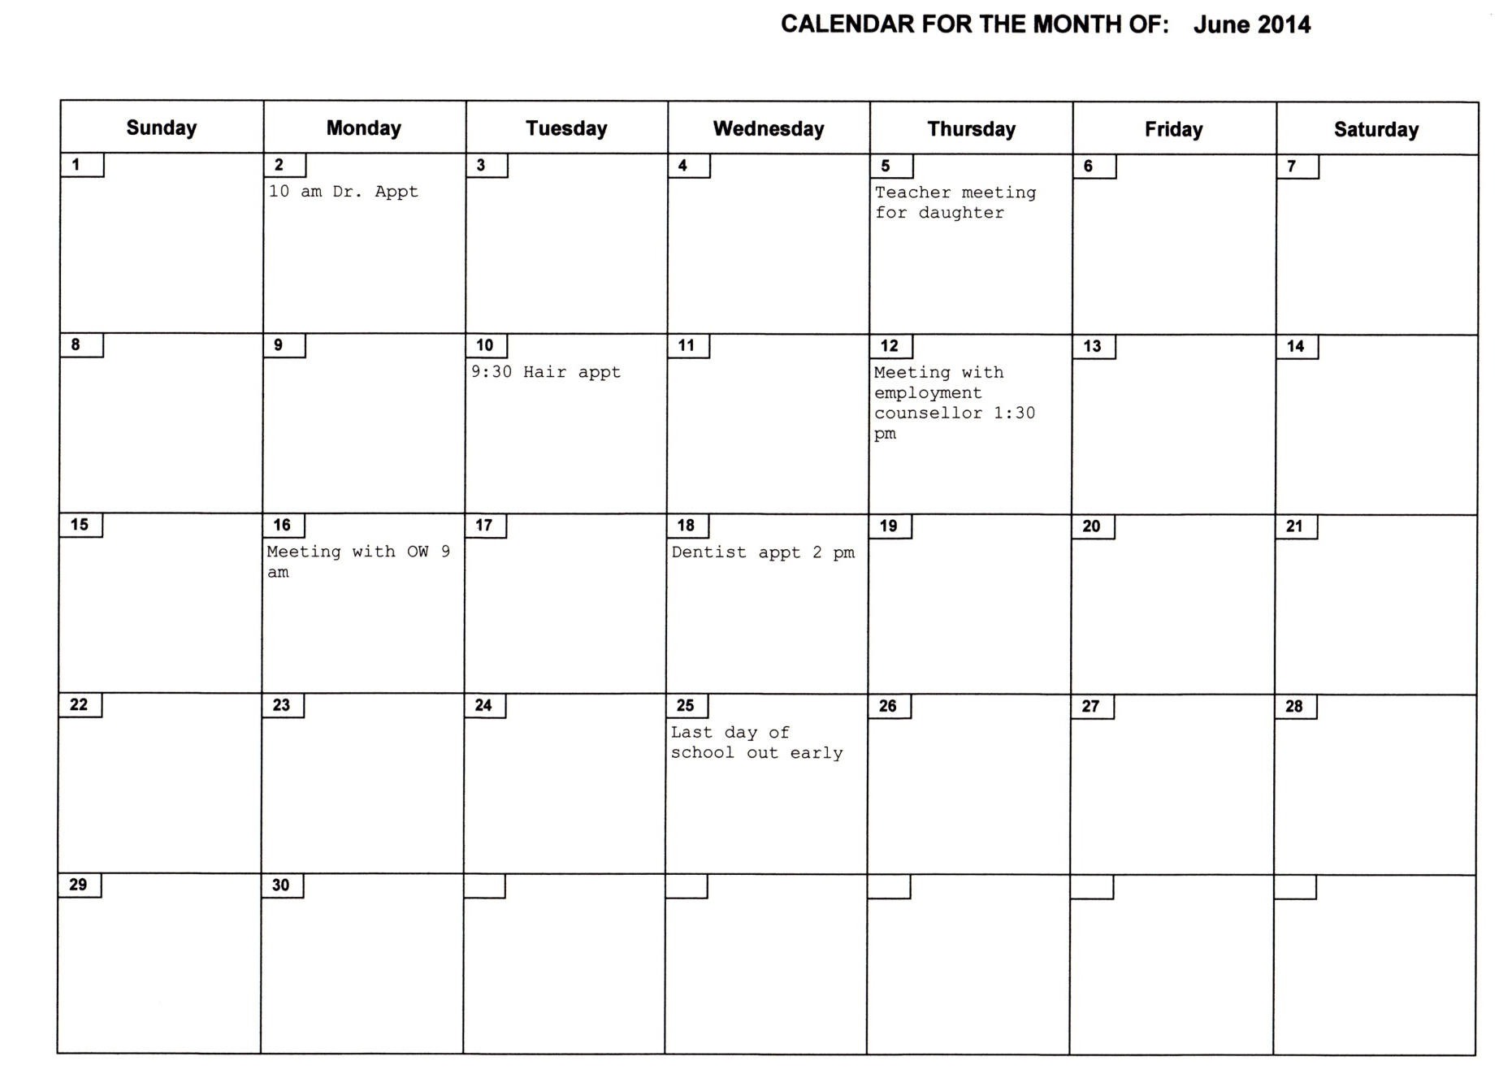

Task Title: Cancelling and rescheduling a workshop
Answer Key
Task 1: You have dialed the number and the receptionist has answered. The learner part of the conversation [You] should be similar to what is here.

Receptionist: Good Morning, Employment Services, May I help you?
You: Yes, I am calling to let you know that I will not be able to make it to the resume workshop today. I am suffering from the flu.
Receptionist: May I have your name please?
You: [learner name]
Receptionist: Thank you for calling. Is there anything else I can do for you?
You: Yes, I would like to be able to take the next available workshop; can you tell me when they are?
Receptionist: The next available dates for the workshop are
June 2nd, June 10th, June 18th and June 26th
Each workshop is 1 1/2 hours long
Which one would you like to be scheduled for?
You: I am looking at my calendar, can you please tell the times of those workshops?
Receptionist: June 2nd and June 18th the workshop is at 9:30 am. and June 10th and 26th the workshop is at 1:30 pm.
You: Thanks, it looks like June 10th will work.
Receptionist: I apologize; I should have let you know that one is full. It looks like the 18th and 26th are not full.
You: June 18th will work for me. Please schedule me in for that workshop?
Receptionist: Okay. Is there anything else I can do for you?
You: No, that's it. Thank you.
Receptionist: Hope you feel better.
You: Thank you, you too!

Task 2: Enter the rescheduled workshop date and time into the calendar provided.
Refer to the learner's completed calendar
Task 3: Why would you not get upset with the receptionist when she tells you that the workshop you wanted is full?
Even if she did not apologize for the error, you should never become upset.

Task 4: a) A workshop is scheduled for 9:30 am on Monday and you have a dentist appointment at 8:45 am. The dentist appointment will take 45 minutes and it will take 25 minutes to get to the workshop. What time will you arrive at the workshop?
8: 45 + 45 minutes = 9:30
9:30 + 25 minutes = 9:55
Arrive at the workshop at 9:55

- Explain your reasons for not attending the workshop.
You would not attend the workshop that day because you would be late.

Task Title: Cancelling and Rescheduling a workshop
Performance Descriptors |  | Needs Work | Completes task with support from practitioner | Completes task independently
A1.1 | - reads short texts to locate a single piece of information
 | - decodes words and makes meaning of sentences in a single text
 | - follows the sequence of events in straightforward chronological texts
 | - follow simple, straightforward instructional texts
 | - identifies the main idea in brief texts
A2.2 | - performs limited searches using one or two search criteria
 | - extracts information from tables and forms
 | - uses layout to locate information
 | - makes connections between parts of documents
 | - makes low-level inferences
B2.2 | - writes texts to explain and describe
 | - conveys intended meaning on familiar topics for a limited range of purposes and audiences
 | - begins to sequence writing with some attention to organizing principles (e.g. time, importance)
 | - uses limited range of vocabulary and punctuation appropriate to the task
 | - begins to select words and tone appropriate to the task
B3.2a | - uses layout to determine where to make entries
 | - begins to make some inferences to decide what information is needed, where and how to enter the information
 | - makes entries using a limited range of vocabulary
C2.1 | - adds, subtracts, multiplies and divides whole numbers and decimals
 | - recognizes values in number and word format
 | - understands chronological order
 | - understands and uses common date formats
 | - reads time on analog and digital clocks
 | - identifies and performs required operation
 | - represents dates and times using standard conventions
 | - measures time using common instruments, such as clocks, timers and stopwatches
 | - chooses appropriate units of measurement (e.g. hours, minutes, seconds)
 | - interprets and represents time using whole numbers, decimals (e.g. .25, .5) and simple common fractions (e.g. ½, ¼ hour)
 | - follows apparent steps to reach solutions
 | - rounds to nearest minute or hour
B1.2 | - shows an awareness of factors that affect interactions, such as differences in opinions and ideas, and social, linguistic and cultural differences
 | - demonstrates some ability to use tone appropriately
 | - uses strategies to maintain communication, such as encouraging responses from others and asking questions
 | - speaks or signs clearly in a focused and organized way
 | - rephrases to confirm or increase understanding

This task: was successfully completed___ needs to be tried again___

Learner Comments

____________________________ _________________________

Instructor (print) Learner Signature

