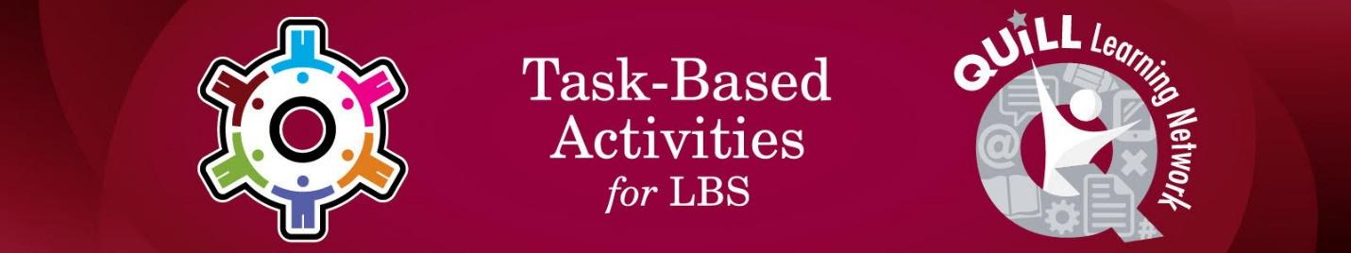

Task Title: Complete a PLAR Science Lesson about Space

# OALCF Cover Sheet – Practitioner Copy

**Learner Name:**

**Date Started:**

**Date Completed:**

|  |  |  |
| --- | --- | --- |
| **Goal Path:** | Employment | Apprenticeship |
| Secondary School | Post Secondary | Independence |

**Successful Completion:**  Yes No

**Task Description:**

The learner will complete a Science lesson on Space and the Solar System to prepare for PLAR.

**Main Competency/Task Group/Level Indicator:**

* Find and Use Information/Read continuous text/A1.2

**Materials Required:**

* Pen and Paper and/or computer or digital device

# Learner Information

Prior Learning Assessment and Recognition (PLAR) is a process that students can complete to gain credits towards their Ontario Secondary School Diploma (OSSD) based on their prior learning and experience. One of the components of PLAR is completing a series of assessments in History, Geography, Science and Math. Many students review PLAR preparation materials to prepare for the assessments. Scan Lesson 1 – Space and the Solar System.

|  |
| --- |
| LESSON 1 - SPACE AND THE SOLAR SYSTEM  When you go outside during the day, what do you see up in the sky? Planes, clouds, sun! And at night, why is it I see the moon, stars that I cannot see during the day? If I go out into the countryside, why is it that those objects in the sky seem so much brighter and seem to be so many more than in the city? These ideas that come to mind are dealing with that area of the universe called space. We use a telescope that enlarges objects that are out in space.  What is this area called space? Space is the universe that includes that area beyond and around the earth. The study of what is in space beyond Earth is called astronomy. The people that watch and study the skies are called astronomers.  The “heavenly bodies” That we see up in space are made up of groups of stars that take on various shapes or patterns. These are the star constellations. Sometimes we see objects that are moving across the universe. These might be satellites which are objects that revolve around planets or other objects which can be natural, i.e. moon, or man made (artificial), i.e. weather satellites or space stations. Some of these objects seen at night are sphere-shaped objects that follow a certain path around a star.  Our solar system is made up of the Sun and all the objects that travel around it. The planets are non-luminous, which means light reflects off them, while the Sun (star) is luminous which means it gives off its own light. In our solar system, there are 9 planets and one star (Sun). How can we tell the difference between a star and a planet. Stars give off huge amounts of light and heat. A planet is a sphere-shaped object that follows a certain path around a star. When one looks up in the sky at night, how can one distinguish between a planet and a star? One can only see five planets when viewing without binoculars or telescopes. These planets are closer to Earth than the stars are, so they appear larger than the stars. These planets that can be seen without assistance are Mercury, Venus, Mars, Jupiter, and Saturn. Those that require the use of a powerful telescope are Uranus, Neptune and Pluto.  The nine planets in order from the Sun are Mercury, Venus, Earth, Mars. These are called the Inner Planets because they are closest to the Sun and are known as the terrestrial planets since they are small rocky planets. Jupiter, Saturn, Uranus, Neptune and Pluto are called the Outer Planets because they are furthest away from the Sun and are known as the gas giants since they are large and gaseous.  A black and white of planets  Description automatically generated SUN |

# Work Sheet

**Task 1: List the names of the terrestrial planets.**

Answer:

**Task 2: List the names of the outer planets.**

Answer:

**Task 3: What is the name of the study of space beyond Earth?**

Answer:

**Task 4: What is the meaning of “non-luminous”?**

Answer:

# Answers

**Task 1: List the names of the terrestrial planets.**

Answer: Mercury, Venus, Earth, and Mars

**Task 2: List the names the outer planets.**

Answer: Jupiter, Saturn, Uranus, Neptune (and Pluto)

**Task 3: What is the name of the study of space beyond Earth?**

Answer: Astronomy

**Task 4: What is the meaning of non-luminous?**

Answer: Light reflects off the object/planet

# Performance Descriptors

| Levels | Performance Descriptors | Needs Work | Completes task with support from practitioner | Completes task independently |
| --- | --- | --- | --- | --- |
| A1.2 | Scans text to locate information |  |  |  |
| A1.2 | Reads more complete texts to locate a single piece of information |  |  |  |
| A1.2 | Makes low-level inferences |  |  |  |
| A1.2 | Obtains information from detailed reading |  |  |  |

This task: Was successfully completed Needs to be tried again

Learner Comments:

Instructor (print): Learner (print):