Task Title: Complete An Incident Report

OALCF Cover Sheet – Practitioner Copy

Learner Name:
Date Started (m/d/yyyy):
Date Completed (m/d/yyyy):
Successful Completion: Yes No

Goal Path: | Employment | Apprenticeship
Secondary School | Post Secondary | Independence
Task Description: Completing an incident report at work.
Competency: A: Find and Use Information B: Communicate Ideas and Information C: Understand and Use Numbers

Task Groups: A1: Read continuous text B2: Write continuous text
B3: Complete and create documents C2: Manage time

Level Indicators:
- A1.2: Read texts to locate and connect ideas and information
- B2.2: Write texts to explain and describe information and ideas
- B3.1a: Make straightforward entries to complete very simple documents
- C2.1: Measure time and make simple comparisons and calculations
Performance Descriptors: See chart on last page
Materials Required:
- Incident report form
- Pen
- Paper for rough draft
- Dictionary and thesaurus

Learner Information
Employees are sometimes asked to complete an incident report if they witness an accident or an event where fire, police or ambulance needed to be called.

Work Sheet
Task 1: Fill out the top portion of the “Insurance Report” using the following details:
You operate a drill press in a factory called Kolman. It is located in Barrie on Oak Street at number #41. Your employee number is 256. On January 3rd around 11:15 in the morning, there was a fire at the factory which began in the north corner of the large room that contains your drill press. No one was hurt in the fire, but the factory was closed for repairs for three weeks. It is now the first day of the next month, and you have to fill out a report for the insurance agency. The agency is trying to find out what caused the fire and wants to know what you saw.

Task 2: Complete the “Description of Incident or Accident” section using the following details (these details need to be sorted into a logical order):
Before you left your drill press you saw the following in no particular order:
- an employee throws a cigarette butt accidentally into the vat of wood stain
- the vat of wood stain catches on fire
- smoke quickly fills the room with haze
- a woman employee runs to the fire alarm and yells “Fire”
- a foreman waves his arms wildly at a maintenance man
- the maintenance man hits the sprinkler pipes with a long piece of wood
- water from the sprinkler pipes begins to fall
- employees run to the exits on the east side of the building
You can add other details that you think are important if they are not supplied. When writing the description of the incident, use your own words, and write it in a story form, using complete sentences.

Insurance Report

Date of Incident: _______________________ Employee # ___________

Name of Company ______________________________________________

Address:______________________________________________________
# Street Unit #

_____________________________________________________________
City Province Postal Code

Phone: ______-______-______ Location of incident ___________________
Area code

Description of Incident or Accident (Attach additional paper if necessary)

_____________________________________________________________

_____________________________________________________________

_____________________________________________________________

_____________________________________________________________

_____________________________________________________________

_____________________________________________________________

_____________________________________________________________

_____________________________________________________________

_____________________________________________________________

_____________________________________________________________

Reported by: Signature:

Position: Date:

ANSWER KEY

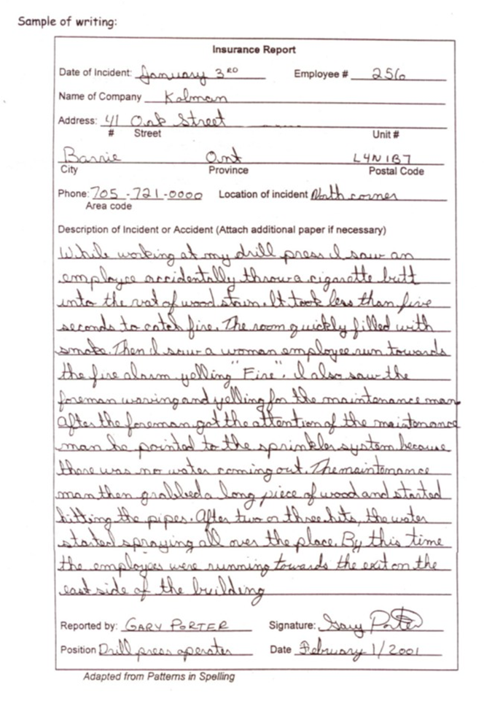
Levels | Performance Descriptors | Needs Work | Completes task with support from practitioner | Completes task independ- ently
A1.2 | - scans text to locate information
A1.2 | - locates multiple pieces of information in simple texts
A1.2 | - makes low-level inferences
A1.2 | - makes connections between sentences and between paragraphs in a single text
A1.2 | - reads more complex texts to locate a single piece of information
B2.2 | - writes texts to explain and describe
B2.2 | - conveys intended meaning on familiar topics for a limited range of purposes and audiences
B2.2 | - begins to sequence writing with some attention to organizing principles (e.g. time, importance)
B2.2 | - connects ideas using paragraph structure
B2.2 | - uses limited range of vocabulary and punctuation appropriate to the task
B2.2 | - begins to select words and tone appropriate to the task
B2.2 | - begins to organize writing to communicate effectively
B3.1a | - makes a direct match between what is requested and what is entered
B3.1a | - makes entries using familiar vocabulary
C2.1 | - recognizes values in number and word format
C2.1 | - understands and uses common date formats
C2.1 | - represents dates and times using standard conventions

This task: Was successfully completed Needs to be tried again

Learner Comments:

Instructor (print): Learner Signature:

