Task Title: Complete a Money Order Form

OALCF Cover Sheet – Practitioner Copy

Learner Name:
Date Started (m/d/yyyy):
Date Completed (m/d/yyyy):
Successful Completion: Yes No

Goal Path: | Employment | Apprenticeship
Secondary School | Post Secondary | Independence
Task Description: The learner needs to read and complete a money order.
Competency: A: Find and Use Information
B: Communicate Ideas and Information
C: Understand and Use Numbers
Task Groups: A1: Read Continuous Text
A2: Interpret Documents
B2: Write Continuous Text
C1: Manage Money
Level Indicators:
- A1.1: Read brief texts to locate specific details
- A1.2: Read texts to locate and connect ideas and information
- A2.1: Interpret very simple documents to locate specific details
- A2.2: Interpret simple documents to locate and connect Information
- B2.1: Write brief texts to convey simple ideas and factual information
- C1.1: Compare costs and make simple calculations
- C1.2: Make low-level inferences to calculate costs and expense that
may include rates such as taxes and discounts
Performance Descriptors: See chart on last page
Materials Required:
- Paper and Pen and/or digital device
- Money Order Form (attached)
- Question Sheet

Learner Information
The learner needs to read and complete a money order.
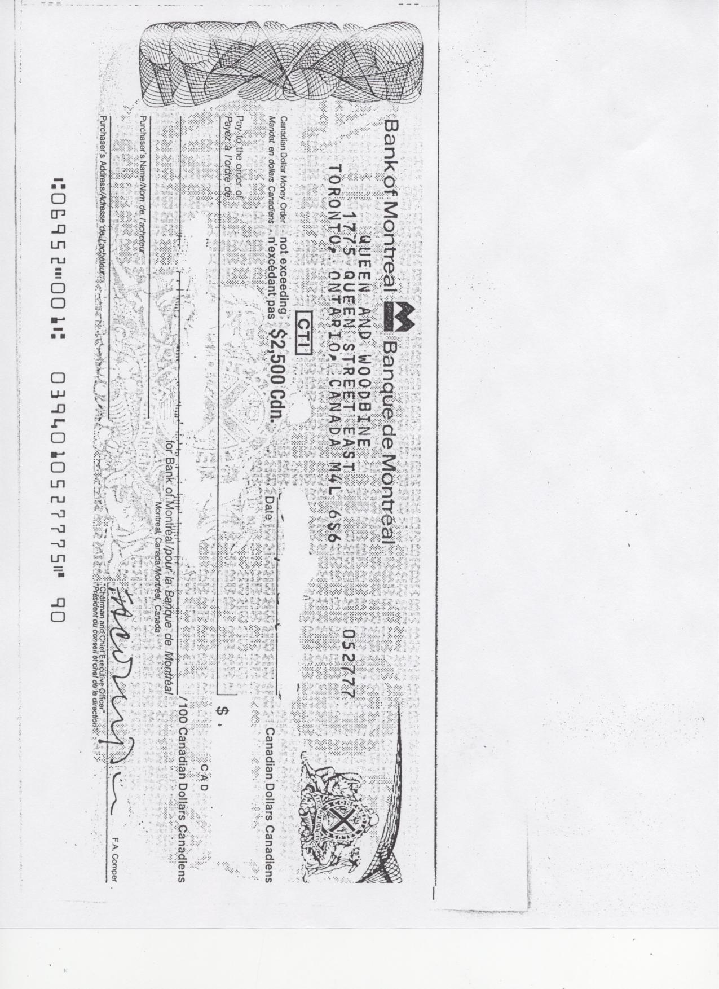
Learner Instructions:
There are times when purchases cannot be paid for by cheque or credit card. An option is to get a money order from places like a bank or a post office. A money order is guaranteed by the bank, like a certified cheque.
Scan the blank money order.

Work Sheet
Task 1: What is the name of the bank listed on the money order?
Answer:

Task 2: Where is the bank located in Toronto?
Answer:

Task 3: What is the maximum amount of money you can send using
the money order?
Answer:

Task 4: Choose the correct answer. This money order is for:
Answer:

American Funds |  | Canadian Funds

Task 5: You have ordered birthday cards and wrapping paper from a mail order company catalogue. The company is Regent Gifts.
Birthday Cards | $12.99 | This company does not accept cash or personal cheques. They only accept a credit card or money order as payment. You do not have a credit card, so you must pay using a money order. The bank charges $7.50 to issue a money order.
Wrapping Paper | $15.95
Tax is included in the prices.
What is the total amount you must pay the bank? (Use the space below to show your calculations.)
Answer:

Task 6: Complete the money order by filling in all the blanks. Write in the total amount to be paid as well. (Note: When you actually purchase a money order, the bank or post office fills in the amount to be paid.)
Answer:

ANSWER KEY

Task Title: Complete a Money Order Form

Task 1: What is the name of the bank listed on the money order?
Bank of Montreal
Task 2: Where is the bank located in Toronto?
1775 Queen Street East (Queen & Woodbine)
Task 3: What is the maximum amount of money you can send using the money order?
$ 2500.00 Canadian
Task 4: Choose the correct answer. This money order is for:
Canadian Funds
Task 5: You have ordered birthday cards and wrapping paper from a mail order company catalogue. The company is Regent Gifts.
Birthday Cards: $12.99
Wrapping Paper: $15.95

Tax is included in the above prices.
This company does not accept cash or personal cheques. They only accept a credit card or money order as payment. You do not have a credit card, so you must pay using a money order. The bank charges $7.50 to issue a money order. What is the total amount you must pay the bank? (Use the space below to show your calculations)
12.99 + 15.95 + 7.50 = $ 36.44

Task 6: Complete the money order by filling in all the blanks. Write in the total amount to be paid as well. (Note: When you actually purchase a money order, the bank or post office fills in the amount to be paid.) - $28.94
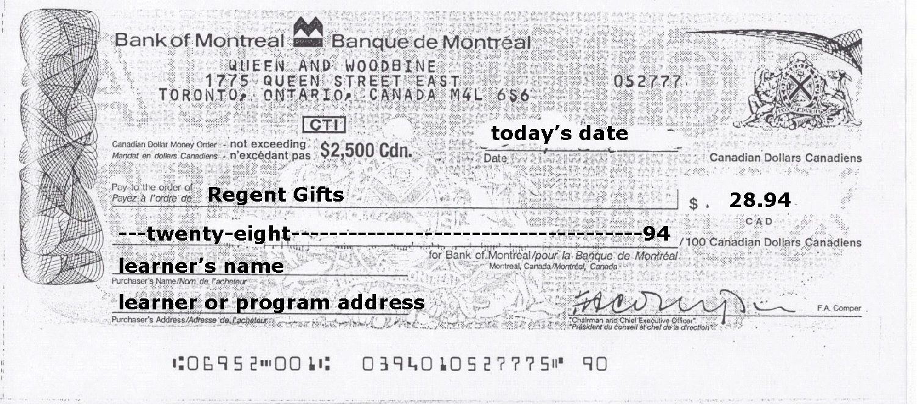

Performance Descriptors
Levels | Performance Descriptors | Needs Work | Completes task with support from practitioner | Completes task independently
A1.1: | Reads short texts to locate a single piece of information
A1.2: | Scans text
A1.2: | Makes low-level inferences
A2.1: | Scans to locate specific details
A2.1: | Interprets brief text and common symbols
A2.2: | Makes low-level inferences
B2.1: | Conveys simple ideas and factual information
C1.1: | Adds, subtracts, multiplies and divides whole numbers and decimals
C1.1: | Interprets and represents costs using monetary symbols and decimals
C1.2: | Represents costs and rates using monetary symbols, decimals and percentages.
C1.2: | Uses strategies to check accuracy (e.g. estimating, using a calculator, repeating a calculation, using the reverse operation)

This task:

Was successfully completed Needs to be tried again

Learner Comments:

Instructor (print):

