Task Title: Completing a PLAR application

OALCF Cover Sheet – Practitioner Copy

Learner Name:
Date Started:
Date Completed:
Goal Path: | Employment | Apprenticeship
Secondary School | Post Secondary | Independence
Successful Completion: Yes No

Task Description:
The learner will read a PLAR application to understand how to challenge credit courses.
Main Competency/Task Group/Level Indicator
- Find and Use Information/Read continuous text/A1.2
- Find and Use Information/Interpret documents/ A2.2
Materials Required:
- Pen and Paper and/or digital device

Learner Information
Prior Learning Assessment and Recognition (PLAR) is a process that adult students can complete to gain credits towards their Ontario Secondary School Diploma (OSSD) based on their prior learning and life experience. Applicants will often be required to complete an application to challenge credit courses and verify that they qualify for PLAR. Scan the PLAR Application Form from the Bluewater District School Board to understand how to challenge a course.

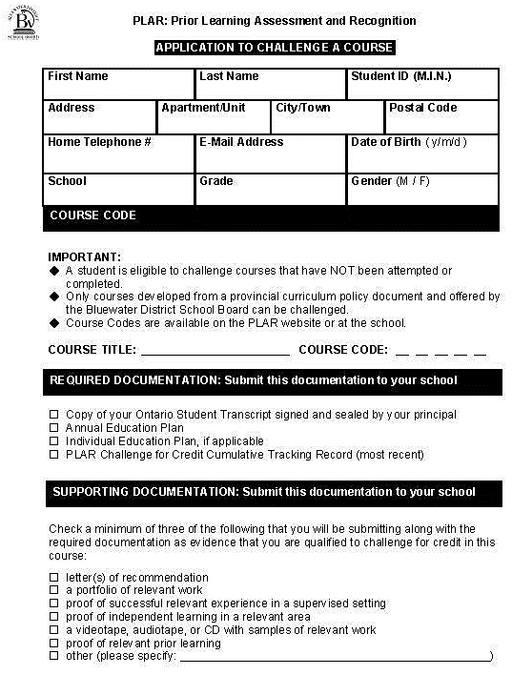
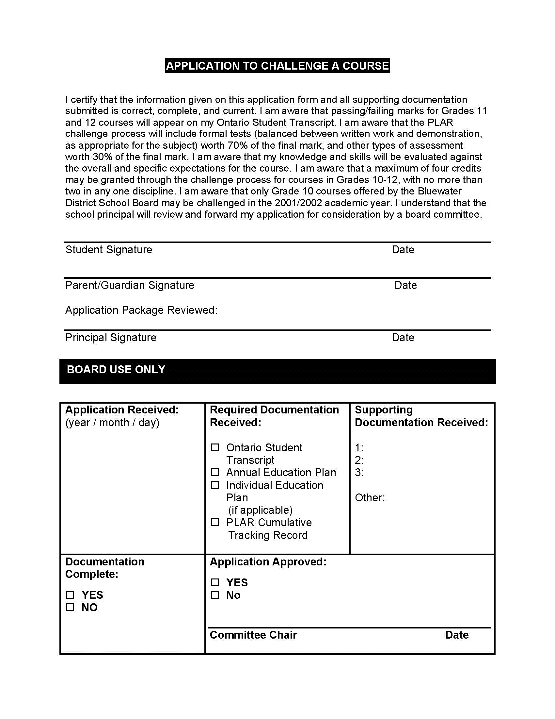

Work Sheet
Task 1: Where can a list of PLAR courses be found?
Answer:

Task 2: List two (2) documents that are required for the application.
Answer:

Task 3: What component of the PLAR assessment has the highest mark value?
Answer:

Task 4: How many credits can be given through the grade 10-12 PLAR challenge process?
Answer:

Task 5: Who is responsible for the final approval of the PLAR application?
Answer:

Answers
Task 1: Where can a list of PLAR courses be found?
Answer: On the PLAR website or at the school

Task 2: List two (2) documents that are required for the application.
Answer: Any 2 of:
Student transcript
Annual education plan
Individual Education Plan (if applicable)
Most recent PLAR Challenge for Credit tracking record

Task 3: What component of the PLAR assessment has the highest mark value?
Answer: Formal tests (could be written work and demonstration)

Task 4: How many credits can be given through the grade 10-12 PLAR challenge process?
Answer: 4

Task 5: Who is responsible for the final approval of the PLAR application?
Answer: the board committee or the Committee Chair
Performance Descriptors
Levels | Performance Descriptors | Needs Work | Completes task with support from practitioner | Completes task independently
A1.2 | Makes connections between sentences and between paragraphs in a single text
A1.2 | Scans text to locate information
A1.2 | Locates multiple pieces of information in simple texts.
A1.2 | Reads more complex texts to locate a single piece of information
A1.2 | Makes low-level inferences
A2.2 | Performs limited searches using one or two search criteria
A2.2 | Extracts information from tables and forms
A2.2 | Uses layout to locate information
A2.2 | Makes connections between parts of documents
A2.2 | Makes low-level inferences

This task: Was successfully completed Needs to be tried again

Learner Comments:

Instructor (print): Learner (print):

