 Task-based Activity Cover Sheet
Task Title: Ontario Protected Deposits – Deposit Insurance Coverage
Learner Name:

Date Started: Date Completed:

Successful Completion: Yes □ No □
Goal Path: Employment □ Apprenticeship □ Secondary School □ Post-Secondary □ Independence X
Task Description:
Learners will understand about deposit insurance in Ontario.
Competency:  A: Find and Use Information | Task Group(s):  A2: Interpret documents
Level Indicators:
A2.1: Interpret very simple documents to locate specific details

Performance Descriptors: see chart on last page
Materials Required:
- Pencil or pen

Task Title: Ontario Protected Deposits – Deposit Insurance Coverage
The Deposit Insurance Corporation of Ontario (DICO) is an Ontario Provincial Agency established under the Credit Unions Act. DICO’s role is to protect depositors of Ontario credit unions from loss of their deposits. Look at “Deposit Insurance Coverage for Ontario Credit Unions”.
Learner Information and Tasks:
Task 1: Why does DICO keep a deposit insurance reserve fund?

Task 2: How often does the board of directors of DICO review the fund?

Task 3: What are all credit unions in Ontario required to display?

Task 4: How does a customer of a credit union find out about their payment if their Credit Union goes out of business?

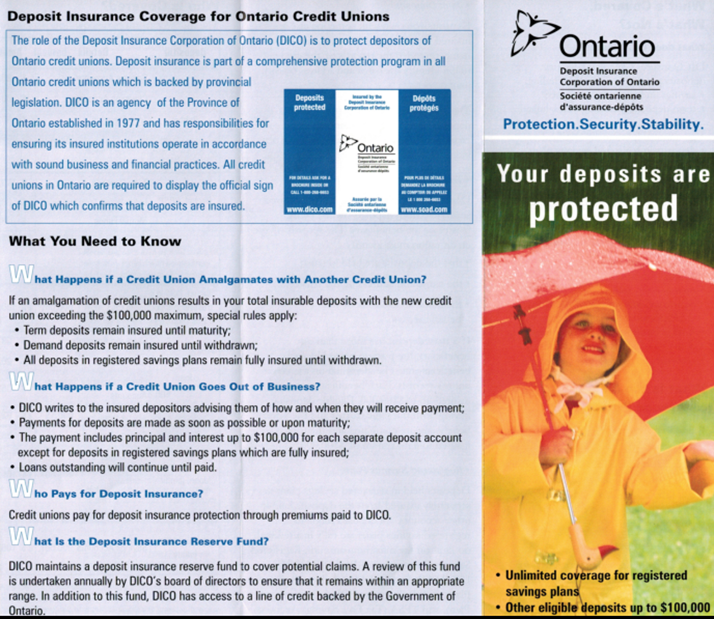
Task Title: Ontario Protected Deposits – Deposit Insurance Coverage
Answer Key
Task 1: Why does DICO keep a deposit insurance reserve fund?
A: to cover potential claims
Task 2: How often does the board of directors of DICO review the fund?
A: annually
Task 3: What are all credit unions in Ontario required to display?
A: the official sign of DICO, which confirms that deposits are insured
Task 4: How does a customer of a credit union find out about their payment if their Credit Union goes out of business?
A: DICO writes to the insured depositors advising them of how and when they will receive payment
Task Title: Ontario Protected Deposits – Deposit Insurance Coverage
Performance Descriptors |  | Needs Work | Completes task with support from practitioner | Completes task independently
A2.1 | - scans to locate specific details

This task: was successfully completed □ needs to be tried again □

Learner Comments

____________________________ _________________________

Instructor (print) Learner Signature

