

Task Title: Forestry Safety Part 1

# OALCF Cover Sheet – Practitioner Copy

**Learner Name:**

**Date Started:**

**Date Completed:**

|  |  |  |
| --- | --- | --- |
| **Goal Path:** | Employment | Apprenticeship |
| Secondary School | Post Secondary | Independence |

**Successful Completion:**  Yes No

**Task Description:**

Read a health and safety document to understand Forestry safety in logging operations.

**Main Competency/Task Group/Level Indicator:**

* Find and Use Information/Read continuous text/A1.2

**Materials Required:**

* Pen or pencil and/or digital device

# Learner Information

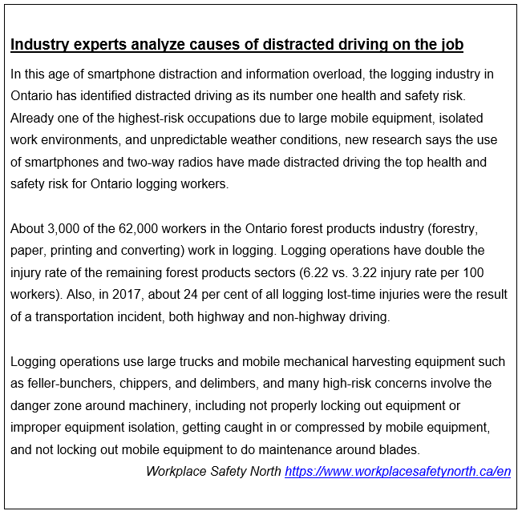The logging industry is made up of various occupations which include driving different pieces of equipment on and off the jobsite. Research was conducted to determine the top dangers logging workers face on the job. Scan the **Logging Operations Health and Safety Introduction.**

# Work Sheet

**Task 1: How many workers in Ontario work in logging?**

Answer:

**Task 2: List the three reasons logging is one of the highest-risk occupations.**

Answer:

**Task 3: List two examples of the “danger zone” around machinery.**

Answer:

**Task 4: What percent of all logging lost-time injuries were the result of a transportation incident?**

Answer:

**Task 5: What is the injury rate per 100 workers of logging operations versus the remaining forest products sectors?**

Answer:

# Answers

**Task 1: How many workers in Ontario work in logging?**

Answer: 3000

**Task 2: List the three reasons logging is one of the highest-risk occupations.**

Answer: large mobile equipment, isolated work environments, and unpredictable weather conditions.

**Task 3: List two examples of the “danger zone” around machinery.**

Answer: Any two of the following:

* not properly locking out equipment or improper equipment isolation
* getting caught in or compressed by mobile equipment
* not locking out mobile equipment to do maintenance around blades

**Task 4: What percent of all logging lost-time injuries were the result of a transportation incident?**

Answer: 24%

**Task 5: What is the injury rate per 100 workers of logging operations versus the remaining forest products sectors?**

Answer: 6.22

# Performance Descriptors

| Levels | Performance Descriptors | Needs Work | Completes task with support from practitioner | Completes task independently |
| --- | --- | --- | --- | --- |
| A1.2 | Scans text to locate information |  |  |  |
| A1.2 | Locates multiple pieces of information in simple texts |  |  |  |
| A1.2 | Reads more complex texts to locate a single piece of information |  |  |  |

This task: Was successfully completed Needs to be tried again

Learner Comments:

Instructor (print): Learner (print):