OALCF Task Cover Sheet
Task Title: GED application
Learner Name:

Date Started: Date Completed:

Successful Completion: Yes___ No___
Goal Path: Employment ✓ Apprenticeship___ Secondary School___ Post Secondary ✔ Independence___
Task Description:
Learners will be asked to look at the GED application form and answer questions about the content.
Competency:  A: Find and Use Information  B: Communicate Ideas and Information | Task Group(s):  A1: Read Continuous text  A2. Interpret Documents  B2: Write Continuous Text
Level Indicators:
A1.1: Read brief texts to locate specific details
A1.2: Read texts to locate and connect ideas and information.
A2.2: Interpret simple documents to locate and connect information.
B2.1: Write brief texts to convey simple ideas and factual information
Performance Descriptors: see chart on last page
Materials Required:
- GED application form
- Instructions
- Paper and pencil and eraser/pen

Task Title: GED application
Adults who do not have their Grade 12 may sometimes opt for getting their GED instead. Look at the GED Test Application.
Learner Information and Tasks:
All answers must be in complete sentences
Task 1: Why would you complete this form?

Task 2: In what province must you be a resident to write this test?

Task 3: If you are writing a certified cheque or money order for your fees, who do you make the cheque payable to?

Task 4: How many times can you write the test in a calendar year?

Task 5: Identify 2 acceptable proof of age documents that can be submitted with the application.

Task 6: How much is the re-scheduling fee that you must pay if you cannot make your appointment?
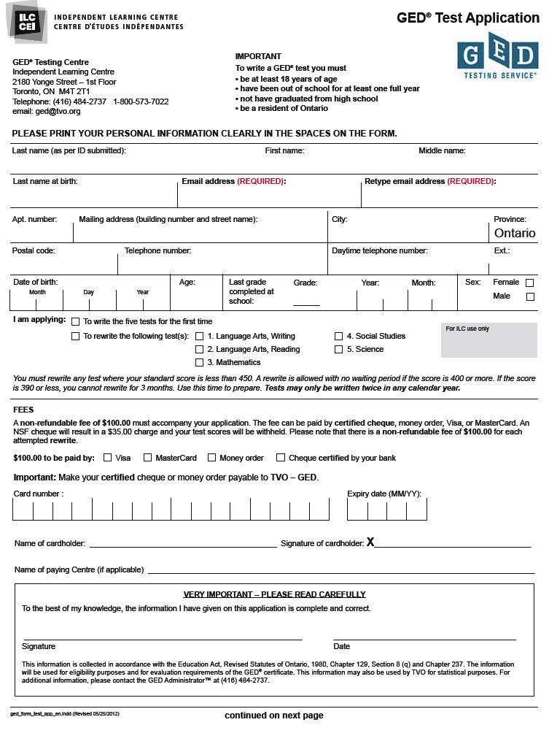
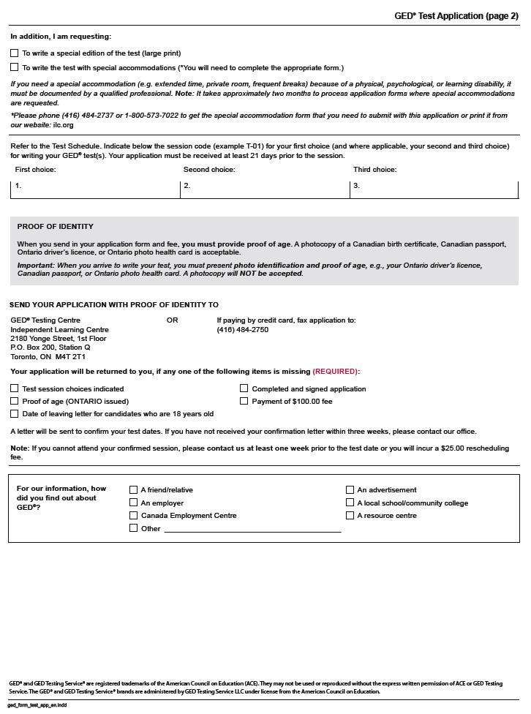
Task Title: GED application
Answer Key
Task 1: Why would you complete this form?
You would complete this form to apply to write the GED test.

Task 2: In what province must you be a resident to write this test?
You must be a resident of Ontario to write this test.

Task 3: If you are writing a certified cheque or money order for your fees, who do you make the cheque payable to?
You would make the cheque or money order payable to TVO-GED.

Task 4: How many times can you write the test in a calendar year?
You can write the test twice in a calendar year.

Task 5: Identify 2 acceptable proof of age documents that can be submitted.
Two acceptable proof of age documents that can be submitted are a Canadian birth certificate and a Canadian passport. (Ontario driver’s licence, Ontario health card are also acceptable.)

Task 6: How much is the re-scheduling fee that you must pay if you cannot make your appointment?
The re-scheduling fee is $25.00.
Task Title: GED application
Performance Descriptors |  | Needs Work | Completes task with support from practition-er | Completes task independ- ently
A1.1 | - reads short texts to locate a single piece of information
 | - decodes words and makes meaning of sentences in a single text
 | - follows the sequence of events in straightforward chronological texts
 | - follow simple, straightforward instructional texts
A1.2 | - scans text to locate information
 | - locates multiple pieces of information in simple texts
 | - makes low-level inferences
 | - reads more complex texts to locate a single piece of information
A2.2 | - performs limited searches using one or two search criteria
 | - extracts information from tables and forms
 | - uses layout to locate information
 | - makes low-level inferences
B2.1 | - writes simple texts to request, remind or inform
 | - conveys simple ideas and factual information
 | - uses sentence structure, upper and lower case and basic punctuation

This task: was successfully completed___ needs to be tried again___

Learner Comments

____________________________ _________________________

Instructor (print) Learner Signature

