OALCF Task Cover Sheet
Task Title: Grocery Store Job Application
Learner Name:

Date Started: Date Completed:

Successful Completion: Yes___ No___
Goal Path: Employment Apprenticeship___ Secondary School Post Secondary Independence___
Task Description:
The learner will enter basic information into a job application form
Competency:  A: Find and Use Information  B: Communicate Ideas and Information | Task Group(s):  A2: Interpret documents  B3: Complete and create documents
Level Indicators:
A2.1: Interpret very simple documents to locate specific details
B3.1a: Make straightforward entries to complete very simple documents

Performance Descriptors: see chart on last page
Materials Required:
- Printed copy of Zehrs Job Application
- Highlighter
- Pencil or pen

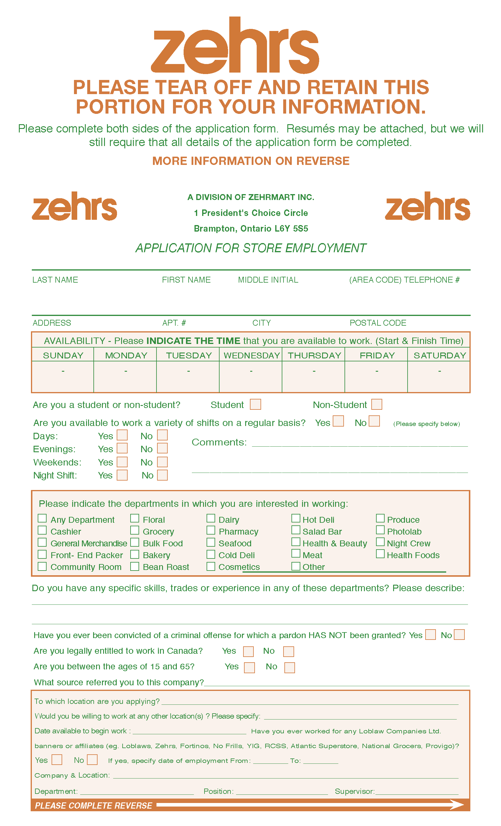
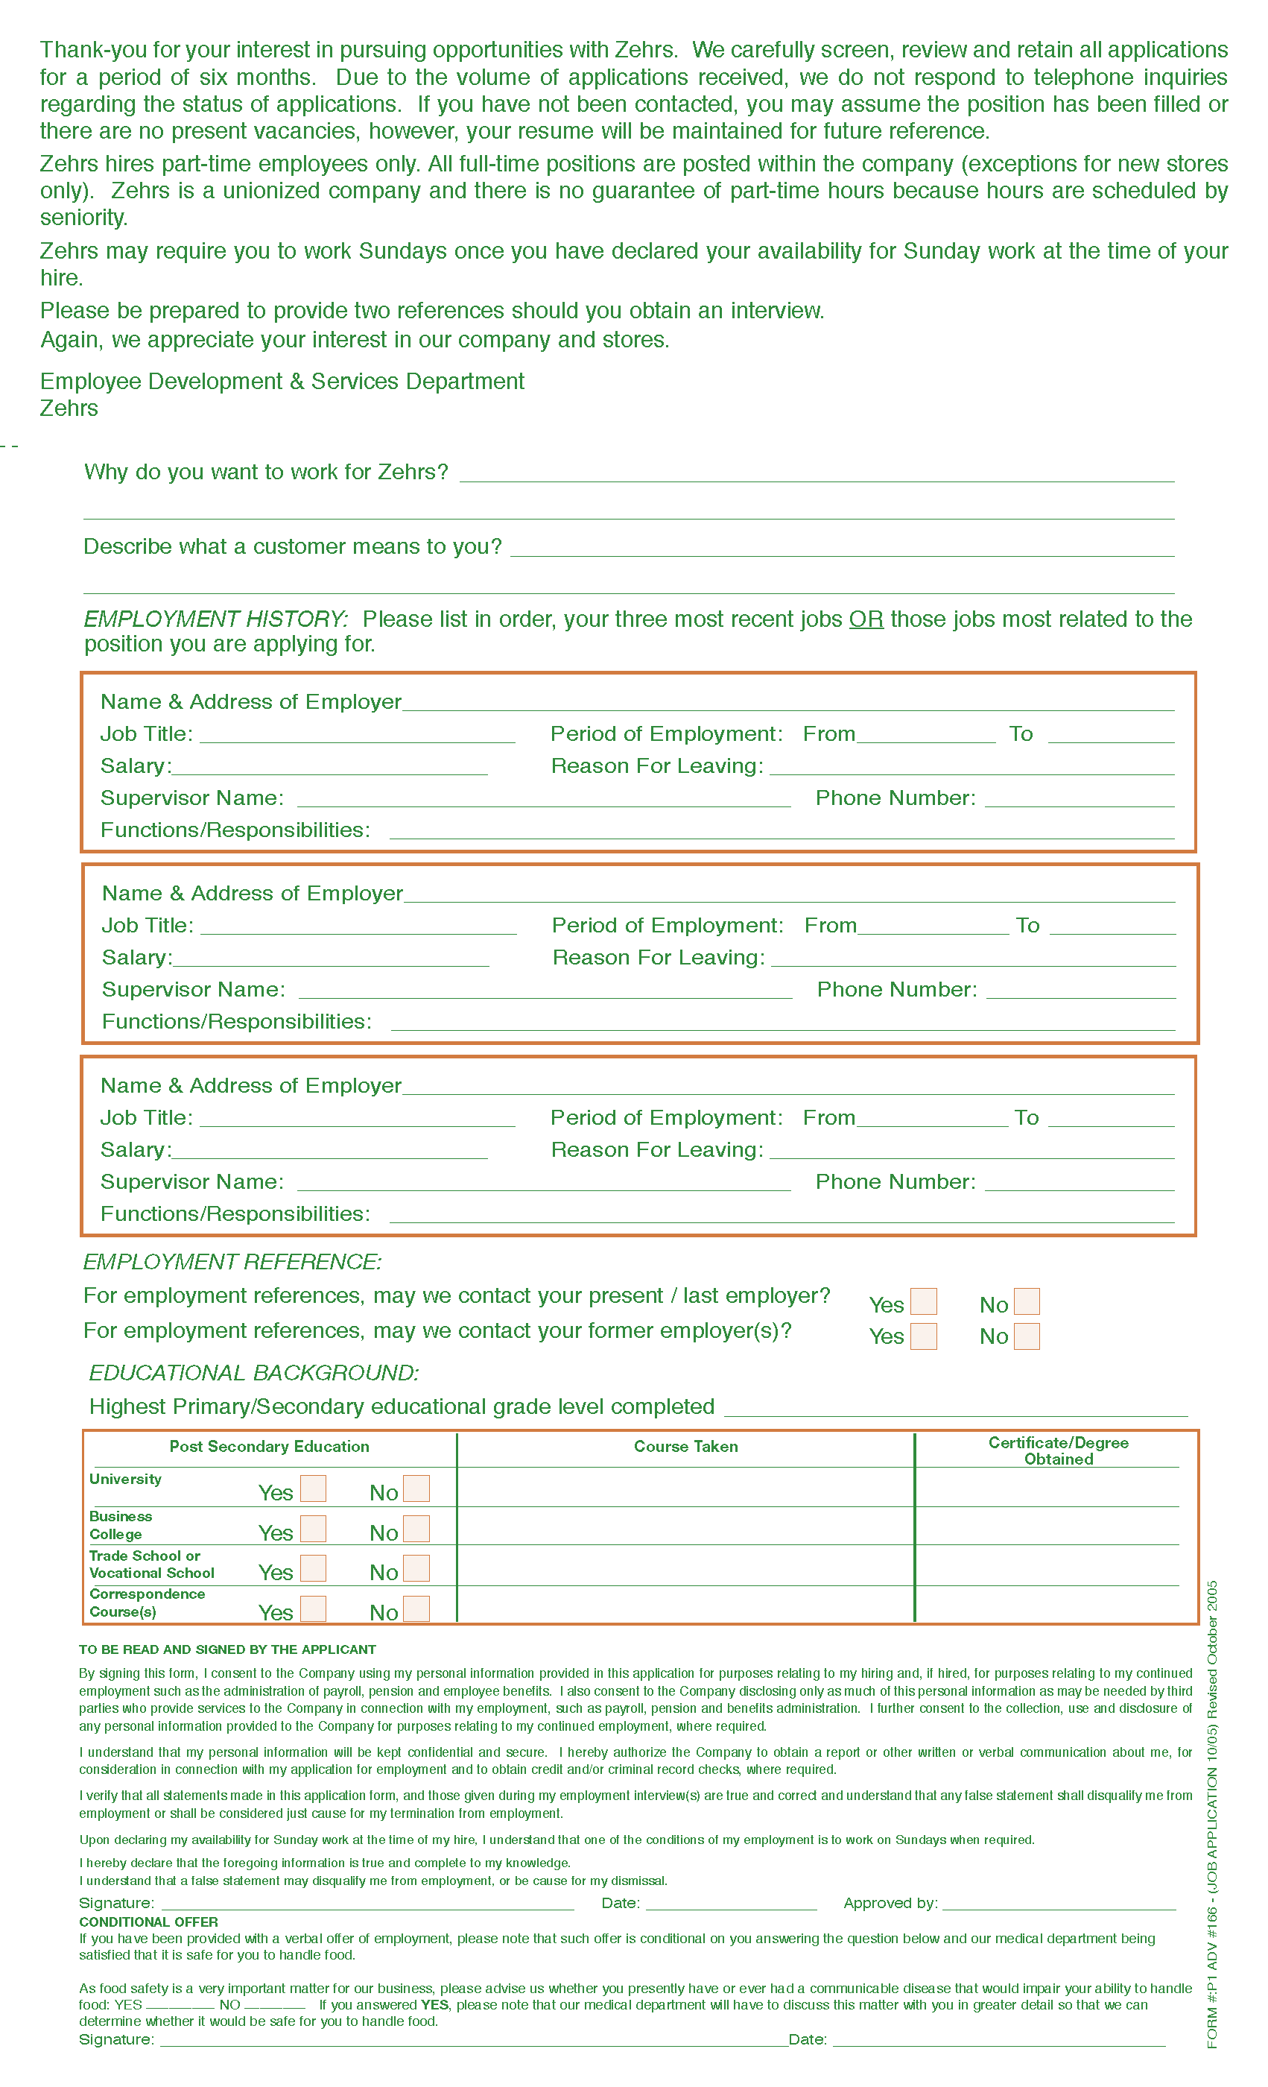
Task Title: Grocery Store Job Application
Applying for a grocery store job usually requires filling out a job application. To do this, the person applying for the job must understand the layout of the form, be able to locate key sections (fields) and enter information into those fields correctly. Look at the “Zehrs application for job employment.”
Learner Information and Tasks:
Task 1: Highlight, circle or underline the name of the store.

Task 2: Circle the section where an applicant would write their name, address and telephone number.

Task 3: Circle the section where an applicant would write the days and times they could work.

Task 4: Circle the section where an applicant would indicate which departments they would like to work in.

Task 5: Circle the section where an applicant would list their Employment History.

Task 6: The applicant is available to work on Saturday and Sundays anytime from 7 a.m. to 11 p.m. Complete the availability section of the form.

Task 7: The applicant wants to work in the floral, hot deli or salad bar departments. Complete the “departments in which you are interested in working” section of the form.

Task Title: Grocery Store Job Application
Performance Descriptors |  | Needs Work | Completes task with support from practitioner | Completes task independently
A2.1 | - scans to locate specific details
 | - requires support to identify sources and to evaluate and integrate information
 | - interprets brief text and common symbols
B3.1a | - makes a direct match between what is requested and what is entered
 | - makes entries using familiar vocabulary

This task: was successfully completed___ needs to be tried again___

Learner Comments

____________________________ _________________________

Instructor (print) Learner Signature

