

Task Title: Interpret and Create Drawings

# OALCF Cover Sheet – Practitioner Copy

**Learner Name: __________________________________________**

**Date Started: ___________________________________________**

**Date Completed: _________________________________________**

|  |  |  |
| --- | --- | --- |
| **Goal Path:** | Employment | Apprenticeship |
| Secondary School | Post Secondary | Independence |

**Successful Completion:**  Yes No

**Task Description:** The learner will use a Legend to interpret electrical features on a blueprint, and to determine materials needed for a job.

**Main Competency/Task Group/Level Indicator:**

* Find and Use Information/Interpret documents/A2.3
* Communicate Ideas and Information/Complete and create documents/B3.2a
* Understand and Use Numbers/Manage data/C4.1

**Materials Required:**

* Pen/pencil and paper

# Learner Information

Electricians interpret, modify and create schematic drawings using standardized icons and legends. They use the drawing to plan tasks and determine materials needed for a job.

Scan the “Blueprint and Electrical Legend”, “Electrical Supplies Order Form” and “Schematic Drawing (Bedroom 1)”.

**Blueprint and Electrical Legend**

|  |  |
| --- | --- |
| **Electrical Supplies Order Form** | |
| Item | No. Requested |
| Pull cord light switch |  |
| Ceiling mounted light fixture |  |
| Pot light |  |
| Bar light fixture |  |
| Switch |  |
| Three-way switch |  |
| Ventilation fan switch |  |
| Duplex receptacle |  |
| Split receptacle |  |
| Ground fault circuit interrupter (GFCI) |  |
| Waterproof receptacle |  |
| 220v receptacle |  |
| Phone jack |  |
| Cable outlet |  |
| Ventilation fan |  |
| Interconnected smoke alarm |  |
| Carbon Monoxide detector |  |
| Thermostat/circulation fan |  |
| Other |  |

**Schematic Drawing (Bedroom 1)**

# Work Sheet

**Task 1: Interpret the Blueprint and Electrical Legend to complete the following tasks.**

1. **How many switches are required for bedroom #2?**

Answer:

_____________________________________________________________

1. **What is the electrical apparatus over the sink?**

Answer:

_____________________________________________________________

**Task 2: The electrician orders supplies. Use the Blueprint and Electrical Legend to decide what electrical supplies are needed for the Bathroom and 2 Bedrooms.**

**Complete the Electrical Supplies Order Form.**

Answer: No written response required here.

Task Completed: Yes

**______________________________________________________**

**Task 3: Refer to the icons of the Electrical Legend to draw the electrical apparatuses, as per the directions below, on the Schematic Drawing (Bedroom 1).**

1. **Switch for overhead light on west wall near door**
2. **Overhead light centered in room**
3. **Pull cord light switch in closet centered between sliding doors**
4. **2 duplex receptacles on each of the south and east walls**
5. **1 duplex receptacle on the north wall**

Answer: No written response required here.

Task Completed: Yes

_____________________________________________________________

Answers

**Task 1: Interpret the Blueprint and Electrical Legend to complete the following tasks.**

1. **How many switches are required for bedroom #2?**

Answer: two switches

1. **What is the electrical apparatus over the sink?**

Answer: Bar Light Fixture

**Task 2: The electrician orders supplies. Use the Blueprint and Electrical Legend to decide what electrical supplies are needed for the Bathroom and 2 Bedrooms. Complete the Electrical Supplies Order Form.**

Answer:

|  |  |
| --- | --- |
| **Electrical Supplies Order Form** | |
| **Item** | **No. Requested** |
| Pull cord light switch |  |
| Ceiling mounted light fixture |  |
| Pot light | 2 |
| Bar light fixture | 1 |
| Switch | 6 |
| Three-way switch |  |
| Ventilation fan switch |  |
| Duplex receptacle | 11 |
| Split receptacle |  |
| Ground fault circuit interrupter (GFCI) | 1 |
| Waterproof receptacle |  |
| 220v receptacle |  |
| Phone jack |  |
| Cable outlet |  |
| Ventilation fan | 1 |
| Interconnected smoke alarm | 2 |
| Carbon Monoxide detector |  |
| Thermostat/circulation fan |  |
| Other |  |

**Task 3: Refer to the icons of the Electrical Legend to draw the electrical apparatuses, as per the directions below, on the Schematic Drawing (Bedroom 1).**

**Switch for overhead light on west wall near door**

1. **Overhead light centered in room**
2. **Pull cord light switch in closet centered between sliding doors**
3. **2 duplex receptacles on each of the south and east walls**
4. **1 duplex receptacle on the north wall**

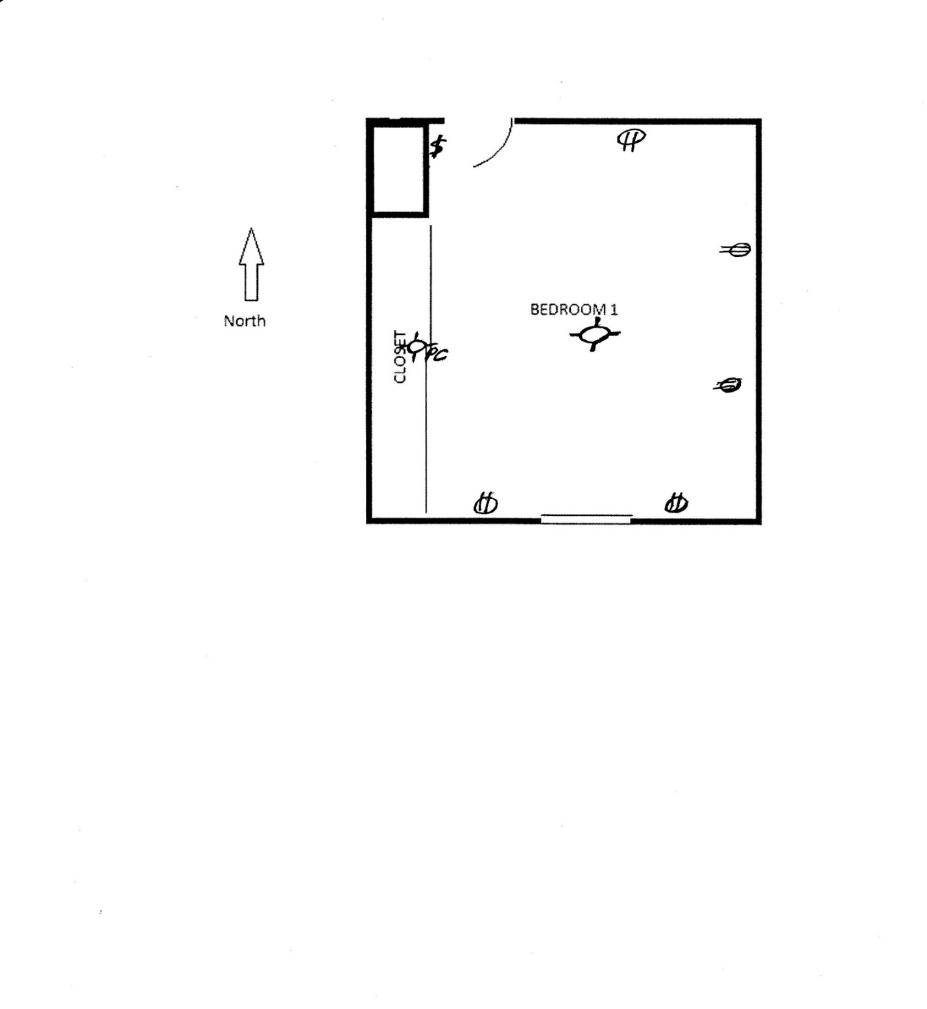

# Performance Descriptors

| Levels | Performance Descriptors | Needs Work | Completes task with support from practitioner | Completes task independently |
| --- | --- | --- | --- | --- |
| A2.3 | Performs complex searches using multiple search criteria |  |  |  |
|  | Integrates several pieces of information from documents |  |  |  |
|  | Compares or contrasts information between two or more documents |  |  |  |
|  | Uses layout to locate information |  |  |  |
| B3.2a | Uses layout to determine where to make entries |  |  |  |
|  | Follows instructions on documents |  |  |  |
| C4.1 | Identifies and compares quantities of items |  |  |  |

This task: Was successfully completed Needs to be tried again

Learner Comments:

Instructor (print): Learner (print):

**__________________ _________________**