Practitioner submitted task: Prepared for the Project, Teaching to Fish (Build Tasks) Integrating OALCF Task Development within Ontario’s Literacy Programs (2014)

Task Title: Modified Work Policy Statement

OALCF Cover Sheet – Practitioner Copy

Learner Name:
Date Started (m/d/yyyy):
Date Completed (m/d/yyyy):
Successful Completion: Yes No

Goal Path: | Employment | Apprenticeship
Secondary School | Post Secondary | Independence
Task Description:
Understanding a modified work program policy for employees who are returning to work after an injury/illness.
Competency: A: Find and Use Information
B: Communicate Ideas and Information
Task Groups: A1: Read continuous text
B3: Complete and create documents
Level Indicators:
A1.1: Read brief texts to locate specific details
A1.2: Read texts to locate and connect ideas and information
B3.2a: Use layout to determine where to make entries in simple documents
Performance Descriptors: See chart on last page
Materials Required:
- Modified Work Policy Statement
- Task Set, Pen/pencil or digital device

Learner Information
Employees who are returning to work after an illness or injury may require a modified work program. Read the “Modified Work Policy Statement.”
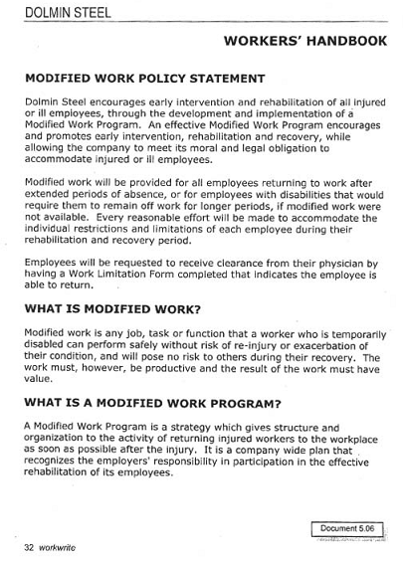
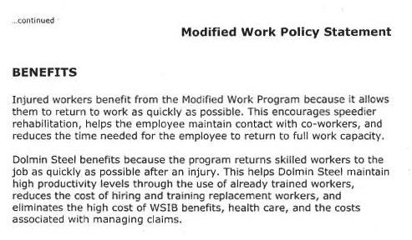

Work Sheet

Task 1: Following an injury or illness, who provides clearance before
an employee returns to work?
Answer:

Task 2: What form must be completed to indicate the employee is
able to return to work?
Answer:

Task 3: List two benefits for the employer and two benefits for the employee for using a modified work program.
Answer:
Modified Work Program
Benefits to the employer | Benefits to the employee

Answer Key

Task 1: Following an injury or illness, who provides clearance before an employee returns to work?
Clearance must be given by the employee’s physician.
Task 2: What form must be completed to indicate the employee is able to return to work?
The Work Limitation Form.
Task 3: List two benefits to the employer and two benefits to the employee for using a modified work program.

Any two of the following or similar answers will suffice.

Benefits to the employer | Benefits to the employee
-helps them maintain high productivity levels because workers are already skilled | -allows them to get back to work quickly
-less costly than hiring and training new workers | -encourages rehabilitation
-reduces the cost associated with WSIB benefits | -keep in contact with other employees
-reduces the cost associated with health care
-reduces the cost associated with managing claims

Performance Descriptors 1
Levels | Performance Descriptors | Needs Work | Completes task with support from practitioner | Completes task independently
A1.1 | Reads short texts to locate a single piece of information
 | Follows simple, straightforward instructional texts
A1.2 | Scans text to locate information
 | Locates multiple pieces of information in simple texts
 | Makes low-level inferences
B3.2a | Uses layout to determine where to make entries
 | Begins to make some inferences to decide what information is needed, where and how to enter the information

Performance Descriptors 2
This task: Was successfully completed Needs to be tried again

Learner Comments:

Instructor (print):

