Task Title: Ontario Protected Deposits – What’s Covered

OALCF Cover Sheet – Practitioner Copy

Learner Name:
Date Started (m/d/yyyy):
Date Completed (m/d/yyyy):
Successful Completion: Yes No
Goal Path: | Employment | Apprenticeship
Secondary School | Post Secondary | Independence √
Task Description:
The learner will complete tasks related to the Deposit Insurance Corporation of Ontario (DICO).
Competency: A Find and Use Information
Task Groups: A2: Interpret Documents

Level Indicators:
- A2.1: Interpret very simple documents to locate specific details
- A2.2: Interpret simple documents to locate and connect information
Performance Descriptors: See chart on the last page
Materials Required:
- Pencil or pen

Learner Information
The Deposit Insurance Corporation of Ontario (DICO) is an Ontario Provincial Agency established under the Credit Unions Act. DICO’s role is to protect depositors of Ontario credit unions from the loss of their deposits.
Look at the “What’s Covered” brochure.
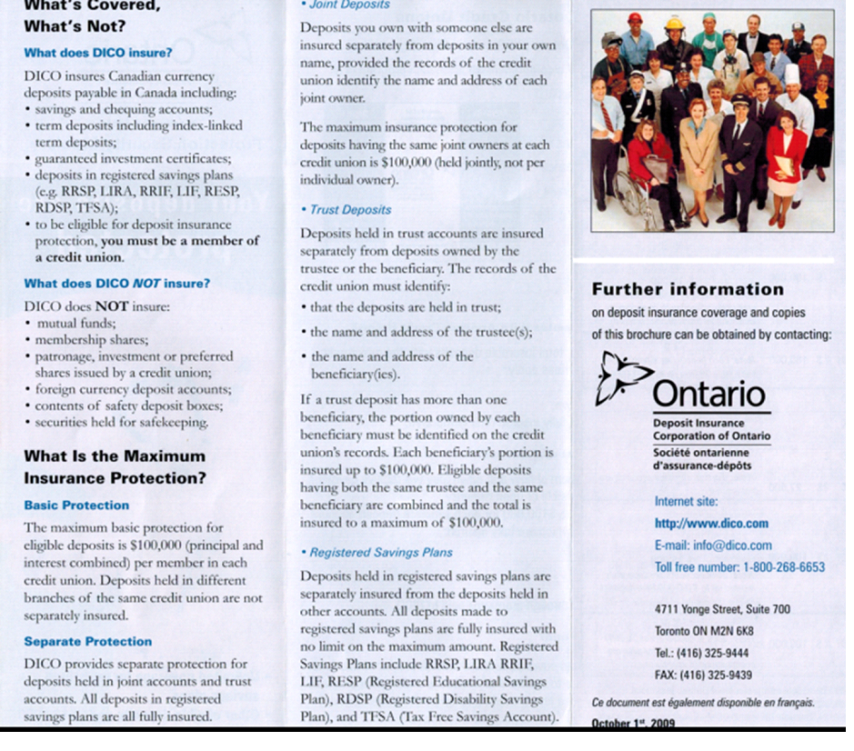

Work Sheet
Task 1: List 3 things DICO insures.
Answer:

Task 2: List 3 things DICO does not insure.
Answer:

Task 3: How much is the maximum basic protection for eligible
deposits?
Answer:

Task 4: How much is the maximum basic protection for a registered
savings plan?
Answer:

Answer Key
In addition to reading and writing skills, tasks 3, 6 and 8 are also opportunities to demonstrate critical thinking.

Task 1: List 3 things DICO insures.
A: any 3 of the 5 listed
Task 2: List 3 things DICO does not insure.
A: any 3 of the 6 listed
Task 3: How much is the maximum basic protection for eligible deposits?
A: $100,000
Task 4: How much is the maximum basic protection for a registered savings plan?
A: fully insured – no maximum

Performance Descriptors 1
Levels | Performance Descriptors | Needs Work | Completes task with support from practitioner | Completes task independently
A2.1 | scans to locate specific details
A2.2 | performs limited searches using one or two search criteria

Performance Descriptors 2
This task: Was successfully completed Needs to be tried again
Learner Comments:

Instructor (print): Learner Signature

