Task prepared for the project "Using Technology to Facilitate Connections between Literacy and the Broader Community" (2014). This task set was vetted by this project and was not reviewed by the QUILL team.

Task Title: Out for Breakfast

OALCF Cover Sheet – Practitioner Copy

Learner Name:
Date Started (m/d/yyyy):
Date Completed (m/d/yyyy):
Successful Completion: Yes No

Goal Path: | Employment | Apprenticeship
Secondary School | Post Secondary | Independence
Task Description: Learners will read a restaurant menu and answer questions about costs.
Competency: A: Find and Use Information, C: Understand and Use Numbers
Task Groups: A2: Interpret documents, C1: Manage money
Level Indicators:
- A2.1: Interpret very simple documents to locate specific details
- C1.2: Make low-level inferences to calculate costs and expenses that may include rates such as taxes and discounts
Performance Descriptors: See chart on last page
Materials Required:
- Learner information and task sheet
- Copy of sample menu
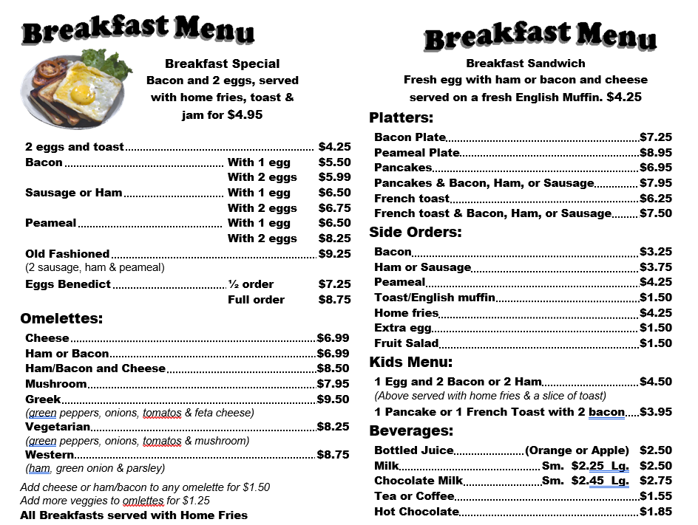

Learner Information and Tasks 1
Task 1: Look at the menu. If you order the breakfast special and a bottle of orange juice, how much will the subtotal (before tax) of your bill be?
Answer:

Task 2: How much would it cost (before tax) for a western omelette with cheese?
Answer:

Task 3: How much would the total bill be for peameal with 2 eggs, French toast with sausage, and two cups of coffee, including 13% tax?
Answer:

Task 4: Which costs more, the bacon plate or the peameal plate?
Answer:

Learner Information and Tasks 2
Task 5: What is the difference in cost (before tax) between a full order of Eggs Benedict and a half order of Eggs Benedict?
Answer:

Task 6: If you ordered a ham omelette and you wanted to add tomatoes, how much would the subtotal be?
Answer:

Task 7: You are having breakfast with five of your friends. You each order the breakfast special and coffee. If you split the bill evenly, including tax, how much would each of you pay?
Answer:

Answers
Task 1: Look at the menu. If you order the breakfast special and a bottle of orange juice, how much will the subtotal (before tax) of your bill be?
$4.95 + $2.50 = $7.50
Task 2: How much would it cost (before tax) for a western omelette with cheese?
$8.75 + $1.50 = $10.25
Task 3: How much would the total bill be for peameal with 2 eggs, French toast with sausage, and two cups of coffee, including 13% tax?
- $8.25 + $7.50 + $1.55 + $1.55 = $18.85
- $18.85 x 13% = $2.45
- $18.85 + $2.45 = $21.30
Task 4: Which costs more, the bacon plate or the peameal plate?
The peameal plate ($8.95 vs $7.25)
Task 5: What is the difference in cost (before tax) between a full order of Eggs Benedict and a half order of Eggs Benedict?
$8.75 - $7.25 = $1.50
Task 6: If you ordered a ham omelette and you wanted to add tomatoes, how much would the subtotal be?
$6.99 + $1.25 = $8.24
Task 7: You are having breakfast with five of your friends. You each order the breakfast special and coffee. If you split the bill evenly, including tax, how much would each of you pay?
- $4.95 + $1.55 = $6.50
- $6.50 x 13% = $0.85
- $6.50 + $0.85 = $7.35
Or
  - $4.95 + $1.55 = $6.50
  - $6.50 x 6 = $39.00
  - $39.00 x 13% = $5.07
  - $39.00 + $5.07 = $44.07
  - $44.07 ÷ 6 = $7.35

Performance Descriptors 1
Levels | Performance Descriptors | Needs Work | Completes task with support from practitioner | Completes task independently
A2.1 | Scans to locate specific details
A2.1 | Interprets brief text and common symbols
C1.2 | Calculates using numbers expressed as whole numbers, fractions, decimals, percentages and integers
C1.2 | Calculates percentages
C1.2 | Chooses and performs required operation(s); may make inferences to identify required operation(s)
C1.2 | Selects appropriate steps to reach solutions
C1.2 | Represents costs and rates using monetary symbols, decimals and percentages

This task: Was successfully completed Needs to be tried again

Performance Descriptors 2
Learner Comments:

Instructor (print): Learner (print):

