OALCF Task Cover Sheet
Task Title: Plan a One-Day Bus Trip
Learner Name:

Date Started: Date Completed:

Successful Completion: Yes___ No___
Goal Path: Employment___ Apprenticeship___ Secondary School___ Post-Secondary___ Independence
Task Description:
Learners are required to plan a one-day bus trip to visit three locations using a city bus schedule provided.
Competency:  A: Find and Use Information  B: Communicate Ideas and Information  C: Understand and Use Numbers | Task Group(s):  A2: Interpret documents  B3: Complete and create documents  C2: Manage time
Level Indicators:
A2.2: Interpret simple documents to locate and connect information
B3.1a: Make straightforward entries to complete very simple documents
C2.1: Measure time and make simple comparisons and calculations

Performance Descriptors: see chart on last page
Skill Building Activities: Please find skill building activities at the end of this task set or click page.
Materials Required:
- One-Day Bus Trip handout
- City of London bus schedule
- A watch or item that tells the time

Task Title: Plan a One-Day Bus Trip
The city bus is a great way to get around when you need to do errands, visit friends and places, or go shopping. Plan a one-day trip using the city bus to visit Central Library downtown and then meet friends for shopping and lunch at Westmount Mall and Shoeless Joe’s Restaurant. You will leave your home around 8:30 am and return home around 5:00 pm. Your trip will start and end at White Oaks Mall.
Learner Information and Tasks

You will take three separate bus rides, they are:
- From White Oaks Mall to Central Library
- From Central Library to Westmount Mall (and Shoeless Joe’s Restaurant)
- From Westmount Mall to White Oaks Mall

Look at the City of London bus schedules and maps to plan your day trip. Fill in the three charts below with details about the bus and time. There is one chart for each bus ride. Allow enough time at each place before you have to catch the bus to your next place. The locations are:
White Oaks Mall – on Wellington Street south, near the corner of Bradley Ave
Central Library – on the corner of Wellington Street and Dundas Street
Westmount Mall and Shoeless Joe’s Restaurant – on Wonderland Road south, near the corner of Viscount Ave
Task Title: Plan a One-Day Bus Trip
- From White Oaks Mall to Central Library
From Wellington Street south, near the corner of Bradley Ave to the corner of Wellington Street and Dundas Street
Bus Route Number: | Bus Route Name:
Bus Stop Pick-up Location (or nearest corner):
Pick-up Time: |  | Drop-off Time:
Bus Stop Drop-off Location (or nearest corner):

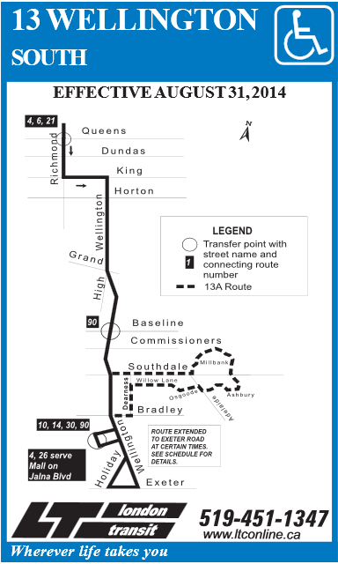

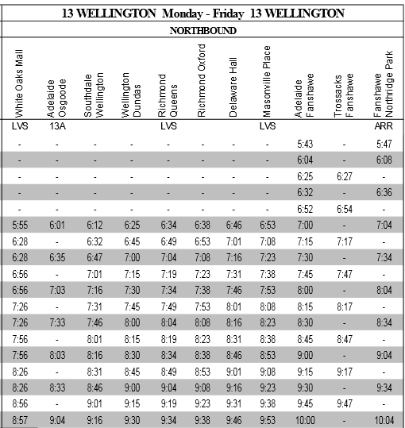

- From Central Library to Westmount Mall (and Shoeless Joe’s Restaurant)
From the corner of Wellington Street and Dundas Street to Wonderland Road south, near the corner of Viscount Ave. (The bus is near Clarence Street and King Street.)
Bus Route Number: | Bus Route Name:
Bus Stop Pick-up Location (or nearest corner):
Pick-up Time: |  | Drop-off Time:
Bus Stop Drop-off Location (or nearest corner):

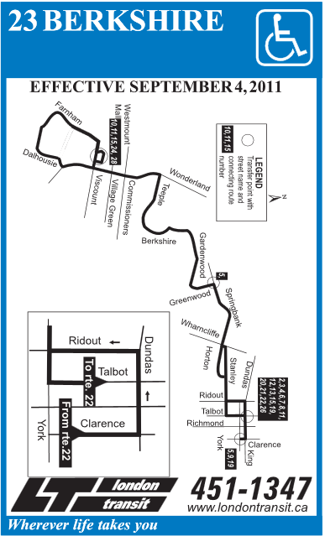

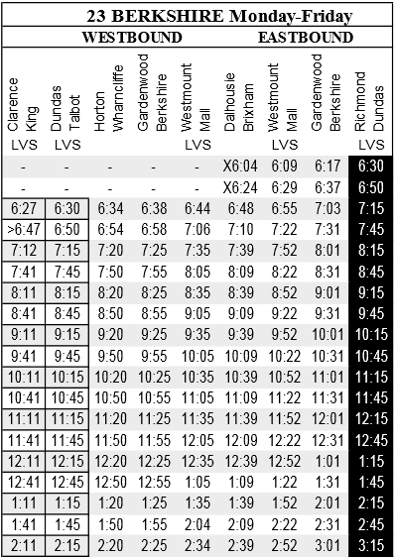

- From Westmount Mall to White Oaks Mall
From Wonderland Road south, near the corner of Viscount Ave to Wellington Street south, near the corner of Bradley Ave
Bus Route Number: | Bus Route Name:
Bus Stop Pick-up Location (or nearest corner):
Pick-up Time: |  | Drop-off Time:
Bus Stop Drop-off Location (or nearest corner):

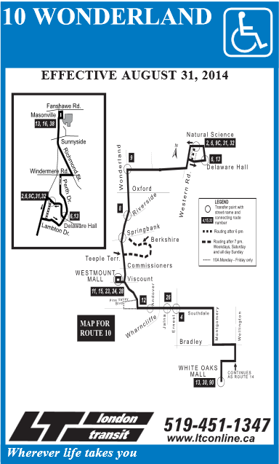

10 WONDERLAND Monday-Friday
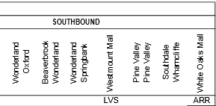
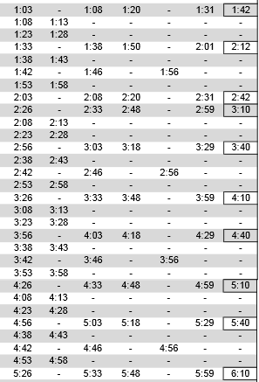

Task Title: Plan a One-Day Bus Trip
Answer Key: The pick-up and drop-off times given below are approximate times only. Refer to the bus schedules to confirm the times that the learner has chosen.
- From White Oaks Mall to Central Library
Bus Route Number: 13 | Bus Route Name: Wellington
Bus Stop Pick-up Location (or nearest corner): White Oaks Mall OR Wellington and Bradley
Pick-up Time: approx. 8:26 |  | Drop-off Time: approx. 8:45
Bus Stop Drop-off Location (or nearest corner): Wellington and Dundas
- From Central Library to Westmount Mall (and Shoeless Joe’s Restaurant)
Bus Route Number: 23 | Bus Route Name: Berkshire
Bus Stop Pick-up Location (or nearest corner): Clarence and King
Pick-up Time: approx. 11:41 |  | Drop-off Time: approx. 12:05
Bus Stop Drop-off Location (or nearest corner): Westmount Mall OR Wonderland and Viscount
- From Westmount Mall to White Oaks Mall
Bus Route Number: 10 | Bus Route Name: Wonderland
Bus Stop Pick-up Location (or nearest corner): Westmount Mall OR Wonderland and Viscount
Pick-up Time: approx. 4:18 |  | Drop-off Time: approx. 4:40
Bus Stop Drop-off Location (or nearest corner): White Oaks Mall OR Wellington and Bradley

Task Title: Plan a One-Day Bus Trip
Performance Descriptors |  | Needs Work | Completes task with support from practitioner | Completes task independently
A2.2 | - performs limited searches using one or two search criteria
 | - locates information in simple graphs and maps
B3.1a | - makes a direct match between what is requested and what is entered
 | - makes entries using familiar vocabulary
C2.1 | - understands chronological order
 | - represents dates and times using standard conventions
 | - follows apparent steps to reach solutions

This task: was successfully completed___ needs to be tried again___

Learner Comments

____________________________ _________________________

Instructor (print) Learner Signature

Skill Building Activity: Plan a One-Day Bus Trip
There are many reasons to take the bus even if you have a car and a driver’s licence, you may still take the bus. Some people take the bus because it is better for the environment or because gas and parking may be more expensive.
Answer the following questions in complete sentences.
- Do you take the bus or have you ever taken the bus? If so, how often do/did you take the bus and why?

- Which bus comes closest to your home and how often?

- List three places in the city that you frequently visit. Do you take the bus or drive to these places?

- Write a paragraph about a time that you took a bus trip. Your paragraph should be 5-8 sentences in length.

