OALCF Task Cover Sheet
Task Title: Preparations before pouring Concrete
Learner Name:

Date Started: Date Completed:

Successful Completion: Yes___ No___
Goal Path: Employment ✓ Apprenticeship ✓ Secondary School Post Secondary Independence___
Task Description:
Carpenters build forms to hold concrete. They also review waterstop and rebar information to make decisions about materials to be used before the concrete is poured.
Competency:  A: Find and Use Information  B: Communicate Ideas and Information  C: Understand and Use Numbers  D: Use Digital Technology | Task Group(s):  A1: Read continuous text  A2: Interpret documents  B2: Write continuous text  C3: Use measures
Level Indicators:
A1.1: Read brief texts to locate specific details
A1.2: Read texts to locate and connect ideas and information
A2.2: Interpret simple documents to locate and connect information
B2.1: Write brief texts to convey simple ideas and factual information
B2.2: Write texts to explain and describe information and ideas
C3.3: Use measures to make multi-step calculations; use specialized measuring tools
D.1: Perform simple digital tasks according to a set procedure
D.2: Perform well-defined, multi-step digital tasks
Performance Descriptors: see chart on last page
Materials Required:
- Pencil
- Calculator
- Waterstops Chart
- Concrete Formwork Computations document
- Rebar Information document

Task Title: Preparations before pouring Concrete
Carpenters build forms to hold concrete. They also review waterstop and rebar information to make decisions about materials to be used before the concrete is poured and to estimate the amount of materials required. When doing computations, carpenters use calculators for accuracy.
Look at the Waterstops Chart, Concrete Formwork Computations document, and Rebar Information document.
Learner Information and Tasks:
Task 1: Use the Waterstops Chart to complete these tasks.
a) Where are center-placed waterstops attached before the concrete is placed?
b) What is done to the fins of a Split-fin waterstop at the First Placement stage?
c) Name one factor in determining the type of waterstop to be used to prevent water leakage at a vertical joint of concrete.

Task 2: Use the Concrete Formwork Computations document to complete tasks b and c.
a) Search the internet to look up the definitions of “walers” and “strongbacks”. In your own words, write the definitions.

b) It is determined that 107.5 linear feet of lumber is required to form a concrete project. In order to compensate for waste, what is the estimated range of lumber, in linear feet, to be ordered for this project? Note: “linear feet” means the length of the material.

c) Plywood may be used for sheathing. What forms require sheathing?

Task 3: Use the Rebar Information document to complete these tasks.
a) What can be done to improve concrete’s lateral load resistance?

b) Where will the carpenter find the information about placing and spacing of rebars?

c) It is determined that rebar, 2.223 cm in diameter, is required to provide lateral strength to the concrete to be poured for a structure. What size of rebar is to be used?

Waterstops Chart
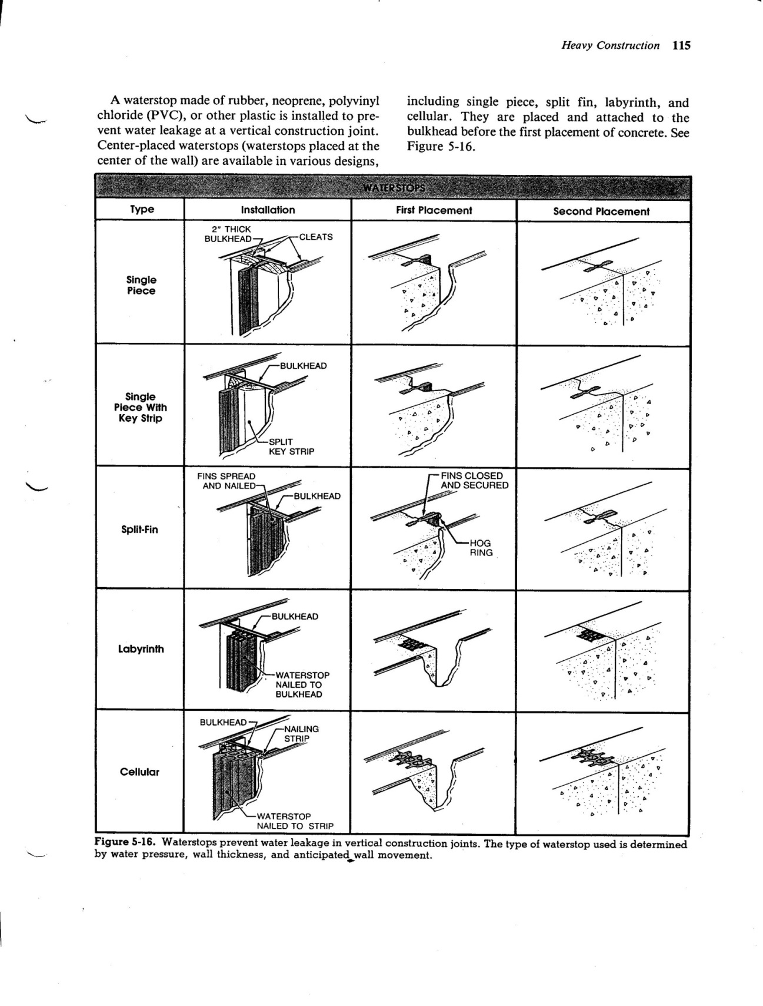

Concrete Formwork Computations
Form Materials and Concrete Quantity Takeoff
Estimating form materials and concrete is a rough calculation of the amount of form materials and volume of concrete required for a specific construction project. Professional estimators commonly estimate the form materials and concrete for heavy construction projects. On small construction projects, such as construction of foundation footings and walls for a residence, the estimating is performed by the contractor or job supervisor.
Form Materials Quantity Takeoff
Form materials are estimated separately for each section of the concrete work. When estimating, dimensions of the form materials are rounded to the next highest foot increment before calculations are performed. For example, the dimension of a wall section measuring 5’ 4½” is rounded to 6’.
When estimating plywood form components, the total surface area of the forms is determined by multiplying the length of the forms by the height. When estimating dimensional lumber such as planks, studs, walers, braces, and stakes, the total length of the lumber is calculated.
Waste occurs when form components are cut from standardized sizes of form materials. Estimators add 5% to 15% of the total amount of form materials to compensate for waste. Underestimation of form materials results in a delay in form construction.
Sheathing
Sheathing is the form material in direct contact with the concrete. Plywood or 2” thick members are used as sheathing for foundation and pier footing forms. Foundation walls are sheathed with plywood reinforced with studs and/or walers, or 2” thick members reinforced with cleats and strongbacks.
Rebar Information
Reinforcing Steel
A concrete wall is subject to both compressive and lateral pressures. Concrete without reinforcement has a great deal of compressive resistance to vertical loads, but far less resistance to lateral loads. The lateral resistance of concrete walls is strengthened by placing rebars (steel reinforcing bars) in the walls. This combination is commonly referred to as reinforced concrete construction.
Rebars are steel bars with ridges and a rough surface. The uneven surface helps bond the concrete to the steel. Standard size rebars range from ⅜” to 2¼” in diameter and are identified n=by numbers from #3 to #18. The diameter of the rebar is found by multiplying the number designation by ⅛”. For example, a #6 rebar is 6/8” or ¾”, in diameter. The size of the rebars required for a wall, as well as their placement and spacing, is shown in section view drawings of prints.
STANDARD REBAR SIZES
Bar Size Designation | Weight Per Foot |  | Diameter |  | Cross-Sectional Area Squared
Bar Size Designation | LB | KG | IN. | CM | IN. | CM
#3 | 0.376 | 0.171 | 0.375 | 0.953 | 0.11 | 0.71
#4 | 0.668 | 0.303 | 0.500 | 1.270 | 0.20 | 1.29
#5 | 1.043 | 0.473 | 0.625 | 1.588 | 0.31 | 2.00
#6 | 1.502 | 0.681 | 0.750 | 1.905 | 0.44 | 2.84
#7 | 2.044 | 0.927 | 0.875 | 2.223 | 0.60 | 3.87
#8 | 2.670 | 1.211 | 1.000 | 2.540 | 0.79 | 5.10
#9 | 3.400 | 1.542 | 1.128 | 2.865 | 1.00 | 6.45
#10 | 4.303 | 1.952 | 1.270 | 3.336 | 1.27 | 8.19
#11 | 5.313 | 2.410 | 1.410 | 3.581 | 1.56 | 10.07
#14 | 7.650 | 3.470 | 1.693 | 4.300 | 2.25 | 14.52
#18 | 13.600 | 6.169 | 2.257 | 5.733 | 4.00 | 25.81

Task Title: Preparations before pouring Concrete
Answer Key
Task 1: a) bulkhead
b) The fins are closed and secured.
c) The answer should be one of the following factors:
water pressure
wall thickness
anticipated wall movement
Task 2: a) Answers will vary but look for ‘own words’ written in full sentences. ‘Straight’ or ‘straighten’ should be included within the definitions; walers definition should include ‘horizontal’ and ‘support’; strongbacks definition should include ‘frame’ or ‘beam’ or ‘girder’ and ‘stiffen’, ‘support’ or ‘reinforce’; both provide support to formwork that will hold the concrete.
b) Realize 107.5 should be rounded to 108. Calculate 5% of 108 and add this to 108. Repeat for 15%. These results are the range of lumber, in linear feet, to be ordered for the project.
108 x 5% = 108 x .05 = 5.4
108 + 5.4 = 113.4
Round 113.4 up to 114. This is the lower range.
108 x 15% = 108 x .15 = 16.2
108 + 16.2 = 124.2
Round 124.2 up to 125. This is the upper range.
The range of lumber to be ordered for the project is 114 to 125 linear feet.
c) foundation and pier footing
Task 3: a) by placing rebars in the walls
b) in section view drawings of prints
c) #7

Task Title: Preparations before pouring Concrete
Performance Descriptors |  | Needs Work | Completes task with support from practitioner | Completes task independently
A1.1 | - reads short texts to locate a single piece of information
 | - follow simple, straightforward instructional texts
A1.2 | - scans text to locate information
 | - locates multiple pieces of information in simple texts
 | - makes low-level inferences
 | - makes connections between sentences and between paragraphs in a single text
 | - reads more complex texts to locate a single piece of information
 | - obtains information from detailed reading
A2.2 | - performs limited searches using one or two search criteria
 | - extracts information from tables and forms
 | - uses layout to locate information
 | - makes connections between parts of documents
 | - makes low-level inferences
B2.1 | - writes simple texts to request, remind or inform
 | - conveys simple ideas and factual information
 | - demonstrates a limited understanding of sequence
 | - uses sentence structure, upper and lower case and basic punctuation
 | - uses highly familiar vocabulary
B2.2 | - writes texts to explain and describe
 | - begins to sequence writing with some attention to organizing principles (e.g. time, importance)
 | - uses limited range of vocabulary and punctuation appropriate to the task
 | - begins to select words and tone appropriate to the task
 | - begins to organize writing to communicate effectively
C3.3 | - calculates using numbers expressed as whole numbers, fractions, decimals, percentages and integers
 | - manages unfamiliar elements (e.g. context, content) to complete tasks
 | - makes estimates involving many factors where precision is required
 | - chooses and performs required operations; makes inferences to identify required operations
 | - interprets, represents and converts measures using whole numbers, decimals, percentages, ratios and fractions
D.1 | - follows simple prompts
 | - follows apparent steps to complete tasks
 | - interprets brief text and icons
 | - locates specific functions and information
D.2 | - selects and follows appropriate steps to complete tasks
 | - locates and recognizes functions and commands
 | - makes low-level inferences to interpret icons and text
 | - performs simple searches using keywords (e.g. internet, software help menu)

This task: was successfully completed___ needs to be tried again___

Learner Comments

____________________________ _________________________

Instructor (print) Learner Signature

