OALCF Task Cover Sheet
Task Title: Purchase Furniture on a Budget
Learner Name:

Date Started: Date Completed:

Successful Completion: Yes___ No___
Goal Path: Employment___ Apprenticeship___ Secondary School___ Post-Secondary___ Independence

Task Description:
In this activity, the learner has $2000.00 to purchase furniture for a family room. The family consists of two adults, two children, one dog, and one bird.

Competency:  A: Find and Use Information  B: Communicate Ideas and Information  C: Understand and Use Numbers | Task Group(s):  A2: Interpret Documents  B2: Write Continuous Text  B3a: Complete Documents  C1: Manage Money
Level Indicators:
A2.1: Read brief texts to locate specific details
B2.1: Write brief texts to convey simple ideas and factual information
B3.1a: Make straightforward entries to complete very simple documents
C1.1: Compare costs and make simple calculations
C1.2: Make low-level inferences to calculate costs and expenses that may include rates such as taxes and discounts
C1.3: Find, integrate, and analyze numerical information to make multi-step calculations to compare cost options and prepare budgets
Performance Descriptors: see chart on last page
Materials Required:
- A copy of the task based activity
- A copy of the flyer with the furniture items
- Pencil and eraser

Task Title: Purchase Furniture on a Budget
Learner Information and Task

To purchase furniture for a home can take a lot of time, planning, and money. The family has $2000.00 to spend on furniture for a family room. The family has two adults, two children, one dog, and one bird.
Look at the flyer of furniture items and decide what to buy for the family room. The furniture items are divided into separate categories, for example: couch, chair, television, etc. You must choose at least one item from each category. Make sure to calculate the 13% Ontario sales tax. There is also a $75.00 delivery fee.

Task 1: Fill in the chart below with your choice of furniture items and calculate their cost. Choose at least one item from each category.

Category | Furniture Item | Cost of Item | 13% Sales Tax | Total Cost of Item
Couch
Chair
Coffee and end tables
Television
Television Stand
Bookshelf
Floor lamp
Table lamp
Artwork
Clock
Bird cage
Dog bed
Plants
Delivery Fee |  | $75.00 | $9.75 | $84.75
Total Cost of Furniture with Tax and Delivery Fee (total budget of $2,000.00)

Task 2: How much sales tax would you pay on the 3-piece couch set?
_______________________________________________________________________

Task 3: How much would three floor lamps cost with sales tax?
_______________________________________________________________________

Task 4: How much money do you have left from your $2000.00 budget?
_______________________________________________________________________

Task 5: Approximately how much money can you spend on furniture items, without sales tax and the delivery fee? Round your answer to the nearest $100.00
_______________________________________________________________________

Category | Furniture Item
Couch | $459.00 $425.00 3-piece set $399.00 $485.00
Chair | $42.00 $55.00 $97.00 $85.00 $76.00 $90.00 $88.00
Coffee and end tables | 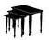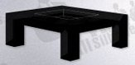  $165.00 $87.00 set $129.00 $95.00 $189.00 3-piece set
Television | 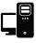  $125.00 $257.00 $329.00 $350.00 $419.00
Television stand | 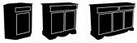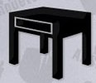  $58.00 $68.00 $88.00 $49.00 $67.00
Bookshelf | 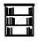  $27.00 $86.00 $45.00
Floor lamp | All floor lamps are $67.00 each
Table lamp | All table lamps are $45.00 each
Artwork | $35.00 set $29.00 $24.00 $67.00
Clock | 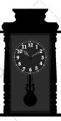  $30.00 $46.00 $20.00 $85.00
Bird cage | 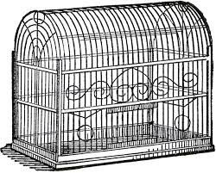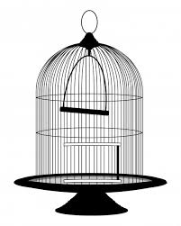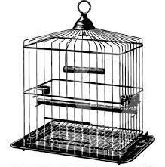  $65.00 $125.00 $79.00 $109.00
Dog bed | 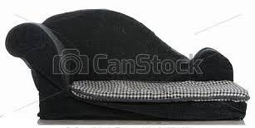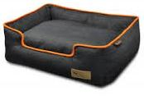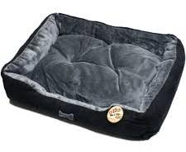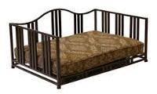  $115.00 $57.00 $27.00 $48.00 $139.00
Plants | All plants are $12.00 each
Task Title: Purchase Furniture on a Budget
Answer Key:
Task 1: There is no right or wrong answer to Task 1. The learner must choose at least one furniture item from each category, calculate the amount of sales tax to be paid and the total cost of that item. In addition, the learner needs to figure out the total cost of the furniture items and then add the $75.00 delivery fee (plus sales tax) for the final total cost. The learner has a $2,000.00 budget.
Task 2: $55.25 sales tax only
Task 3: $227.13
Task 4: between $0.00 and $798.00 *
Task 5: $1,700.00 **

*This is a range showing the least to most amount of money you would have left from the $2,000.00 budget. Therefore, any amount between these two values is correct.
**This number is rounded to the nearest $100.00

Task Title: Purchase Furniture on a Budget
Performance Descriptors |  | Needs Work | Completes task with support from practitioner | Completes task independently
A2.1 | - scans to locate specific details
 | - interprets brief text and common symbols
 | - locates specific details in simple documents, such as labels and signs
 | - identifies how lists are organized (e.g. sequential, chronological, alphabetical)
B2.1 | - conveys simple ideas and factual information
B3.1a | - makes a direct match between what is requested and what is entered
 | - makes entries using familiar vocabulary
C1.1 | - adds, subtracts, multiplies, and divides whole numbers and decimals
 | - identifies and performs required operation
 | - interprets and represents costs using monetary symbols and decimals
 | - rounds to nearest dollar
C1.2 | - calculates using numbers expressed as whole numbers, fractions, decimals, percentages, and integers
 | - calculates percentages
 | - represents costs and rates using monetary symbols, decimals, and percentages
 | - makes simple estimates
C1.3 | - uses strategies to check accuracy (e.g. estimating, using a calculator, repeating a calculation, using the reverse operation)

This task: was successfully completed___ needs to be tried again___

Learner Comments

____________________________ _________________________

Instructor (print) Learner Signature

