

Task Title: Balance a Cash Register

OALCF Cover Sheet – Practitioner Copy

Learner Name: __________________________________________
Date Started: ___________________________________________
Date Completed: ________________________________________
Goal Path: | Employment | Apprenticeship
Secondary School | Post Secondary | Independence
Successful Completion: Yes No

Task Description:
The learner will calculate total amounts of money for the end of day cash report and compare it to the sales summary. They will report a reason for any difference.
Main Competency/Task Group/Level Indicator (e.g. A1.2):
- Understand and Use Numbers/Manage Money/C1.2
- Communicate Ideas and Information/Write Continuous Text/B2.1
- Communicate Ideas and Information/Complete and Create Documents/B3.2
Materials Required:
- Pen/pencil and paper and/or digital device
- Calculator or digital device with calculator function (optional)

Learner Information
Cashiers are required to balance their cash register at the end of their shift. They must reconcile the day's transactions. They receive a cash-out report with a Sales Summary and need to verify if the amounts in the register match the totals recorded during the day.
Scan the End of Day Cash Register Report.

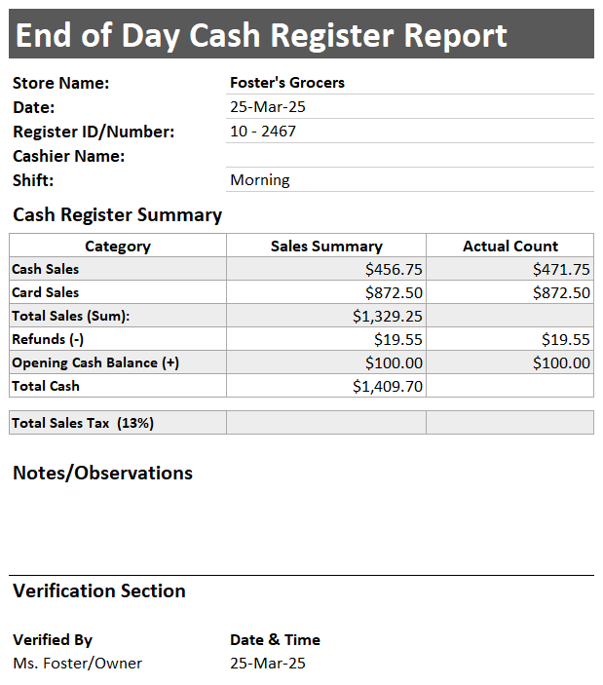

Work Sheet
Task 1: Enter your name into the Cash Register Report.
Answer: No written response required here.
Task Completed: Yes

______________________________________________________
Task 2: Complete the End of Day Cash Register Report.
Answer: No written response required here.
Task Completed: Yes

______________________________________________________
Task 3: Calculate the difference between the Sales Summary total and the Actual Count total.
Answer:

______________________________________________________
Task 4: Write a possible reason in the Notes section for any difference.
Answer: No written response required here.
Task Completed: Yes

______________________________________________________

Answers
The report should be completed as shown below.
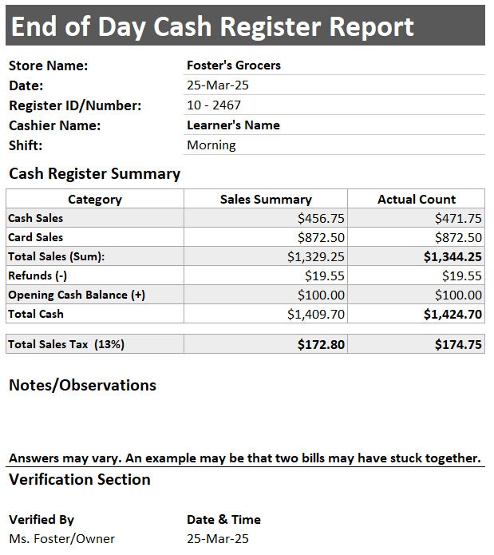

Performance Descriptors
Levels | Performance Descriptors | Needs Work | Completes task with support from practitioner | Completes task independently
B2.1 | Writes simple texts to request, remind, or inform
B3.2 | Uses layout to determine where to make entries
C1.2 | Calculates using numbers expressed as whole numbers, fractions, decimals, percentages, and integers
 | Calculates percentages
 | Chooses and performs required operation(s); may make inferences to identify required operation(s)
 | Represents costs and rates using monetary symbols, decimals, and percentages

This task: Was successfully completed Needs to be tried again

Learner Comments:

Instructor (print): Learner (print):

_______________________ _______________________

