

Task Title: Browse Classified Listings

# OALCF Cover Sheet – Practitioner Copy

**Learner Name: __________________________________________**

**Date Started: ___________________________________________**

**Date Completed: _________________________________________**

|  |  |  |
| --- | --- | --- |
| **Goal Path:** | Employment | Apprenticeship |
| Secondary School | Post Secondary | Independence |

**Successful Completion:**  Yes No

**Task Description:** The learner will browse through classified advertisements to search for a used couch.

**Main Competency/Task Group/Level Indicator:**

* Find and Use Information/Interpret documents/A2.2

**Materials Required:**

* Pen/pencil and paper and/or digital device

# Learner Information

Online classified advertisements are a great place to find used furniture at a reasonable cost. Look at the five classified advertisements from Kijiji.

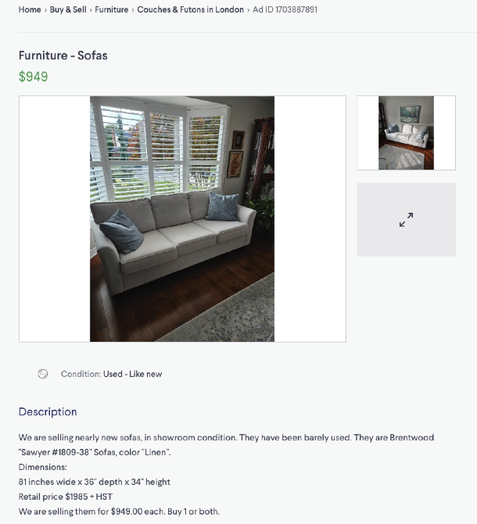

# 

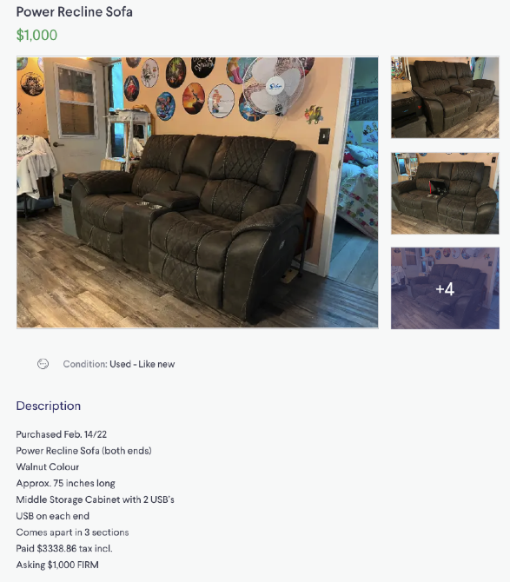

# 

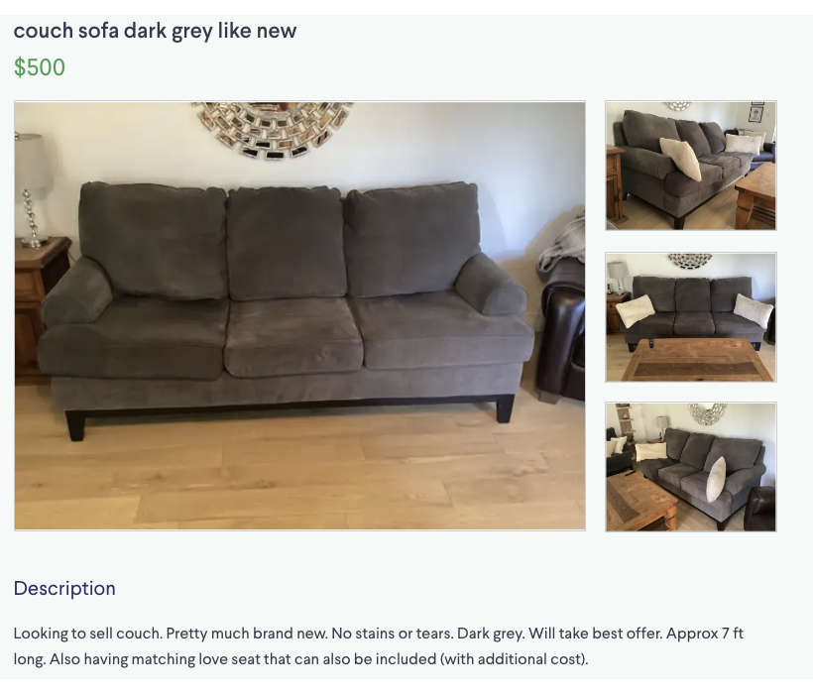

# Work Sheet

**Task 1: If your budget is $700, how many of the couches listed are in your price range?**

Answer:

**______________________________________________________**

**Task 2: You prefer a fabric couch. How many couches could you consider purchasing?**

Answer:

**______________________________________________________**

**Task 3: You want to purchase a couch that meets the following criteria:**

* **Seats 3 people**
* **Fabric can be removed for washing**
* **Comes apart so it can fit through your apartment doorway**

**Which of the couch advertisements give enough information so you can make your decision?**

Answer:

**______________________________________________________**

# Answers

**Task 1: If your budget is $700, how many of the couches listed are in your price range?**

Answer: two.

**Task 2: You prefer a fabric couch. How many couches could you consider purchasing?**

Answer: four. There may be some variation in this answer. Only one couch is specifically described as leather; the remaining couches appear to be fabric in the pictures, but the learner may interpret this differently.

**Task 3: You want to purchase a couch that meets the following criteria:**

* **Seats 3 people**
* **Fabric can be removed for washing**
* **Comes apart so it can fit through your apartment doorway**

**Which of the couch advertisements give enough information so you can make your decision?**

Answer: None of the ads give enough information to confirm whether or not they meet all three criteria.

Couch 1: Looks like it has three seats, do not know if fabric can be removed, do not know if it comes apart for moving.

Couch 2: does not look like it has three seats, do not know if fabric can be removed, do not know if it can come apart for moving.

Couch 3: does not look like it has three seats, do not know if fabric can be removed, does come apart for moving.

Couch 4: does have three seats, removable covers for washing, do not know if it comes apart for moving.

Couch 5: looks like it has three seats, do not know if fabric can be removed, do not know it if comes apart for washing.

# Performance Descriptors

| Levels | Performance Descriptors | Needs Work | Completes task with support from practitioner | Completes task independently |
| --- | --- | --- | --- | --- |
| A2.2 | performs limited searches using one or two search criteria |  |  |  |
|  | extracts information from tables and forms |  |  |  |
|  | uses layout to locate information |  |  |  |
|  | makes connections between parts of documents |  |  |  |
|  | makes low-level inferences |  |  |  |
|  | begins to identify sources and evaluate information |  |  |  |

This task: Was successfully completed Needs to be tried again

Learner Comments:

Instructor (print): Learner (print):

**__________________ _________________**