

Task Title: Bus and Train Schedule

# OALCF Cover Sheet – Practitioner Copy

**Learner Name: __________________________________________**

**Date Started: ___________________________________________**

**Date Completed: _________________________________________**

|  |  |  |
| --- | --- | --- |
| **Goal Path:** | Employment | Apprenticeship |
| Secondary School | Post Secondary | Independence |

**Successful Completion:**  Yes No

**Task Description:** Learners will read a bus and train schedule to find information and make determinations about which bus or train to take.

**Main Competency/Task Group/Level Indicator:**

* Find and Use Information/Interpret documents/A2.2
* Understand and Use Numbers/Manage time/C2.2

**Materials Required:**

* Pen/pencil and paper and/or digital device

# Learner Information

Reading a transit schedule helps us schedule our time. We need to know when and where different routes stop so we can plan travel to appointments, work or school.

Scan the “Bus and Train Schedule between Bramalea Station and Union Station”.

**Bus and Train Schedule between Bramalea Station and Union Station**

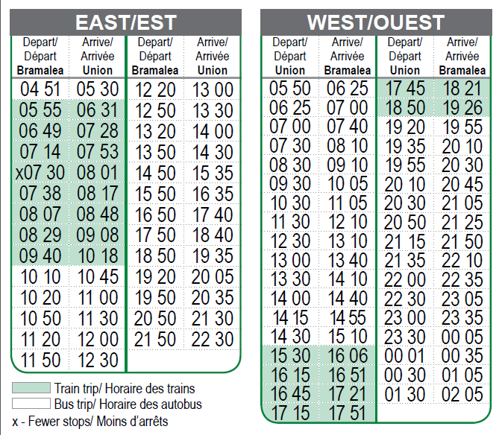

# Work Sheet

**Task 1: When does the last train depart Bramalea to go to Union Station?**

Answer:

**______________________________________________________**

**Task 2: What time does the train with fewer stops leave Bramalea?**

Answer:

**______________________________________________________**

**Task 3: What time does the last bus depart from Bramalea each evening?**

Answer:

**______________________________________________________**

**Task 4: What time does this last bus from Bramalea arrive at Union Station?**

Answer:

**______________________________________________________**

**Task 5: What time does the first bus leave Union Station for Bramalea each morning?**

Answer:

**______________________________________________________**

**Task 6: You have to get to Union Station at 2:00 p.m. What time would your bus leave Bramalea?**

Answer:

**______________________________________________________**

**Task 7: You want to arrive at Bramalea at 6:21 p.m., would you need to take a bus or a train from Union Station?**

Answer:

**______________________________________________________**

**Task 8: You are at Union Station at noon and you want to take a bus to Bramalea, how long will you have to wait before the next bus departs?**

Answer:

**______________________________________________________**

# Answers

**Task 1: When does the last train depart Bramalea to go to Union Station?**

Answer: 9:40am

**Task 2: What time does the train with fewer stops leave Bramalea?**

Answer: 7:30am

**Task 3: What time does the last bus depart from Bramalea each evening?**

Answer: 21:50 (9:50pm)

**Task 4: What time does this last bus from Bramalea arrive at Union Station?**

Answer: 22:30 (10:30pm)

**Task 5: What time does the first bus leave Union Station for Bramalea each morning?**

Answer: 5:50am

**Task 6: You have to get to Union Station at 2:00 p.m. What time would your bus leave Bramalea?**

Answer: 13:20 (1:20pm)

**Task 7: You want to arrive at Bramalea at 6:21 p.m., would you need to take a bus or a train from Union Station?**

Answer: train

**Task 8: You are at Union Station at noon and you want to take a bus to Bramalea, how long will you have to wait before the next bus departs?**

Answer: ½ hour (30 minutes)

# Performance Descriptors

| Levels | Performance Descriptors | Needs Work | Completes task with support from practitioner | Completes task independently |
| --- | --- | --- | --- | --- |
| A2.2 | performs limited searches using one or two search criteria |  |  |  |
|  | extracts information from tables and forms |  |  |  |
|  | uses layout to locate information |  |  |  |
|  | makes connections between parts of documents |  |  |  |
|  | makes low-level inferences |  |  |  |
| C2.2 | interprets, represents and converts time using whole numbers, decimals, percentage, ratios and simple, common fractions (e.g. ½, ¼) |  |  |  |
|  | selects appropriate steps to reach solutions |  |  |  |
|  | understands and converts time between 12- and 24-hour clocks |  |  |  |

This task: Was successfully completed Needs to be tried again

Learner Comments:

Instructor (print): Learner (print):

**__________________ _________________**