

Task Title: Calculate Angles

# OALCF Cover Sheet – Practitioner Copy

**Learner Name: __________________________________________**

**Date Started: ___________________________________________**

**Date Completed: _________________________________________**

| **Goal Path:** | Employment | Apprenticeship |
| --- | --- | --- |
| Secondary School | Post Secondary | Independence |

**Successful Completion:**  Yes No

**Task Description:** Carpenters calculate angles to construct trusses and stairs.

**Main Competency/Task Group/Level Indicator:**

* Find and Use Information/Read continuous text/A1.2
* Find and Use Information/Interpret documents/A2.2
* Understand and Use Numbers/Manage money/C1.2
* Understand and Use Numbers/Use measures/C3.3

**Materials Required:**

* Pen/pencil and paper and/or digital device
* Calculator or digital device with calculator function

# Learner Information

Carpenters use calculators and formulas to calculate angles to meet safety regulations and to determine amounts of material required.

# Review the Angle Drawings information and read the Ontario Regulation 67/93: Healthcare and Residential Facilities document about ladder safety.

**Angles Drawings**





All measurement answers are to be in feet or decimals of feet.

Carpenters use the a2 + b2 = c2 formula to calculate lengths of stairs and stringers (c) where a = height or rise and b = length or run.

**Ontario Regulation 67/93: Healthcare and Residential Facilities**

83. When a ladder is being used it shall,

(a) be placed on a firm footing and secured against slipping;

(b) if the ladder is between six and nine metres in length, be securely fastened or be held in place by one or more workers while being used;

(c) if the ladder exceeds nine metres in length, be securely fastened or stabilized to prevent it from tipping or falling;

(d) when not securely fastened, be inclined so that the horizontal distance from the top support to the foot of the ladder is not less than one-quarter and not more than one-third of the length of the ladder; and

(e) if the ladder is likely to be endangered by traffic, have a worker stationed at its foot to direct such traffic or have barriers or warning signs placed at its foot.  O. Reg. 67/93, s. 83.

# [Source: <https://www.ontario.ca/laws/regulation/930067/v22#BK17>]

# Work Sheet

**Task 1: Look at the diagram of a ladder. Calculate the range of allowable distance between the wall and the bottom of the ladder when the ladder is not securely fastened as described in Ontario Regulation 67/93: Healthcare and Residential Facilities.**

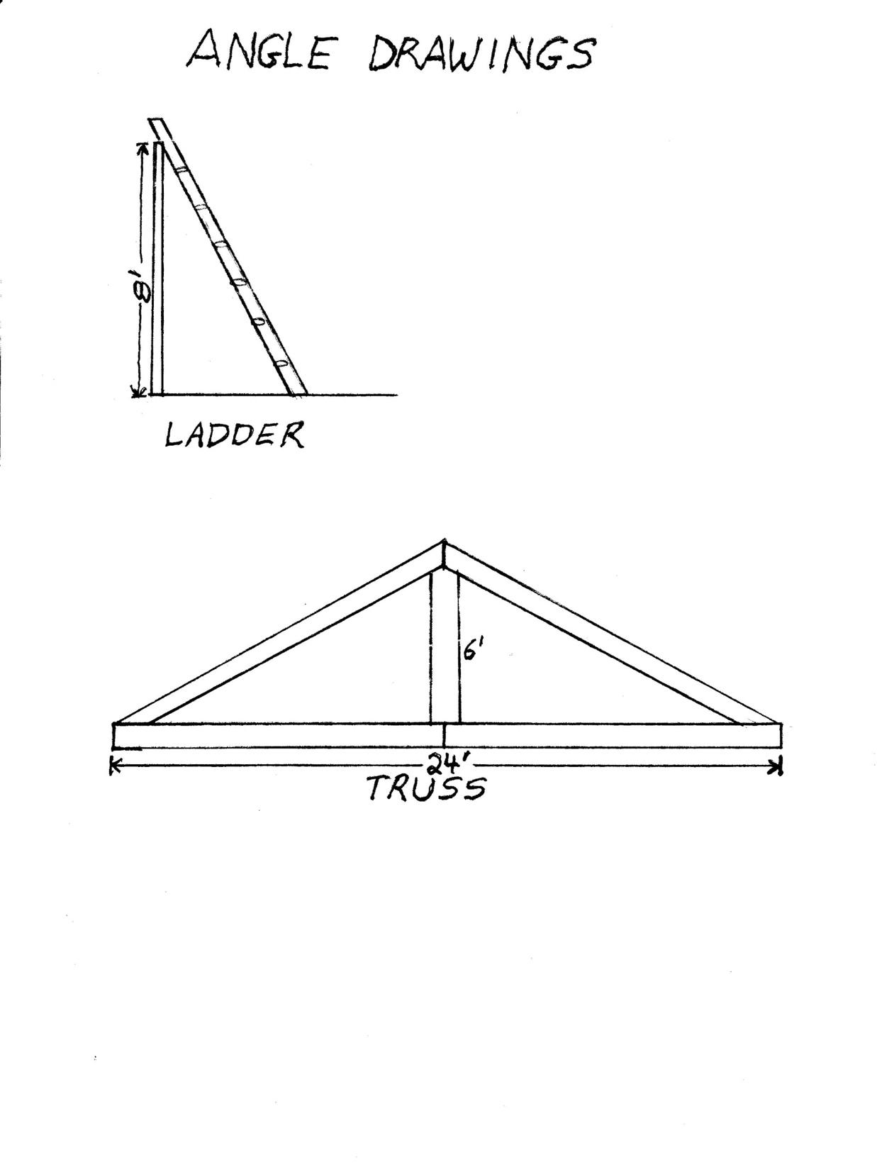

Answer:

**______________________________________________________**

**Task 2: Look at the diagram of a truss.**

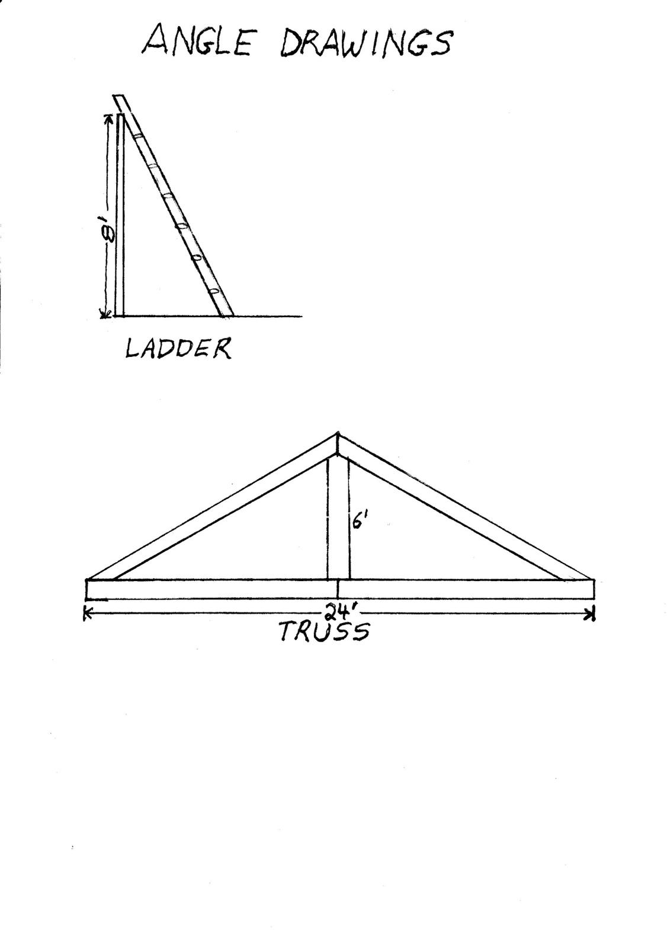

1. **Calculate the length of the remaining sides of the truss.**

Answer:

1. **If 2X4 lumber is 36¢/linear foot, plus HST, how much will the lumber cost for the truss?**

Answer:

**______________________________________________________**

**Task 3: Look at the diagram of a staircase. A staircase is to be built from the second floor of the house to the patio. The staircase will join the second floor deck twelve feet above the ground and rest on the patio nine feet from the house. How long will each stringer be?**

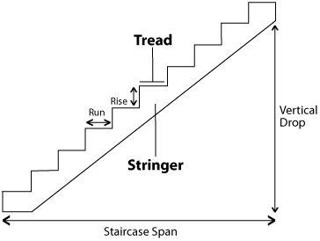

Answer:

Answer:

**______________________________________________________**

# Answers

**Task 1: Look at the diagram of a ladder. Calculate the range of allowable distance between the wall and the bottom of the ladder when the ladder is not securely fastened as described in Ontario Regulation 67/93: Healthcare and Residential Facilities.**

Answer: The distance of the foot of the ladder from the wall must be at least ¼ of the height but not more than 1/3 of the height.

Height = 8’

Distance = ¼ x 8’ = 2’ (minimum)

Distance = 1/3 x 8’ = 2.7’

The distance between the wall and the bottom of the ladder must be at least 2’ but not more than 2.7’.

**Task 2: Look at diagram of a truss.**

1. **Calculate the length of the remaining sides of the truss.**

Answer:

a2 + b2 = c2, where a = 6’ and b = 24/2 = 12’

62 + 122 = c2

36 + 144 = c2

180 = c2

√180 = c

13.42’ = c

The length of the remaining two sides of the truss is 13.42’ each.

1. **If 2X4 lumber is 36¢/linear foot, plus HST, how much will the lumber cost for the truss?**

Answer:

The truss will require one length of “a” (6’), two lengths of “b” (2 x 12’ = 24’), and two lengths of “c” (2 x 13.42’ = 26.84’).

Total amount of lumber = 6’ + 24’ + 26.84’ = 56.84’

Total cost of lumber = 56.84’ x 36¢ = $20.46 + HST

Total cost of lumber = $20.46 + ($20.46 x .13)

Total cost of lumber = 20.46 + $2.66 = $23.12

**Task 3: Look at the diagram of a staircase. A staircase is to be built from the second floor of the house to the patio. The staircase will join the second floor deck twelve feet above the ground and rest on the patio nine feet from the house. How long will each stringer be?**

Answer: a2 + b2 = c2 where a = height and b = length

122 + 92 = c2

144 + 81 = c2

√225 = c

15 = c

Each stringer will be 15’ long.

# Performance Descriptors

| Levels | Performance Descriptors | Needs Work | Completes task with support from practitioner | Completes task independently |
| --- | --- | --- | --- | --- |
| A1.2 | scans text to locate information |  |  |  |
|  | locates multiple pieces of information in simple texts |  |  |  |
|  | makes low-level inferences |  |  |  |
|  | reads more complex texts to locate a single piece of information |  |  |  |
| A2.2 | locates information in simple graphs and maps |  |  |  |
|  | makes low-level inferences |  |  |  |
| C1.2 | calculates using numbers expressed as whole numbers, fractions, decimals, percentages and integers |  |  |  |
|  | calculates percentages |  |  |  |
|  | interprets and applies rates (e.g. $/kg, $/1) |  |  |  |
|  | chooses and performs required operation(s); may make inferences to identify required operation(s) |  |  |  |
|  | selects appropriate steps to reach solutions |  |  |  |
|  | represents costs and rates using monetary symbols, decimals and percentages |  |  |  |
|  | interprets, represents and converts amounts using whole numbers, decimals, percentages, ratios and simple, common fractions (e.g. ½, ¼) |  |  |  |
| C3.3 | calculates using numbers expressed as whole numbers, fractions, decimals, percentages and integers |  |  |  |
|  | understands and uses properties of angles and triangles to solve problems |  |  |  |
|  | understands and uses formulas for finding the perimeter, area and volume of non-rectangular, composite shapes |  |  |  |
|  | chooses and performs required operations; makes inferences to identify required operations |  |  |  |
|  | selects appropriate steps to solutions from among options |  |  |  |
|  | interprets, represents and converts measures using whole numbers, decimals, percentages, ratios and fractions |  |  |  |



This task: Was successfully completed Needs to be tried again

Learner Comments:

Instructor (print): Learner (print):

**__________________ _________________**