

Task Title: Calculate the Area of a Room that Includes a

Bay Window

# OALCF Cover Sheet – Practitioner Copy

**Learner Name: __________________________________________**

**Date Started: ___________________________________________**

**Date Completed: _________________________________________**

|  |  |  |
| --- | --- | --- |
| **Goal Path:** | Employment | Apprenticeship |
| Secondary School | Post Secondary | Independence |

**Successful Completion:**  Yes No

**Task Description:** Learner will calculate the area of a room that includes a bay window.

**Main Competency/Task Group/Level Indicator:**

* Understand and Use Numbers/Use measures/C3.3

**Materials Required:**

* Pen/pencil and paper and/or digital device
* Calculator or digital device with calculator function
* Ruler

# Notes for Instructors/Practitioners

This is an advanced task requiring the learner to know what a polygon is and how to calculate area using the Pythagorean Theorem.

# Learner Information

An important part of the job of a skilled construction tradesperson involves making calculations based on instructions such as blueprints. Before laying the floor covering, a contractor must calculate the area of the floor to know how much carpet or tile must be ordered. In complex floors, contractors will split the floor into smaller polygons to make the calculations simpler. Look at the “Diagram of the Living Room”.

**Diagram of a Living Room**

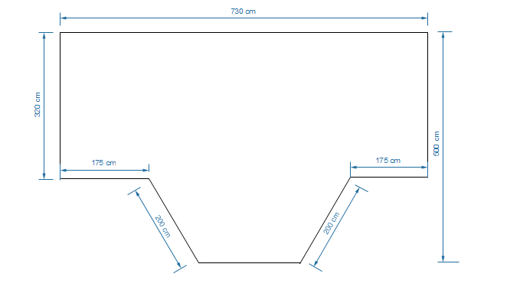

# Work Sheet

**Task 1: Divide the complex polygon into known polygons. Label these on the room diagram.**

Answer: No written response required here.

Task completed: Yes:

_____________________________________________________________

**Task 2: Calculate the unknown lengths and label them on your diagram. If necessary, round calculations to 2 decimal places.**

Answer: No written response required here.

Task completed: Yes:

_____________________________________________________________

**Task 3: Calculate the area of the living room floor.**

Answer:

**______________________________________________________**

# Answers

**Task 1: Divide the complex polygon into known polygons. Label these on the room diagram.**

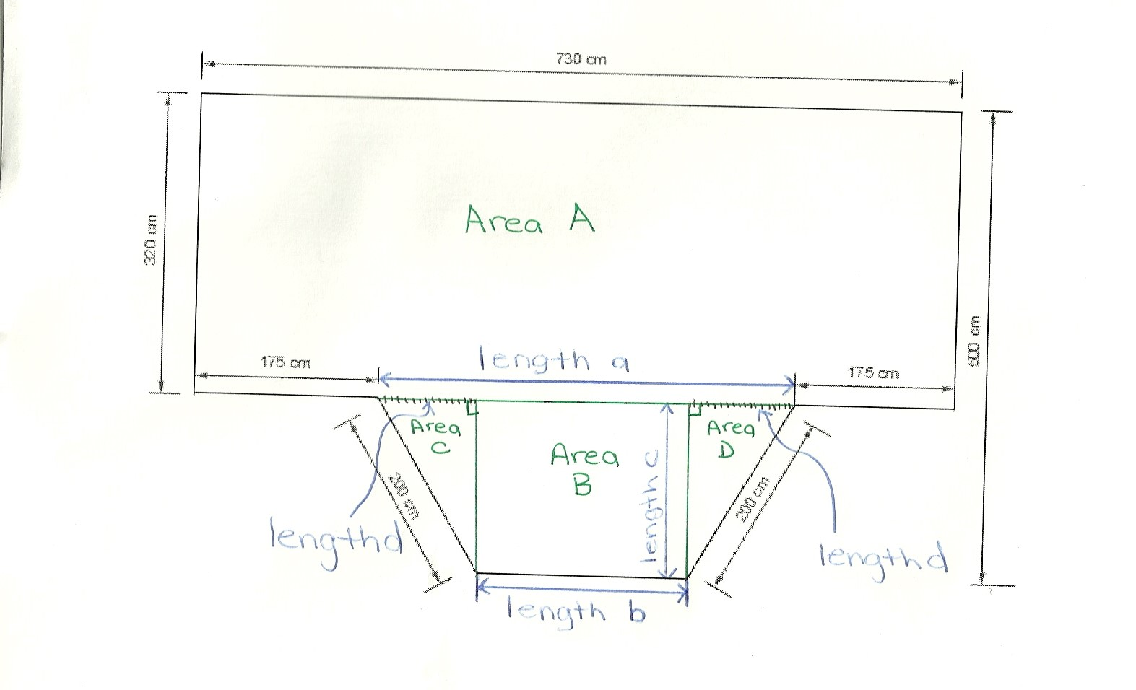Answer: Answers will vary if the learner labelled the diagram differently. One example of a labelled diagram is:

**Task 2: Calculate the unknown lengths and label them on your diagram. If necessary, round calculations to 2 decimal places.**

The following calculations are for the various lengths labelled on the answer diagram:

length a: 730 – (175+175) = 780-350 = 380 cm

length c: 500 - 320 = 180 cm

length d: needs to be calculated with the Pythagorean Theorem. Round to 2 decimal places.

Let c = 200cm c2 = a2 + d2

Let a = 180 cm (200)2 = (180)2 + d2

Let d = unknown side d 40 000 = 32400 + d2

7600 = d2

d = √ 7600 = 87.18 cm

length b: (requires the calculation of length d first)

length b: 730 – (175 + 175 + 87.18 + 87.18 (length d)) =

730 – 524.36 = 205.64 cm

**Task 3: Calculate the area of the living room floor.**

Answer: The following calculations are for the various areas labelled on the diagram:

Area A = length x width = 730 cm x 320 cm = 233 600 cm2

Area B = length x width = 205.64 cm x 180 cm = 37 015.2 cm2

Area C = ½ (base x height) = ½ (87.18 cm x 180 cm) = 7 846.2 cm2

Area D = ½ (base x height) = ½ (87.18 cm x 180 cm) = 7 846.2 cm2

Note: Area C and D are the same. Student could do the calculation once and multiply it by 2 or calculate the area as a rectangle for C and D. All are acceptable methods of finding the area for these figures.

Area of Floor: Area A + Area B + Area C + Area D = 233 600 cm2 + 37 015.2 cm2 + 7 846.2 cm2 + 7 846.2 cm2

Area of Floor: 286 307.6 cm2

# Performance Descriptors

| Levels | Performance Descriptors | Needs Work | Completes task with support from practitioner | Completes task independently |
| --- | --- | --- | --- | --- |
| C3.3 | calculates using numbers expressed as whole numbers, fractions, decimals, percentages and integers |  |  |  |
|  | understands and uses properties of angles and triangles to solve problems |  |  |  |
|  | understands and uses formulas for finding the perimeter, area and volume of non-rectangular, composite shapes |  |  |  |
|  | manages unfamiliar elements (e.g. context, content) to complete tasks |  |  |  |
|  | chooses and performs required operations; makes inferences to identify required operations |  |  |  |
|  | interprets, represents and converts measures using whole numbers, decimals, percentages, ratios and fractions |  |  |  |

This task: Was successfully completed Needs to be tried again

Learner Comments:

Instructor (print): Learner (print):

**__________________ _________________**