

Task Title: Calculate Cost of Items During BOGO Sale

OALCF Cover Sheet – Practitioner Copy

Learner Name: __________________________________________
Date Started: ___________________________________________
Date Completed: _________________________________________

Goal Path: | Employment | Apprenticeship
Secondary School | Post Secondary | Independence
Successful Completion: Yes No

Task Description: The learner will calculate the cost of items during a “buy one, get one” sale.
Main Competency/Task Group/Level Indicator:
- Understand and Use Numbers/Manage money/C1.2
Materials Required:
- Pen/pencil and paper and/or digital device

Learner Information
Stores will often advertise “BOGO” sales in their weekly flyers. “BOGO” stands for Buy One Get One.
Scan the Sharpie Permanent Marker advertisement.

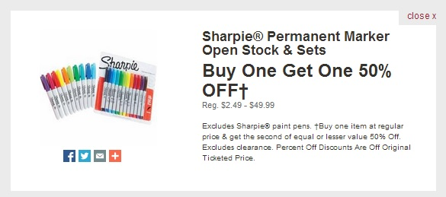

Work Sheet
Task 1: One package of Sharpie markers has an original price of $14.98 and the other has an original price of $39.99. After the “BOGO” discount, how much will it cost for the package of Sharpie® Markers that originally cost $14.98?
Answer:

______________________________________________________
Task 2: Two packages of Sharpie® Markers have the same original price of $29.98. What will be the cost of the discounted package during the “BOGO” sale?
Answer:

______________________________________________________
Task 3: One package of Sharpie Markers costs $2.64 and another package costs $7.99. How much will the total cost be for both marker packages (before taxes) after the “BOGO” discount is applied?
Answer:

______________________________________________________

Answers
Task 1: One package of Sharpie markers has an original price of $14.98 and the other has an original price of $39.99. After the “BOGO” discount, how much will it cost for the package of Sharpie® Markers that originally cost $14.98?
Answer: $14.98 is the package of lesser value so it is 50% off (or half price). Therefore, the package will be $7.49.

Task 2: Two packages of Sharpie® Markers have the same original price of $29.98. What will be the cost of the discounted package during the “BOGO” sale?
Answer: The packages are of equal value so one will be 50% off (or half price). Half of $29.98 is $14.99.

Task 3: One package of Sharpie Markers costs $2.64 and another package costs $7.99. How much will the total cost be for both marker packages (before taxes) after the “BOGO” discount is applied?
Answer: The package with the lesser value is $2.64. You will save 50% of $2.64 which is $1.32. Therefore, you will pay $7.99 for one package and $1.32 for the second package which equals $9.31 total for both marker packages.

Performance Descriptors
Levels | Performance Descriptors | Needs Work | Completes task with support from practitioner | Completes task independently
C1.2 | calculates using numbers expressed as whole numbers, fractions, decimals, percentages and integers
 | calculates percentages
 | chooses and performs required operation(s); may make inferences to identify required operation(s)
 | selects appropriate steps to reach solutions
 | represents costs and rates using monetary symbols, decimals and percentages
 | interprets, represents and converts amounts using whole numbers, decimals, percentages, ratios and simple, common fractions (e.g. ½, ¼)
 | uses strategies to check accuracy (e.g. estimating, using a calculator, repeating a calculation, using the reverse operation)

This task: Was successfully completed Needs to be tried again

Learner Comments:

Instructor (print): Learner (print):
__________________ _________________

