

Task Title: Calculating Cement Mixture Ratios

# OALCF Cover Sheet – Practitioner Copy

**Learner Name: __________________________________________**

**Date Started: ___________________________________________**

**Date Completed: _________________________________________**

|  |  |  |
| --- | --- | --- |
| **Goal Path:** | Employment | Apprenticeship |
| Secondary School | Post Secondary | Independence |

**Successful Completion:**  Yes No

**Task Description:** The learner will use ratios to calculate the amounts of different materials required to mix concrete.

**Main Competency/Task Group/Level Indicator:**

* Understand and Use Numbers/Use measures/C3.2

**Materials Required:**

* Pen/pencil and paper and/or digital device
* Calculator or digital device with calculator function (optional)

# Learner Information

Construction projects frequently require concrete that is mixed differently depending on how it is being used. Construction workers need to be able to mix appropriate amounts, depending on the ratio used for a specific project.

Scan the “Concrete Mixing Ratio Chart”.

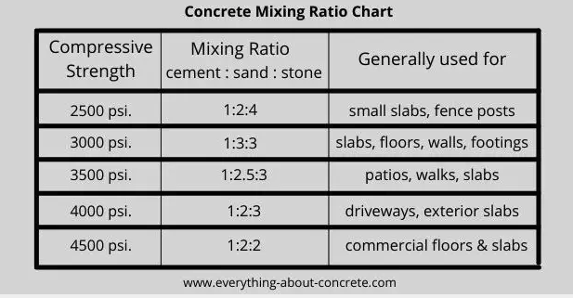

# Work Sheet

**Task 1: A construction team is mixing concrete for a patio. Calculate the amounts of sand and stone required for a mixture that has 20 pounds of cement.**

Answer:

**______________________________________________________**

**Task 2: The team is mixing concrete for a driveway and they need 50 pounds of sand. Calculate the amounts of cement and stone they will need.**

Answer:

**______________________________________________________**

**Task 3: The team is mixing concrete with a compressive strength of 3000 psi. Calculate the amounts of cement and sand they will need to mix with 90 pounds of stone.**

Answer:

**______________________________________________________**

# Answers

**Task 1: A construction team is mixing concrete for a patio. Calculate the amounts of sand and stone required for a mixture that has 20 pounds of cement.**

Answer:

The ratio for patios is 1:2.5:3

20 pounds of cement is 1 x 20. The sand and stone ratios must be multiplied by 20:

20 pounds cement : 50 pounds sand : 60 pounds stone

**Task 2: The team is mixing concrete for a driveway and they need 50 pounds of sand. Calculate the amounts of cement and stone they will need.**

Answer:

The ratio for driveways is 1:2:3

50 pounds of sand is 2 x 25. The remaining materials must be multiplied by 25:

25 pounds cement : 50 pounds sand : 75 pounds stone

**Task 3: The team is mixing concrete with a compressive strength of 3000 psi. Calculate the amounts of cement and sand they will need to mix with 90 pounds of stone.**

Answer:

The ratio for 3000 psi compression strength is 1:3:3

90 pounds of stone is 3 x 30. The remaining materials must be multiplied by 30.

30 pounds of cement : 90 pounds of sand : 90 pounds of stone

# Performance Descriptors

| Levels | Performance Descriptors | Needs Work | Completes task with support from practitioner | Completes task independently |
| --- | --- | --- | --- | --- |
| C3.2 | calculates using numbers expressed as whole numbers, fractions, decimals, percentages and integers |  |  |  |
|  | understands and uses ratio and proportion |  |  |  |
|  | chooses and performs required operation(s); may make inferences to identify required operation(s) |  |  |  |
|  | selects appropriate steps to reach solutions |  |  |  |
|  | uses strategies to check accuracy (e.g. estimating, using a calculator, repeating a calculation, using the reverse operation) |  |  |  |

This task: Was successfully completed Needs to be tried again

Learner Comments:

Instructor (print): Learner (print):

**__________________ _________________**