

Task Title: Calculating Shoe Store Discounts

# OALCF Cover Sheet – Practitioner Copy

**Learner Name: __________________________________________**

**Date Started: ___________________________________________**

**Date Completed: _________________________________________**

|  |  |  |
| --- | --- | --- |
| **Goal Path:** | Employment | Apprenticeship |
| Secondary School | Post Secondary | Independence |

**Successful Completion:**  Yes No

**Task Description:** The learner will interpret sale information in a flyer and make calculations based on discounts.

**Main Competency/Task Group/Level Indicator:**

* Find and Use Information/Interpret documents/A2.1
* Understand and Use Numbers/Manage money/C1.2

**Materials Required:**

* Pen/pencil and paper and/or digital device
* Calculator or digital device with calculator function

# Learner Information

Store flyers may be delivered to homes or posted online. This can help customers learn about new items, sales, or other store promotions.

Scan the **Shoe Store Flyers for Women’s Sandals and Girls’ Athletics**.

**Shoe Store Flyer: Women’s Sandals**

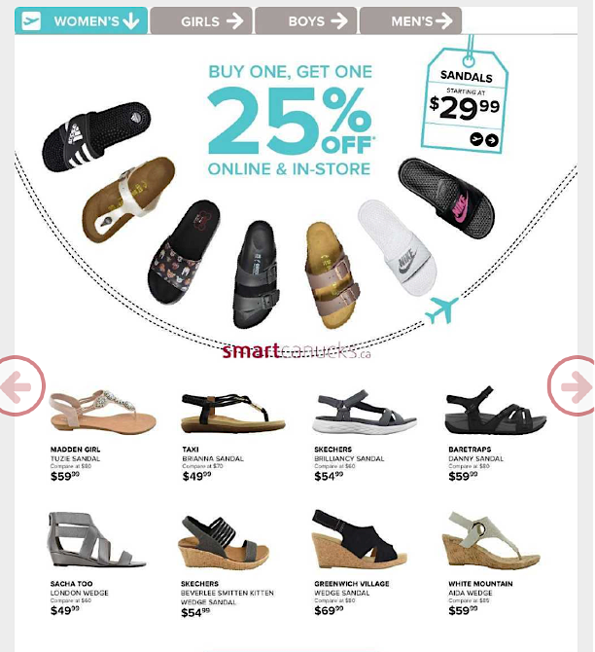

**Shoe Store Flyer: Girls’ Athletics**

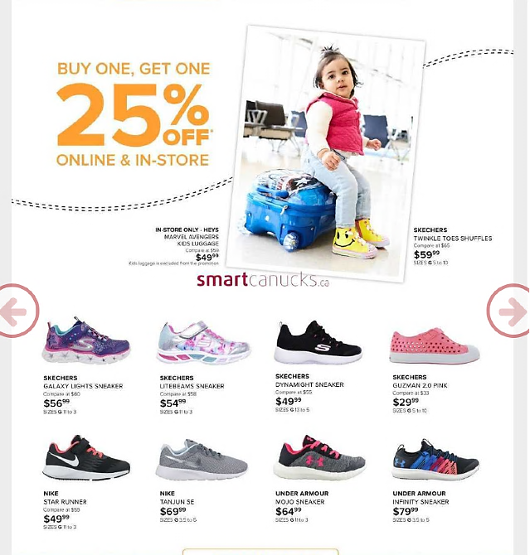

# Work Sheet

**Task 1: A customer purchases the Sacha Too London Wedge Sandal. Calculate the total cost including sales tax (13%).**

Answer:

**______________________________________________________**

**Task 2: A customer purchases the Sketchers Brilliancy Sandal and the White Mountain Aida Wedge Sandal. Calculate the total cost including sales tax (13%). The Buy One, Get One discount is applied to the lowest cost item before tax is calculated.**

Answer:

**______________________________________________________**

**Task 3: A customer purchases Sketchers Litebeams Sneakers and Nike Star Runners. Calculate the total cost including sales tax and discounts.**

Answer:

**______________________________________________________**

**Task 4: One person visited the shoe store on three different days and made the purchases listed in tasks 1, 2 and 3. Calculate the total amount they spent at the shoe store.**

Answer:

**______________________________________________________**

# Answers

**Task 1: A customer purchases the Sacha Too London Wedge Sandal. Calculate the total cost including sales tax (13%).**

Answer: $49.99 x 0.13 = $6.50

$49.99 + $6.50 = $56.49 total

**Task 2: A customer purchases the Sketchers Brilliancy Sandal and the White Mountain Aida Wedge Sandal. Calculate the total cost including sales tax (13%). The Buy One, Get One discount is applied to the lowest cost item before tax is calculated.**

Answer: $54.99 x 0.25 = $13.75

$54.99 - $13.75 = $41.24

$41.24 + $59.99 = $101.23

$101.23 x 0.13 = $13.16

$101.23 + $13.16 = $114.39 total

**Task 3: A customer purchases Sketchers Litebeams Sneakers and Nike Star Runners. Calculate the total cost including sales tax and discounts.**

Answer: $49.99 x 0.25 = $12.50

$49.99 - $12.50 = $37.49

$37.49 + $54.99 = $92.48

$92.48 x 0.13 = $12.02

$92.48 + $12.02 = $104.50 total

**Task 4: One person visited the shoe store on three different days and made the purchases listed in tasks 1, 2 and 3. Calculate the total amount they spent at the shoe store.**

Answer: $56.49 + $114.39 + $104.50 = $275.38 total

**Note for Practitioners**: The learner’s answer to this question depends upon correct calculations in the previous tasks. If the learner did not correctly respond to one or more of the previous questions, determine correctness of this answer based on the numbers they have used.

# Performance Descriptors

| Levels | Performance Descriptors | Needs Work | Completes task with support from practitioner | Completes task independently |
| --- | --- | --- | --- | --- |
| A2.1 | scans to locate specific details |  |  |  |
|  | interprets brief text and common symbols |  |  |  |
|  | locates specific details in simple documents, such as labels and signs |  |  |  |
| C1.2 | calculates using numbers expressed as whole numbers, fractions, decimals, percentages and integers |  |  |  |
|  | calculates percentages |  |  |  |
|  | chooses and performs required operations; may make inferences to identify required operations |  |  |  |
|  | selects appropriate steps to reach solutions |  |  |  |
|  | ises strategies to check accuracy (e.g. estimating, using a calculator, repeating a calculation, using the reverse operation) |  |  |  |

This task: Was successfully completed Needs to be tried again

Learner Comments:

Instructor (print): Learner (print):

**__________________ _________________**