

Task Title: Cancelling and Rescheduling a Workshop

# OALCF Cover Sheet – Practitioner Copy

**Learner Name: __________________________________________**

**Date Started: ___________________________________________**

**Date Completed: _________________________________________**

|  |  |  |
| --- | --- | --- |
| **Goal Path:** | Employment | Apprenticeship |
| Secondary School | Post Secondary | Independence |

**Successful Completion:**  Yes No

**Task Description:** Use proper phone etiquette to cancel and reschedule a workshop. Use a calendar to reschedule and understand appointment times.

**Main Competency/Task Group/Level Indicator:**

* Find and Use Information/Interpret documents/A2.2
* Communicate Ideas and Information/Interact with others/B1.2
* Communicate Ideas and Information/Complete and create documents/B3.2a

**Materials Required:**

* Pen/pencil and paper and/or digital device

# Practitioner Information

# This task is primarily an oral task that requires the Learner to contact an organization to let them know they are unable to participate in a workshop due to illness and reschedule for the next available workshop. Use the script provided below to role play the phone conversation with the Learner.

# **Telephone Script:**

**Receptionist: Good Morning, Employment Services, may I help you?**

**Learner:**

**Receptionist: May I have your name please?**

**Learner:**

**Receptionist: Thank you for calling. Is there anything else I can do for you?**

**Learner:**

**Receptionist: The next available dates for the workshop are June 2nd, June 10th, June 18th and June 26th. Each workshop is 1 1/2 hours long. Which one would you like to be scheduled for?**

**Learner:**

**Receptionist: On June 2nd and June 18th, the workshop is at 9:30 am. On June 10th and 26th, the workshop is at 1:30 pm.**

**Learner:**

**Receptionist: I apologize; I should have let you know that one is full. It looks like the 18th and 26th are not full.**

**Learner:**

**Receptionist: Okay. Is there anything else I can do for you?**

**Learner:**

**Receptionist: Hope you feel better.**

**Learner:**

# Learner Information

# You cannot attend a resume workshop because you are sick. You will need to call the organization that is hosting the resume workshop to let them know and to reschedule for the next available resume workshop. You will have the conversation with your instructor or a fellow student acting as the receptionist.

# Scan the “June Calendar” to review the other commitments you have this month before you call to reschedule.

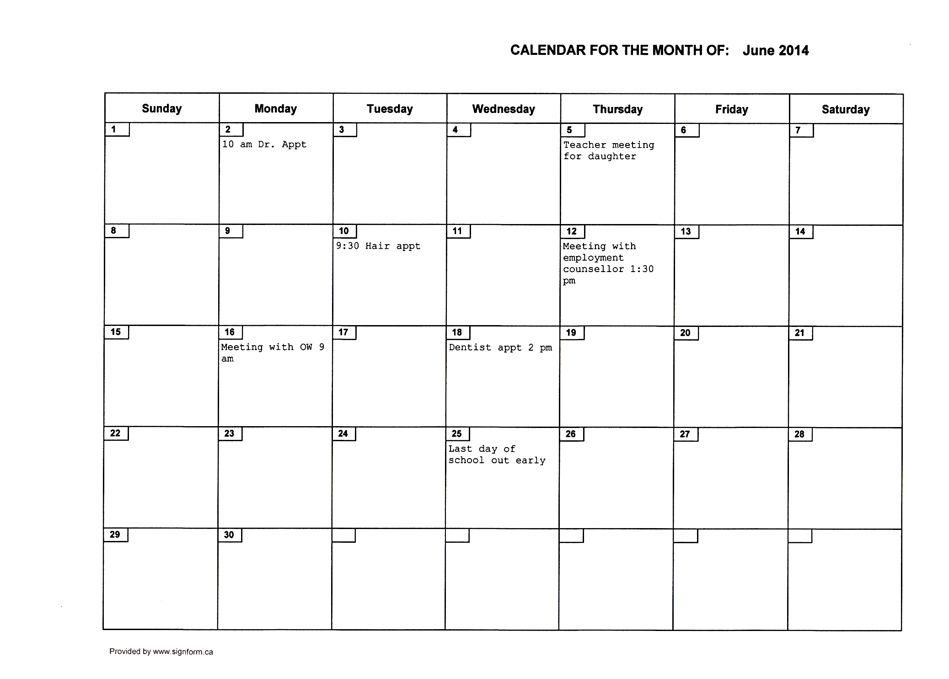**June** **Calendar**

# Work Sheet

**Task 1: You have dialed the number and the receptionist has answered. The receptionist who answers the phone will ask you the following questions. Answer the questions with the information you have available on the June Calendar.**

Answer: This is an oral task. No written response required here.

Task completed: Yes:

**Task 2: Enter the rescheduled workshop date and time into the June calendar.**

Answer:

**Task 3: Why is it important to not be upset with the receptionist when she tells you the workshop you wanted is full?**

Answer:

**______________________________________________________**

# Answers

**Task 1: You have dialed the number and the receptionist has answered. Answer the questions with the information you have available on the June Calendar.**

Answer: Here is a sample answer of a conversation the learner may have with you.

**Receptionist:** Good Morning, Employment Services, may I help you?

**Learner:** Yes, I am calling to let you know that I will not be able to make it to the resume workshop today. I am suffering from the flu.

**Receptionist:** May I have your name please?

**Learner:** [learner name]

**Receptionist:** Thank you for calling. Is there anything else I can do for you?

**Learner:** Yes, I would like to be able to take the next available workshop; can you tell me when they are?

**Receptionist:** The next available dates for the workshop are June 2nd, June 10th, June 18th and June 26th. Each workshop is 1 1/2 hours long. Which one would you like to be scheduled for?

**Learner:** I am looking at my calendar, can you please tell the times of those workshops?

**Receptionist:** On June 2nd and June 18th, the workshop is at 9:30 am. On June 10th and 26th, the workshop is at 1:30 pm.

**Learner:** Thanks, it looks like June 10th will work.

**Receptionist:** I apologize; I should have let you know that one is full. It looks like the 18th and 26th are not full.

**Learner:** June 18th will work for me. Please schedule me in for that workshop.

**Receptionist:** Okay. Is there anything else I can do for you?

**Learner:** No, that's it. Thank you.

**Receptionist:** Hope you feel better.  
**Learner:** Thank you!

**Task 2: Enter the rescheduled workshop date and time into the June calendar.**

Answer: Refer to the learner’s completed calendar to ensure they have written down the correct date and time for the workshop they plan to take. They could attend on either the 18th or the 26th.

**Task 3: Why is it important to not be upset with the receptionist when she tells you the workshop you wanted is full?**

Answer: It is important to treat others with respect and kindness, even if you do not like the answer you receive. The receptionist does not have control over how many people can attend a workshop and/or when workshops are scheduled. Being respectful towards others is an important part of any interaction, whether on the phone or in person.

# Performance Descriptors

| Levels | Performance Descriptors | Needs Work | Completes task with support from practitioner | Completes task independently |
| --- | --- | --- | --- | --- |
| A2.2 | performs limited searches using one or two search criteria |  |  |  |
|  | extracts information from tables and forms |  |  |  |
|  | uses layout to locate information |  |  |  |
|  | makes connections between parts of documents |  |  |  |
|  | makes low-level inferences |  |  |  |
| B1.2 | shows an awareness of factors that affect interactions, such as differences in opinions and ideas, and social, linguistic and cultural differences |  |  |  |
|  | demonstrates some ability to use tone appropriately |  |  |  |
|  | uses strategies to maintain communication, such as encouraging responses from others and asking q speaks or signs clearly in a focused and organized way questions |  |  |  |
|  | rephrases to confirm or increase understanding |  |  |  |
| B3.2a | uses layout to determine where to make entries |  |  |  |
|  | begins to make some inferences to decide what information is needed, where and how to enter the information |  |  |  |
|  | makes entries using a limited range of vocabulary |  |  |  |

This task: Was successfully completed Needs to be tried again

Learner Comments:

Instructor (print): Learner (print):

**__________________ _________________**