

Task Title: Car Salesman

# OALCF Cover Sheet – Practitioner Copy

**Learner Name:___________________________________________**

**Date Started:____________________________________________**

**Date Completed: _________________________________________**

|  |  |  |
| --- | --- | --- |
| **Goal Path:** | Employment | Apprenticeship |
| Secondary School | Post Secondary | Independence |

**Successful Completion:**  Yes No

**Task Description:** Use an automotive vehicle inspection document to record a vehicle’s current condition.

**Main Competency/Task Group/Level Indicator:**

* Find and Use Information/Interpret documents/A2.1 and A2.2
* Communicate Ideas and Information/Complete and create documents/B3.1a and B3.2a

**Materials Required:**

* Pen/pencil and paper and/or digital device

# Learner Information

Sales staff at a car dealership fill out inspection reports in order to help review a vehicle’s current condition whenever a car is being traded in. An inspection report may indicate recommended maintenance or repairs to a vehicle.

Scan the “UCDA Customer Information, Appraisal & Disclosure” form.

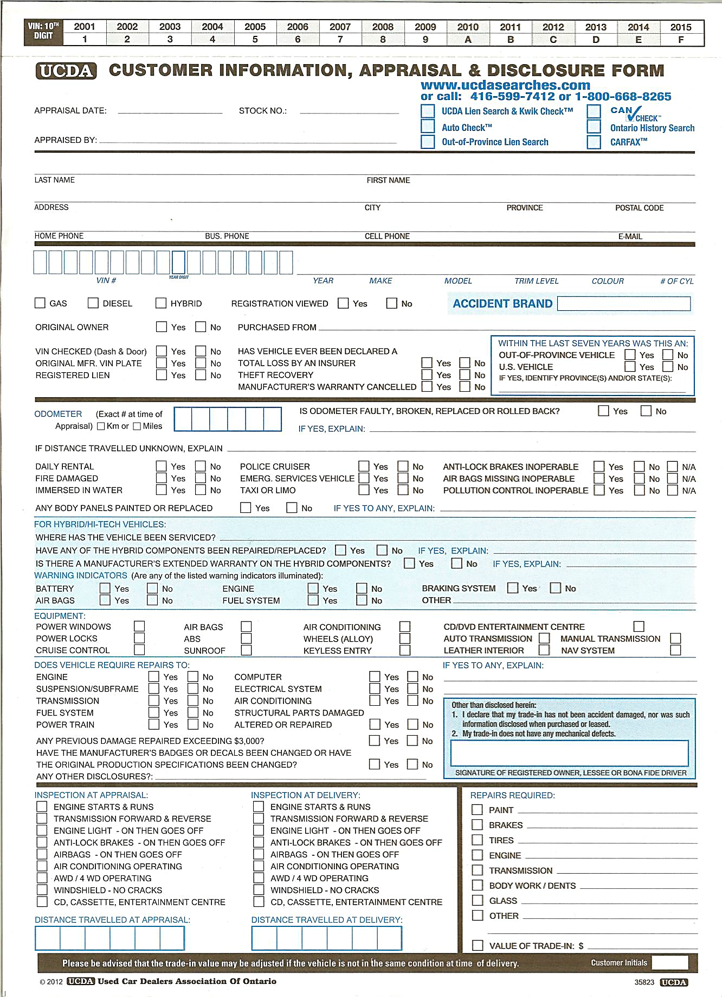

# Work Sheet

**Task 1: A customer is trading in a white 2004 Ford Taurus with an odometer reading of 238,126 km. Using the checklist, enter this information into the appropriate boxes.**

Answer:

**______________________________________________________**

**Task 2: The vehicle’s engine starts and runs properly when it is being appraised. Mark this information on the form.**

Answer:

**______________________________________________________**

**Task 3: The tire tread is very worn, and the car cannot be sold as is. Find where on the form the required repairs need to be recorded, and mark that the tires need to be replaced.**

Answer:

**______________________________________________________**

**Task 4: The vehicle has power windows, power locks, air bags, a sunroof, and a keyless entry. Check the appropriate boxes on the checklist form.**

Answer:

**______________________________________________________**

# Answers

# Performance Descriptors

| Levels | Performance Descriptors | Needs Work | Completes task with support from practitioner | Completes task independently |
| --- | --- | --- | --- | --- |
| A2.1 | scans to locate specific details |  |  |  |
|  | interprets brief text and common symbols |  |  |  |
|  | locates specific details in simple documents, such as labels and signs |  |  |  |
| A2.2 | performs limited searches using one or two serach criteria |  |  |  |
|  | extracts information from tables and forms |  |  |  |
|  | uses layout to locate information |  |  |  |
|  | makes connections between parts of documents |  |  |  |
|  | makes low-level inferences |  |  |  |
| B3.1a | makes a direct match between what is requested and what is entered |  |  |  |
|  | makes entries using familiar vocabulary |  |  |  |
| B3.2a | uses layout to determine where to make entries |  |  |  |
|  | begins to make some inferences to decide what information is needed, where and how to enter the information |  |  |  |
|  | makes entries using a limited range of vocabulary |  |  |  |

This task: Was successfully completed Needs to be tried again

Learner Comments:

Instructor (print): Learner (print):

**__________________ _________________**