

Task Title: Change Power Settings on a Computer

# OALCF Cover Sheet – Practitioner Copy

**Learner Name: __________________________________________**

**Date Started: ___________________________________________**

**Date Completed: _________________________________________**

|  |  |  |
| --- | --- | --- |
| **Goal Path:** | Employment | Apprenticeship |
| Secondary School | Post Secondary | Independence |

**Successful Completion:**  Yes No

**Task Description:** The learner will follow instructions to change the power settings on a Windows computer.

**Main Competency/Task Group/Level Indicator:**

* Find and Use Information/Interpret documents/A2.2
* Use Digital Technology/D.2

**Materials Required:**

* Computer with Microsoft Windows operating system

# Notes for Instructor/Practitioner

This task was created based on Windows 11. Settings may vary with different Windows computers.

# Learner Information

People who use computers need to be familiar with the different power saving settings to be able to get optimum performance from the computer. This can also save energy and reduce utility bills.

# Work Sheet

**Task 1: Turn on the computer. Use the mouse to find and click on the “Start” icon at the bottom of your screen. This will open the computer menu options. Use the mouse to click on “Settings” on the computer menu.**

Answer: No written response required here.

Task completed: Yes:

**Task 2: Click on “System” on the left side of the screen. Then click on “Power & battery” under the System menu. This will open a new menu under “Power & battery”.**

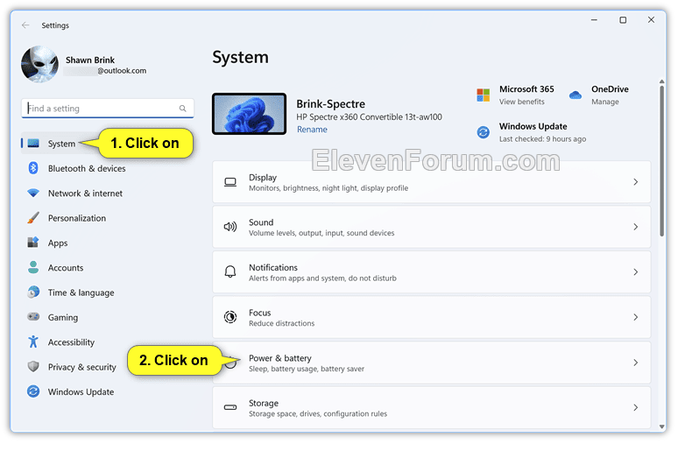

Answer: No written response required here.

Task completed: Yes:

**Task 3: In the “Power & battery” menu, click on “Screen and sleep” to expand the menu. Under “Screen and sleep” there will be several options for changing settings. Click the arrow beside “Never” to change each setting to “After 5 minutes”.**

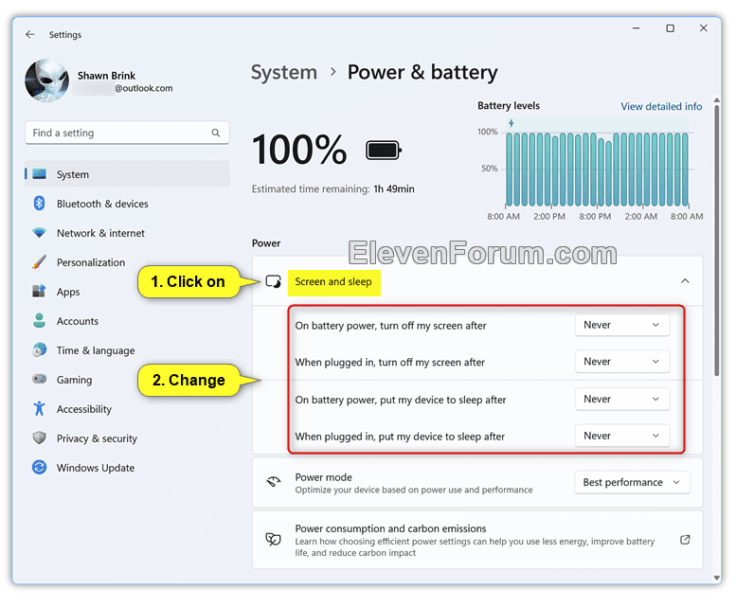

Answer: No written response required here.

Task completed: Yes:

# Answers

Learner will be able to execute the steps to change power settings on the computer. Note: This task was created based on Windows 11. Settings may vary with different Windows computers.

# Performance Descriptors

| Levels | Performance Descriptors | Needs Work | Completes task with support from practitioner | Completes task independently |
| --- | --- | --- | --- | --- |
| A2.2 | extracts information from tables and forms |  |  |  |
|  | makes connections between parts of documents |  |  |  |
| D.2 | selects and follows appropriate steps to complete tasks |  |  |  |
|  | locates and recognizes functions and commands |  |  |  |
|  | makes low-level inferences to interpret icons and text |  |  |  |

This task: Was successfully completed Needs to be tried again

Learner Comments:

Instructor (print): Learner (print):

**__________________ _________________**