

Task Title: Comparing Quantities of Granola Bars

# OALCF Cover Sheet – Practitioner Copy

**Learner Name: __________________________________________**

**Date Started: ___________________________________________**

**Date Completed: _________________________________________**

|  |  |  |
| --- | --- | --- |
| **Goal Path:** | Employment | Apprenticeship |
| Secondary School | Post Secondary | Independence |

**Successful Completion:**  Yes No

**Task Description:** The learner will compare quantities in boxes of granola bars.

**Main Competency/Task Group/Level Indicator:**

* Understand and Use Numbers/Manage data/C4.1

**Materials Required:**

* Pen/pencil and paper and/or digital device
* Calculator or digital device with calculator function (optional)

# Learner Information

# When buying groceries, it’s helpful to compare quantities or amounts to see which item is the best value.

# Scan the various granola bar product boxes shown below.

**Granola Products**

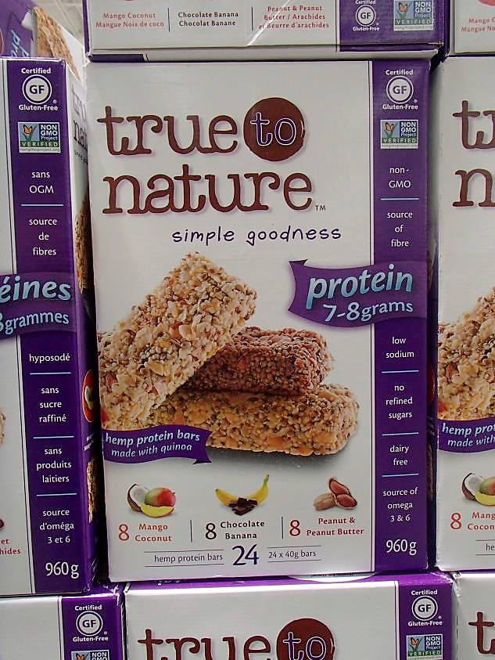 **Box 1 Box 2**

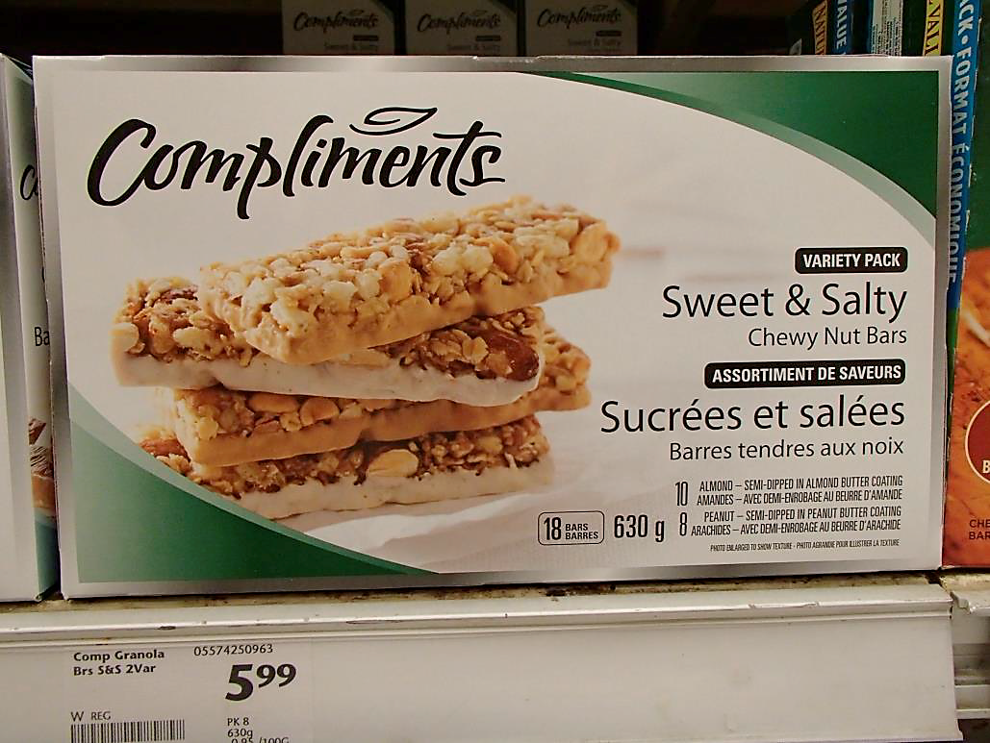

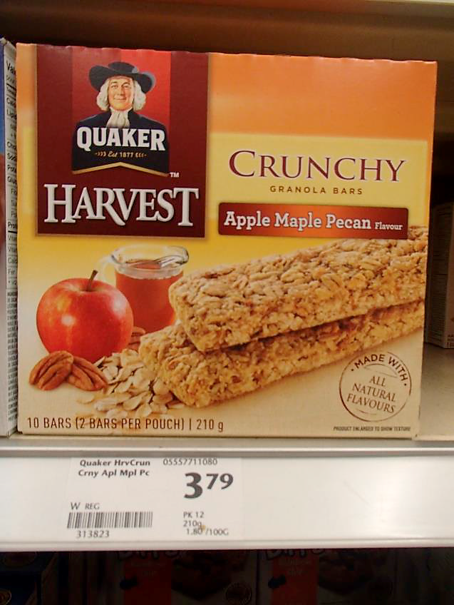**Box 3 Box 4**

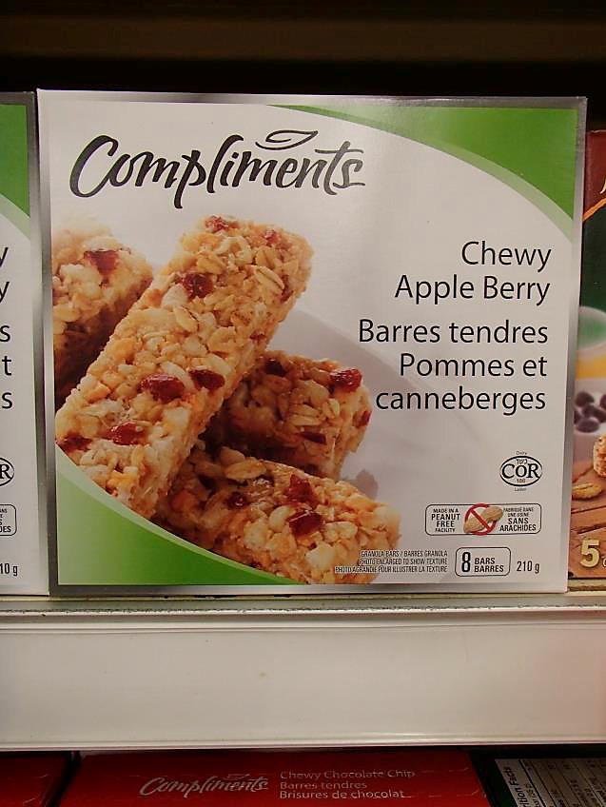

# Work Sheet

**Task 1: Compare boxes 1 and 2. Which box has more granola bars?**

Answer:

**______________________________________________________**

**Task 2: Compare boxes 1 and 2. Which box has more kinds of granola bars in it?**

Answer:

**______________________________________________________**

**Task 3: Compare boxes 3 and 4. If both boxes of granola bars are the same price, which box is the better deal?**

Answer:

**______________________________________________________**

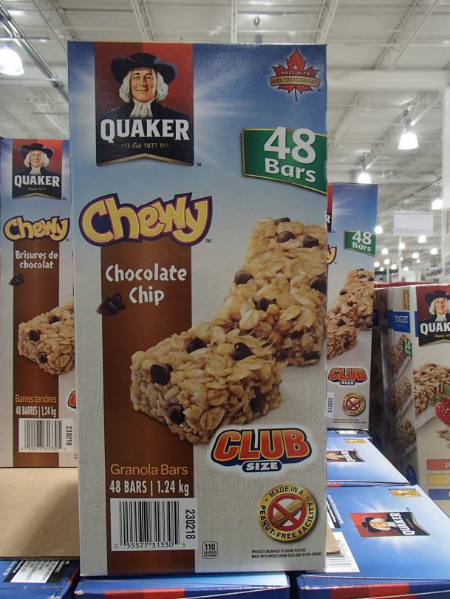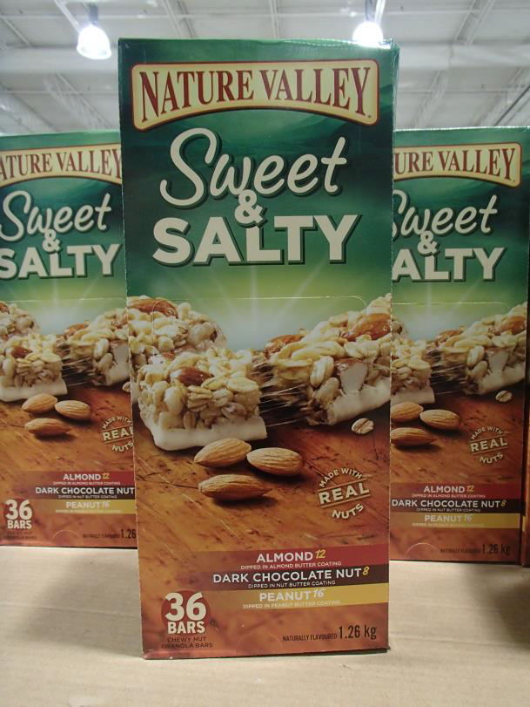**Many factories have a lunch room where employees can purchase a snack while they are at work. Usually the snack bar is run by a canteen manager. In this scenario, the canteen sells two types of granola bars:**

**Task 4: The canteen manager usually sells about 175 of the Quaker Chewy Chocolate Chip granola bars each week. How many of these boxes should they buy to stock the shelves for one week?**

Answer:

**______________________________________________________**

**Task 5: The canteen manager usually sells about 60 of the Nature Valley Sweet & Salty granola bars each week. How many of these boxes should they buy to stock the shelves for one week?**

Answer:

**______________________________________________________**

# Answers

**Task 1: Compare boxes 1 and 2. Which box has more granola bars?**

Answer: Box 1, True to Nature (24 compared to 18)

**Task 2: Compare boxes 1 and 2. Which box has more kinds of granola bars in it?**

Answer: Box 1, True to Nature (3 compared to 2)

**Task 3: Compare boxes 3 and 4. If both boxes of granola bars are the same price, which box is the better deal?**

Answer: Box 3, Quaker Harvest (10 bars compared to 8)

**Many factories have a lunch room where employees can purchase a snack while they are at work. Usually the snack bar is run by a canteen manager. In this scenario, the canteen sells two types of granola bars.**

**Task 4: The canteen manager usually sells about 175 of the Quaker Chewy Chocolate Chip granola bars each week. How many of these boxes should they buy to stock the shelves for one week?**

Answer:

175 ÷ 48 = 3.65

They would need to buy 4 boxes.

**Task 5: The canteen manager usually sells about 60 of the Nature Valley Sweet & Salty granola bars each week. How many of these boxes should they buy to stock the shelves for one week?**

Answer:

60 ÷ 36 = 1.67

They would need to buy 2 boxes.

# Performance Descriptors

| Levels | Performance Descriptors | Needs Work | Completes task with support from practitioner | Completes task independently |
| --- | --- | --- | --- | --- |
| C4.1 | adds, subtracts, multiplies and divides whole numbers and decimals |  |  |  |
|  | identifies and compares quantities of items |  |  |  |
|  | identifies and performs required operation |  |  |  |
|  | makes simple estimates |  |  |  |
|  | interprets and represents values using whole numbers, decimals, percentages and simple, common fractions (e.g. ½, ¼) |  |  |  |
|  | follows apparent steps to reach solutions |  |  |  |
|  | uses strategies to check accuracy (e.g. estimating, using a calculator, repeating a calculation, using the reverse operation) |  |  |  |

This task: Was successfully completed Needs to be tried again

Learner Comments:

Instructor (print): Learner (print):

**__________________ _________________**