

Task Title: Convert Fractions to Decimals on a Timesheet

# OALCF Cover Sheet – Practitioner Copy

**Learner Name: __________________________________________**

**Date Started: ___________________________________________**

**Date Completed: _________________________________________**

|  |  |  |
| --- | --- | --- |
| **Goal Path:** | Employment | Apprenticeship |
| Secondary School | Post Secondary | Independence |

**Successful Completion:**  Yes No

**Task Description:** The learner will convert fractions of hours to decimals on a timesheet.

**Main Competency/Task Group/Level Indicator:**

* Understand and Use Numbers/Manage time/C2.2

**Materials Required:**

* Pen/pencil and paper and/or digital device
* Calculator or digital device with calculator function

# Learner Information

Employees often have to complete their own timesheets. Often the time worked needs to be recorded in decimal format rather than in fractions so this can be entered into a computer program by the payroll clerk.

Scan the **“Howie’s Restaurant Employee Time Sheet”**.

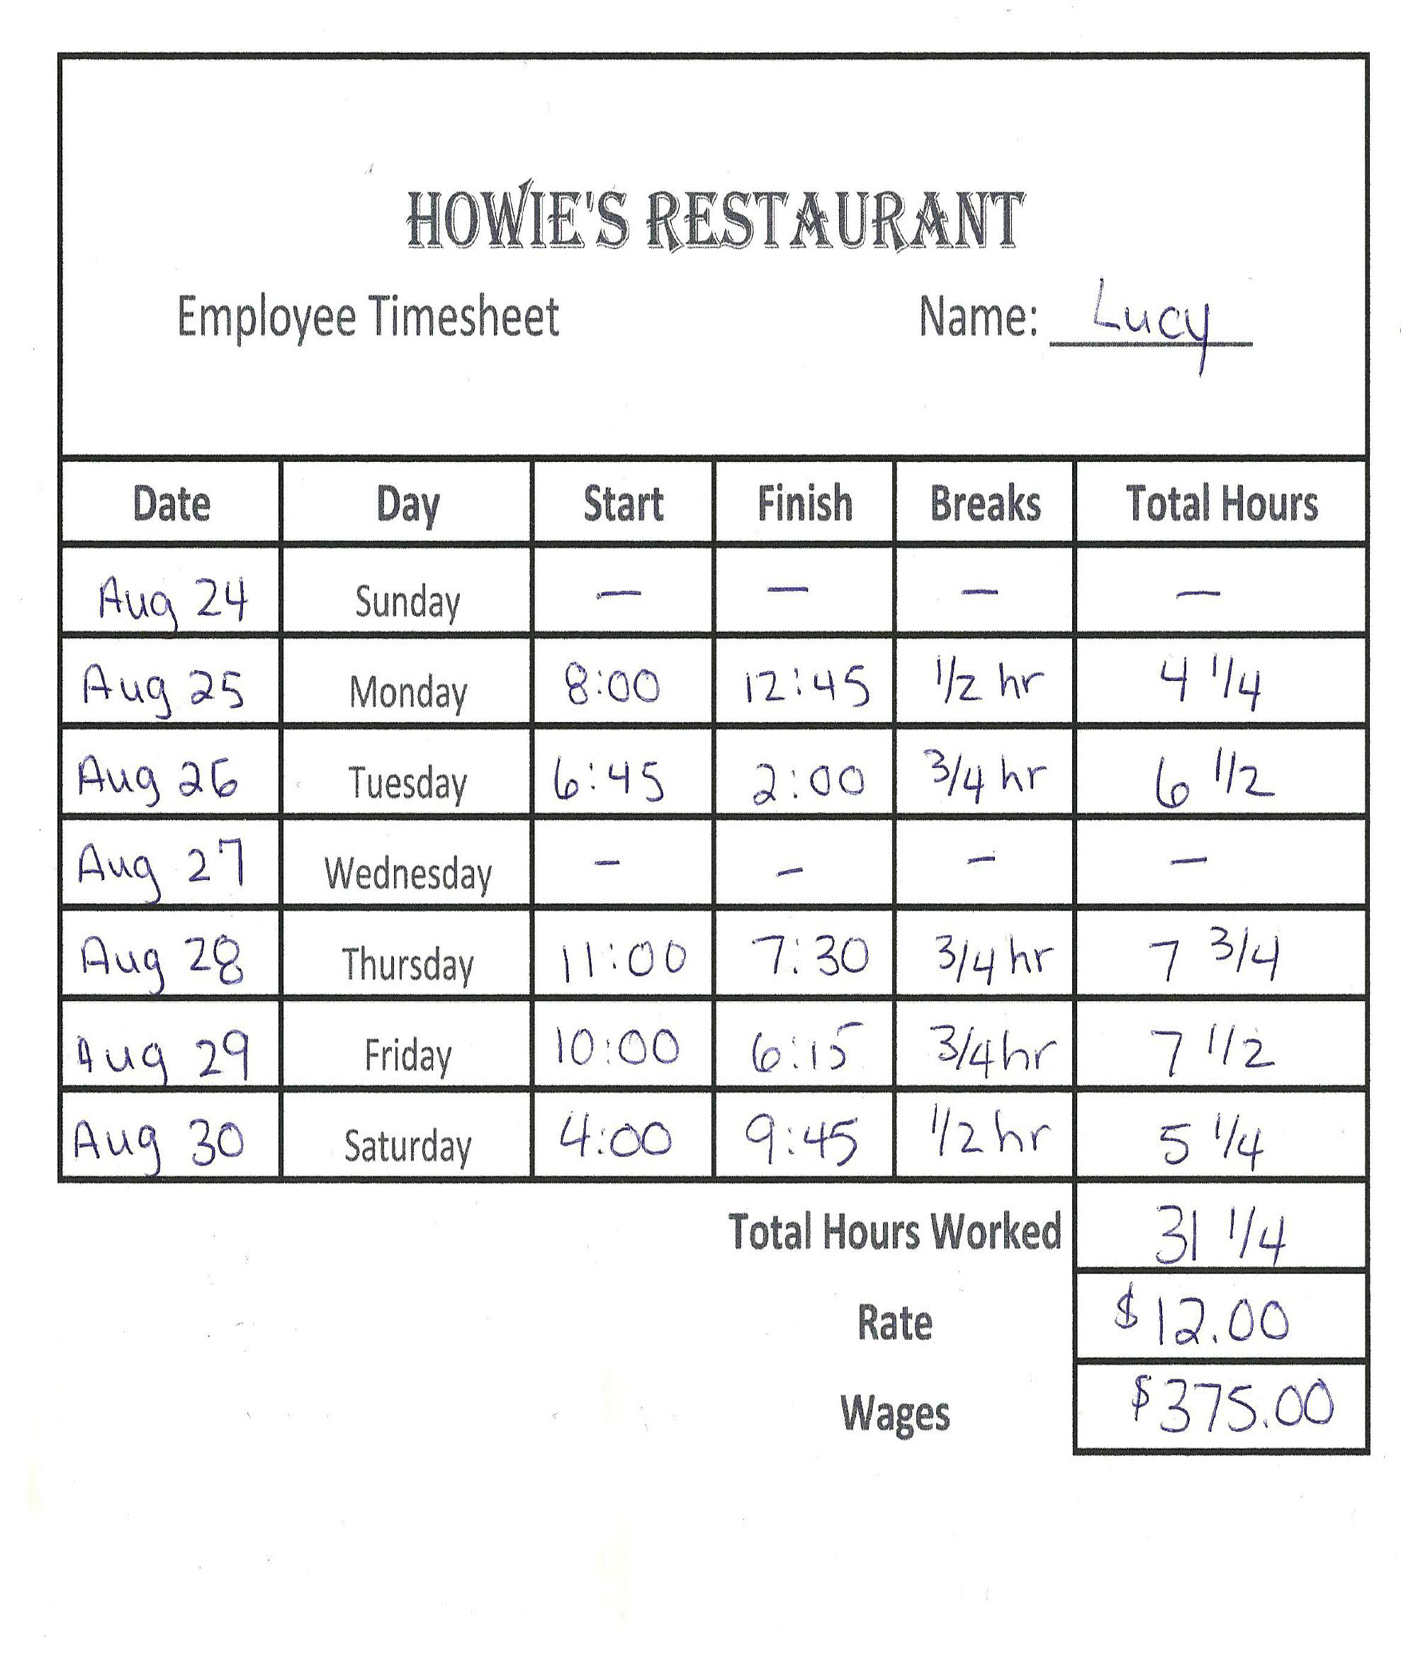

# Work Sheet

**Task 1: Convert the hours spent on breaks on Monday, August 25th to a decimal.**

Answer:

**______________________________________________________**

**Task 2: Convert the total hours worked on Thursday, August 28th to a decimal.**

Answer:

**______________________________________________________**

**Task 3: Convert the total hours worked on Friday, August 29th to a decimal.**

Answer:

**______________________________________________________**

**Task 4: Lucy made a mistake and on Tuesday, August 26th worked until 2:15. Calculate her total hours worked less time spent on breaks and convert your final number to a decimal.**

Answer:

**______________________________________________________**

# Answers

**Task 1: Convert the hours spent on breaks on Monday, August 25th to a decimal.**

Answer: 0.5 hours (1/2 = 1 divided by 2 = 0.5 hours)

**Task 2: Convert the total hours worked on Thursday, August 28th to a decimal.**

Answer: 7.75 hours (7 ¾ = 7 + (3 divided by 4) = 7 + .75 = 7.75 hours)

**Task 3: Convert the total hours worked on Friday, August 29th to a decimal.**

Answer: 7.5 hours (1/2 = 1 divided by 2 = .5 hours so 7 ½ = 7.5 hours)

**Task 4: Lucy made a mistake and on Tuesday, August 26th worked until 2:15. Calculate her total hours worked less time spent on breaks and convert your final number to a decimal.**

Answer: 6:45 am to 2:15 pm = 7 ½ hrs – ¾ hr = 7.5 - .75 = 6.75 hr

# Performance Descriptors

| Levels | Performance Descriptors | Needs Work | Completes task with support from practitioner | Completes task independently |
| --- | --- | --- | --- | --- |
| C2.2 | calculates using numbers expressed as whole numbers, fractions, decimals and percentages |  |  |  |
|  | interprets, represents and converts time using whole numbers, decimals, percentages, ratios and simple, common fractions (e.g. ½, ¼) |  |  |  |
|  | chooses and performs required operation(s); may make inferences to identify required operation(s) |  |  |  |
|  | uses strategies to check accuracy (e.g. estimating, using a calculator, repeating a calculation, using the reverse operation) |  |  |  |

This task: Was successfully completed Needs to be tried again

Learner Comments:

Instructor (print): Learner (print):

**__________________ _________________**

Skill Building Activities

**Links to Online Resources:**

LearningHUB math courses including:

* Everyday Life Math Courses
* Math Foundations 1: Decimals and Fractions
* Math Foundations 2: More Fractions

<https://www.learninghub.ca/apps/pages/index.jsp?uREC_ID=1118749&type=d&pREC_ID=1380783>

LeaningHUB Course Catalogue: <https://www.learninghub.ca/apps/pages/coursecatalogue>

Khan Academy: Converting Between Fractions and Decimals:

<https://www.khanacademy.org/math/cc-seventh-grade-math/cc-7th-fractions-decimals/cc-7th-fracs-to-decimals/v/converting-fractions-to-decimals-ex2>