

Task Title: Doubling a Recipe

# OALCF Cover Sheet – Practitioner Copy

**Learner Name: __________________________________________**

**Date Started: ___________________________________________**

**Date Completed: _________________________________________**

|  |  |  |
| --- | --- | --- |
| **Goal Path:** | Employment | Apprenticeship |
| Secondary School | Post Secondary | Independence |

**Successful Completion:**  Yes No

**Task Description:** The learner will make calculations to double the ingredients in a recipe for macaroni and cheese.

**Main Competency/Task Group/Level Indicator:**

* Find and Use Information/Read continuous text/A1.2
* Understand and Use Numbers/Use measures/C3.2

**Materials Required:**

* Pen/pencil and paper and/or digital device
* Calculator or digital device with calculator function

# Learner Information

Sometimes you want to increase the number of portions given in a recipe. This involves calculating how much more of each ingredient you will need to double or triple a recipe.

Scan the “Baked Macaroni and Cheese Recipe” and the “Cooking Conversion Chart”.

**Baked Macaroni and Cheese Recipe**

Prep Time: 15 minutes Ready In: 45 minutes

Cook Time: 30 minutes Yield: 10 servings

Ingredients:

1 (16 oz) package of elbow macaroni

½ cup of evaporated milk 1½ cups of shredded cheese

2 eggs ½ cup grated parmesan cheese

1 (8 oz) container sour cream 1 tbsp butter

1 tsp salt 1 tbsp mustard

½ tsp black pepper

Directions:

1. Preheat oven to 350° F.
2. Bring a large pot of lightly salted water to a boil. Add pasta and cook for 8-10 minutes or until al dente; drain and rinse with cold water.
3. In a medium bowl, mix milk, eggs, sour cream, salt, and pepper.
4. Layer macaroni, cheddar cheese, and milk mixture into a 9” x 13” baking dish until it is full. Sprinkle with parmesan cheese and pour melted butter on top.
5. Bake in a preheated oven for 20 to 30 minutes or until milk mixture is done.

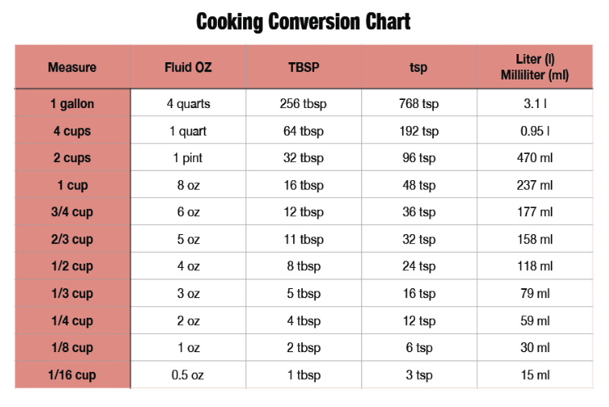

# Work Sheet

**Task 1: What oven temperature is required for this recipe?**

Answer:

**______________________________________________________**

**Task 2: What size of baking dish is required for this recipe?**

Answer:

**______________________________________________________**

**Task 3: List six ingredients required for this recipe.**

Answer:

**______________________________________________________**

**Task 4: How long should the pasta cook before you add it to the baking dish with the other ingredients?**

Answer:

**______________________________________________________**

**Task 5: You need to serve 20 people. The original recipe makes 10 servings. Calculate the new measurements for each ingredient so you can double the recipe.**

Answer:

**______________________________________________________**

**Task 6: In Canada, most products are sold in metric volumes and weights. Use the Cooking Conversion Chart to calculate the required weight of sour cream in millilitres for both the original recipe and the doubled recipe.**

Answer:

**______________________________________________________**

# Answers

**Task 1: What oven temperature is required for this recipe?**

Answer: 350° F.

**Task 2: What size of baking dish is required for this recipe?**

Answer: 9” x 13”

**Task 3: List six ingredients required for this recipe.**

Answer: Any six of:

* 1 (16 oz) package of elbow macaroni
* ½ cup of evaporated milk
* 1½ cups of shredded cheese
* 2 eggs
* ½ cup grated parmesan cheese
* 1 (8 oz) container sour cream
* 1 tbsp butter
* 1 tsp salt
* 1 tbsp mustard
* ½ tsp black pepper

**Task 4: How long should the pasta cook before you add it to the baking dish with the other ingredients?**

Answer: 8-10 minutes or until al dente.

**Task 5: You need to serve 20 people. The original recipe makes 10 servings. Calculate the new measurements for each ingredient so you can double the recipe.**

Answer: See next page

|  |  |
| --- | --- |
| **Current Recipe** | **Doubled Recipe** |
| 1 (16 oz) package of elbow macaroni | 2 packages or 32 oz of elbow macaroni |
| ½ cup of evaporated milk | 1 cup of evaporated milk |
| 1½ cups of shredded cheese | 3 cups of shredded cheese |
| 2 eggs | 4 eggs |
| ½ cup grated parmesan cheese | 1 cup of grated parmesan cheese |
| 1 (8 oz) container sour cream | 2 containers of sour cream or 16 oz |
| 1 tbsp butter | 2 tbsp butter |
| 1 tsp salt | 2 tsp salt |
| 1 tbsp mustard | 2 tbsp mustard |
| ½ tsp black pepper | 1 tsp black pepper |

**Task 6: In Canada, most products are sold in metric volumes and weights. Use the Cooking Conversion Chart to calculate the required weight of sour cream in millilitres for both the original recipe and the doubled recipe.**

Answer:

8 oz = 237ml

16 oz = 474ml (2 x 237ml)

# Performance Descriptors

| Levels | Performance Descriptors | Needs Work | Completes task with support from practitioner | Completes task independently |
| --- | --- | --- | --- | --- |
| A1.2 | scans text to locate information |  |  |  |
|  | locates multiple pieces of information in simple texts |  |  |  |
|  | follows the main events of descriptive, narrative and information texts |  |  |  |
|  | obtains information from detailed reading |  |  |  |
| C3.2 | calculates using numbers expressed as whole numbers, fractions, decimals, percentages and integers |  |  |  |
|  | converts units of measurement within the same system and between systems |  |  |  |

This task: Was successfully completed Needs to be tried again

Learner Comments:

Instructor (print): Learner (print):

**__________________ _________________**