

Task Title: Financing a Cell Phone

# OALCF Cover Sheet – Practitioner Copy

**Learner Name: __________________________________________**

**Date Started: ___________________________________________**

**Date Completed: _________________________________________**

|  |  |  |
| --- | --- | --- |
| **Goal Path:** | Employment | Apprenticeship |
| Secondary School | Post Secondary | Independence |

**Successful Completion:**  Yes No

**Task Description:** Compare cell phone purchase costs and monthly plans to determine the best option.

**Main Competency/Task Group/Level Indicator:**

* Find and Use Information/Read continuous text/A1.2
* Communicate Ideas and Information/Complete and create documents/B3.2a
* Understand and Use Numbers/Manage money/C1.3

**Materials Required:**

* Pen/pencil and paper and/or digital device
* Calculator or digital device with calculator function

# Learner Information

Comparing cell phone purchase options and monthly plans can help save money and budget monthly costs.

Scan “Rogers Cell Phone Offers March 2025” and “Rogers 5G Monthly Phone Plan Options”.

**Rogers Cell Phone Offers March 2025**

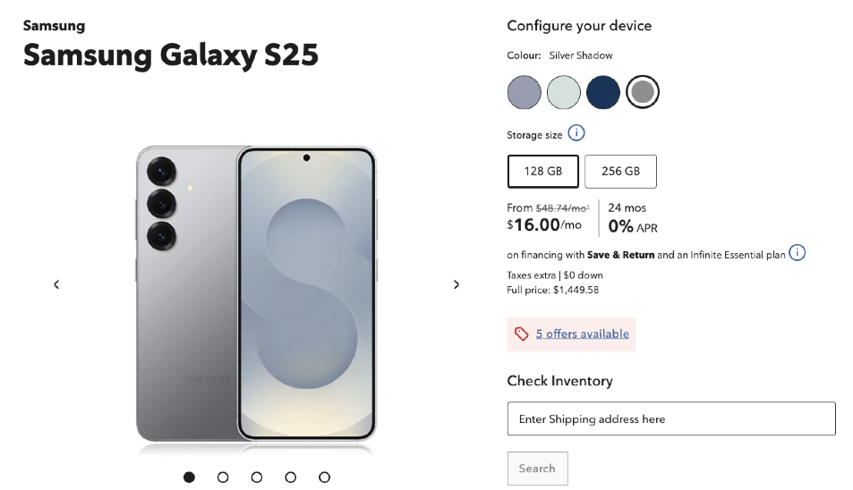

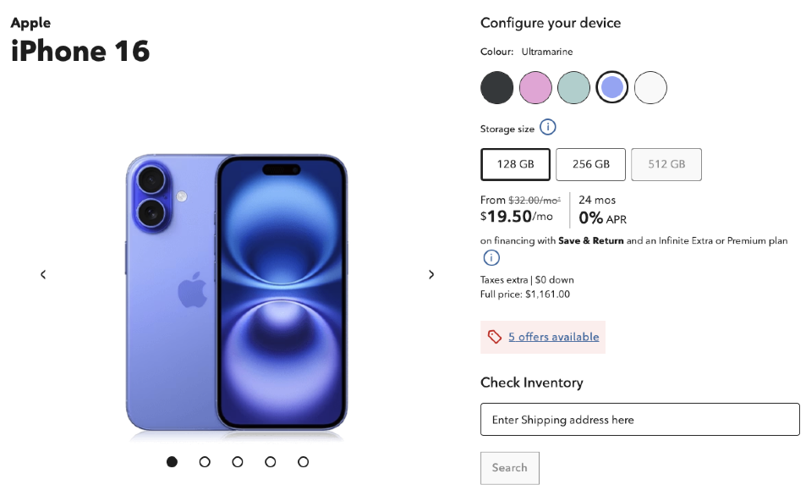

# 

**Rogers 5G Monthly Phone Plan Options**

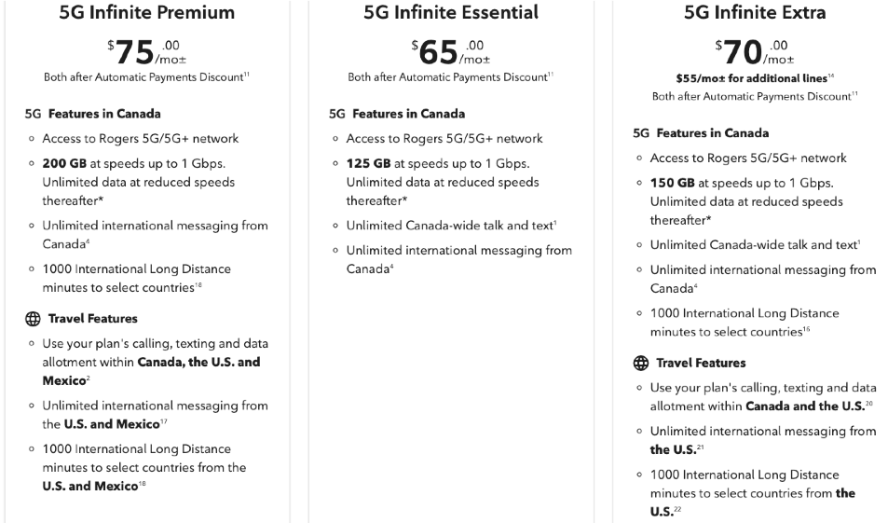

# Work Sheet

**Task 1: Complete the chart to see the total cost of buying each phone at full price compared to paying for it over 24 months. Determine the least expensive option for each phone. Both full price and monthly charges will have 13% HST added.**

Answer:

|  |  |  |  |
| --- | --- | --- | --- |
| **Phone Type** | **Full Price Purchase** | **Total Purchase Price over 24-Months** | **Least Expensive Option [Full Price Purchase or 24-Month Purchase]** |
| **Samsung Galaxy S25** |  |  |  |
| **Apple iPhone 16** |  |  |  |
| **Google Pixel 9 Pro** |  |  |  |

**Task 2: Which phone is the least expensive when purchased at full price?**

Answer:

**______________________________________________________**

**Task 3: Which phone is the least expensive when purchased over 24-months?**

Answer:

**______________________________________________________**

**Task 4: Complete the chart to determine the total monthly cost for each phone if it is purchased using a 24-month payment plan and monthly costs are determined by the 5G Infinite Essential Phone Plan. Both the monthly phone cost and monthly phone plan will have 13% HST added.**

Answer:

|  |  |  |  |
| --- | --- | --- | --- |
| **Phone Payment** | **Monthly Cost of Phone on 24-Month Payment Plan** | **Monthly Cost of 5G Infinite Essential Phone Plan** | **Total Monthly Cost** |
| **Samsung Galaxy S25** |  |  |  |
| **Apple iPhone 16** |  |  |  |
| **Google Pixel 9 Pro** |  |  |  |

**Task 5: Which phone has the lowest monthly cost?**

Answer:

**______________________________________________________**

# Answers

**Task 1: Complete the chart to see the total cost of buying each phone at full price compared to paying for it over 24 months. Determine the least expensive option for each phone. Both full price and monthly charges will have 13% HST added.**

Answer:

|  |  |  |  |
| --- | --- | --- | --- |
| **Phone Type** | **Full Price Purchase** | **Total Purchase Price over 24-months** | **Least Expensive Option [Full Price Purchase or 24-Month Purchase]** |
| **Samsung Galaxy S25** | $1,449.58 + $188.45 (13%) = $1,630.03 | $16.00 + $2.08 (13%) = $18.08/month x 24 = $433.92 | 24-month purchase |
| **Apple iPhone 16** | $1,161.00 + $150.93 (13%) = $1,311.93 | $19.50 + $2.54 (13%) = $22.04/month x 24 = $528.84 | 24-month purchase |
| **Google Pixel 9 Pro** | $1,580.00 + $205.40 (13%) = $1,785.40 | $15.00 + $1.95 (13%) = $16.95/month x 24 = $406.80 | 24-month purchase |

**Task 2: Which phone is the least expensive when purchased at full price?**

Answer: Apple iPhone 16

**______________________________________________________**

**Task 3: Which phone is the least expensive when purchased over 24-months?**

Answer: Google Pixel 9 Pro

**______________________________________________________**

**Task 4: Complete the chart to determine the total monthly cost for each phone if it is purchased using a 24-month payment plan and monthly costs are determined by the 5G Infinite Essential Phone Plan. Both the monthly phone cost and monthly phone plan will have 13% HST added.**

Answer:

|  |  |  |  |
| --- | --- | --- | --- |
| **Phone Payment** | **Monthly Cost of phone on 24-month payment plan** | **Monthly Cost of 5G Infinite Essential Phone Plan** | **Total Monthly Cost** |
| **Samsung Galaxy S25** | $16.00 + $2.08 (13%) = $18.08/month | $65.00 + $8.45 (13%) = $73.45/month | $18.08 + $73.45 = $91.53/month |
| **Apple iPhone 16** | $19.50 + $2.54 (13%) = $22.04/month | $65.00 + $8.45 (13%) = $73.45/month | $22.04 + $73.45 = $95.49/month |
| **Google Pixel 9 Pro** | $15.00 + $1.95 (13%) = $16.95/month | $65.00 + $8.45 (13%) = $73.45/month | $16.95 + $73.45 = $90.40/month |

**Task 5: Which phone has the lowest monthly cost?**

Answer: Google Pixel 9 Pro

**______________________________________________________**

# Performance Descriptors

| Levels | Performance Descriptors | Needs Work | Completes task with support from practitioner | Completes task independently |
| --- | --- | --- | --- | --- |
| A1.2 | scans text to locate information |  |  |  |
|  | locates multiple pieces of information in simple texts |  |  |  |
|  | makes low-level inferences |  |  |  |
|  | begins to identify sources and evaluate information |  |  |  |
| B3.2a | uses layout to determine where to make entries |  |  |  |
|  | begins to make some inferences to decide what is needed, where and how to enter the information |  |  |  |
|  | makes entries using a limited range of vocabulary |  |  |  |
|  | follows instructions on documents |  |  |  |
| C1.3 | calculates using numbers expressed as whole numbers, fractions, decimals, percentages and integers |  |  |  |
|  | manages unfamiliar elements (e.g. context, content) to complete the task |  |  |  |
|  | chooses and performs required operations; makes inferences to identify operations |  |  |  |
|  | selects appropriate steps to reach solutions from among options |  |  |  |
|  | identifies a variety of ways to complete the task |  |  |  |
|  | finds, integrates and analyzes numerical information |  |  |  |
|  | organizes and displays numerical information (e.g. tables, graphs) |  |  |  |
|  | uses strategies to check accuracy |  |  |  |

This task: Was successfully completed Needs to be tried again

Learner Comments:

Instructor (print): Learner (print):

**__________________ _________________**