

Task Title: Follow Directions to a Local Retail Outlet

# OALCF Cover Sheet – Practitioner Copy

**Learner Name: __________________________________________**

**Date Started: ___________________________________________**

**Date Completed: _________________________________________**

|  |  |  |
| --- | --- | --- |
| **Goal Path:** | Employment | Apprenticeship |
| Secondary School | Post Secondary | Independence |

**Successful Completion:**  Yes No

**Task Description:** Read a map to find the way to a local store.

**Main Competency/Task Group/Level Indicator:**

* Find and Use Information/Read continuous text/A1.1

**Materials Required:**

* Pen/pencil and paper and/or digital device

# Learner Information

# In many jobs, employees may be asked to go to local supply stores to pick up items instead of having them shipped. In everyday life, we often need to follow directions and maps.

Scan the map of Burlington, Ontario.

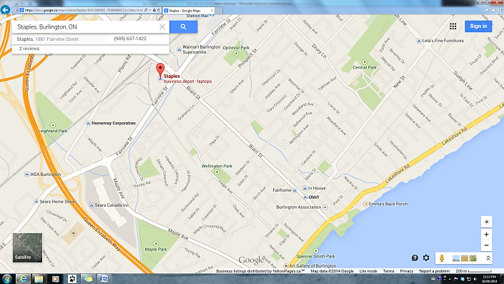

# Work Sheet

**Task 1: Find and circle the Fairhome Furniture Store at 468 Brant Street.**

Answer: No written response required here.

Task completed successfully: Yes: No:

**______________________________________________________**

**Task 2: Find and circle the Staples office supply store at 1881 Fairview Street.**

Answer: No written response required here.

Task completed successfully: Yes: No:

_____________________________________________________________

**Task 3: Use the map to find the way to Staples from the Fairhome Furniture Store. You are walking. You want to stay on major streets and walk the most direct route possible. Highlight or draw a line on the map showing your route.**

Answer: No written response required here.

Task completed successfully: Yes: No:

_____________________________________________________________

# Answers

Answers will be circled and highlighted on the map as follows:

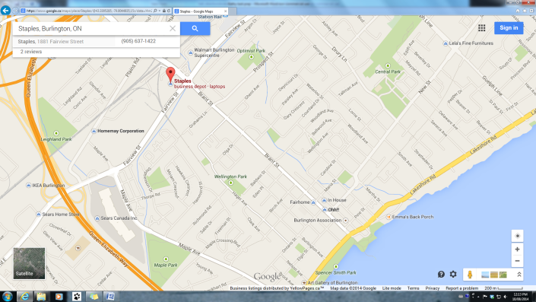

# Performance Descriptors

| Levels | Performance Descriptors | Needs Work | Completes task with support from practitioner | Completes task independently |
| --- | --- | --- | --- | --- |
| A1.1 | reads short texts to locate a single piece of information |  |  |  |
|  | decodes words and makes meaning of sentences in a single text |  |  |  |
|  | follows the sequence of events in straightforward chronological texts |  |  |  |
|  | follow simple, straightforward instructional texts |  |  |  |

This task: Was successfully completed Needs to be tried again

Learner Comments:

Instructor (print): Learner (print):

**__________________ _________________**