

Task Title: Interpret Documents to Find Electrical Information

# OALCF Cover Sheet – Practitioner Copy

**Learner Name: __________________________________________**

**Date Started: ___________________________________________**

**Date Completed: _________________________________________**

|  |  |  |
| --- | --- | --- |
| **Goal Path:** | Employment | Apprenticeship |
| Secondary School | Post Secondary | Independence |

**Successful Completion:**  Yes No

**Task Description:** Learner will interpret diagrams and read tables that are commonly used by electricians to plan their work.

**Main Competency/Task Group/Level Indicator:**

* Find and Use Information/Interpret documents/A2.2

**Materials Required:**

* Pen/pencil and paper and/or digital device

# Learner Information

Electricians interpret diagrams and read tables to plan work and complete tasks.

Scan the “Hot Water Tank Label”, “Electrical Schematic”, and “Cable Chart”.

**Hot Water Tank Label**

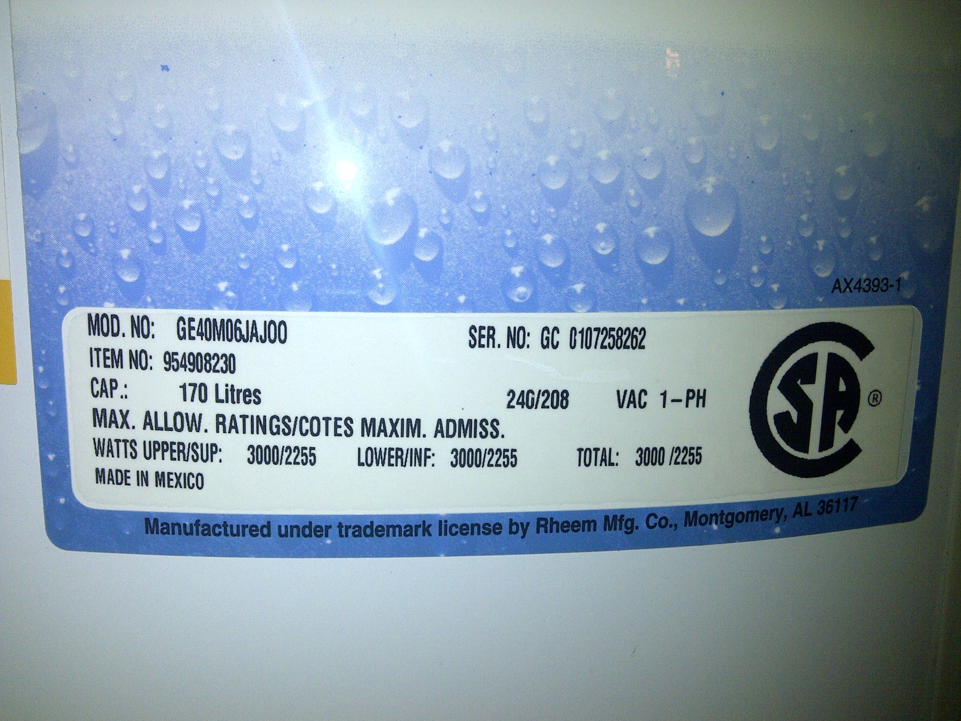

**Electrical Schematic**

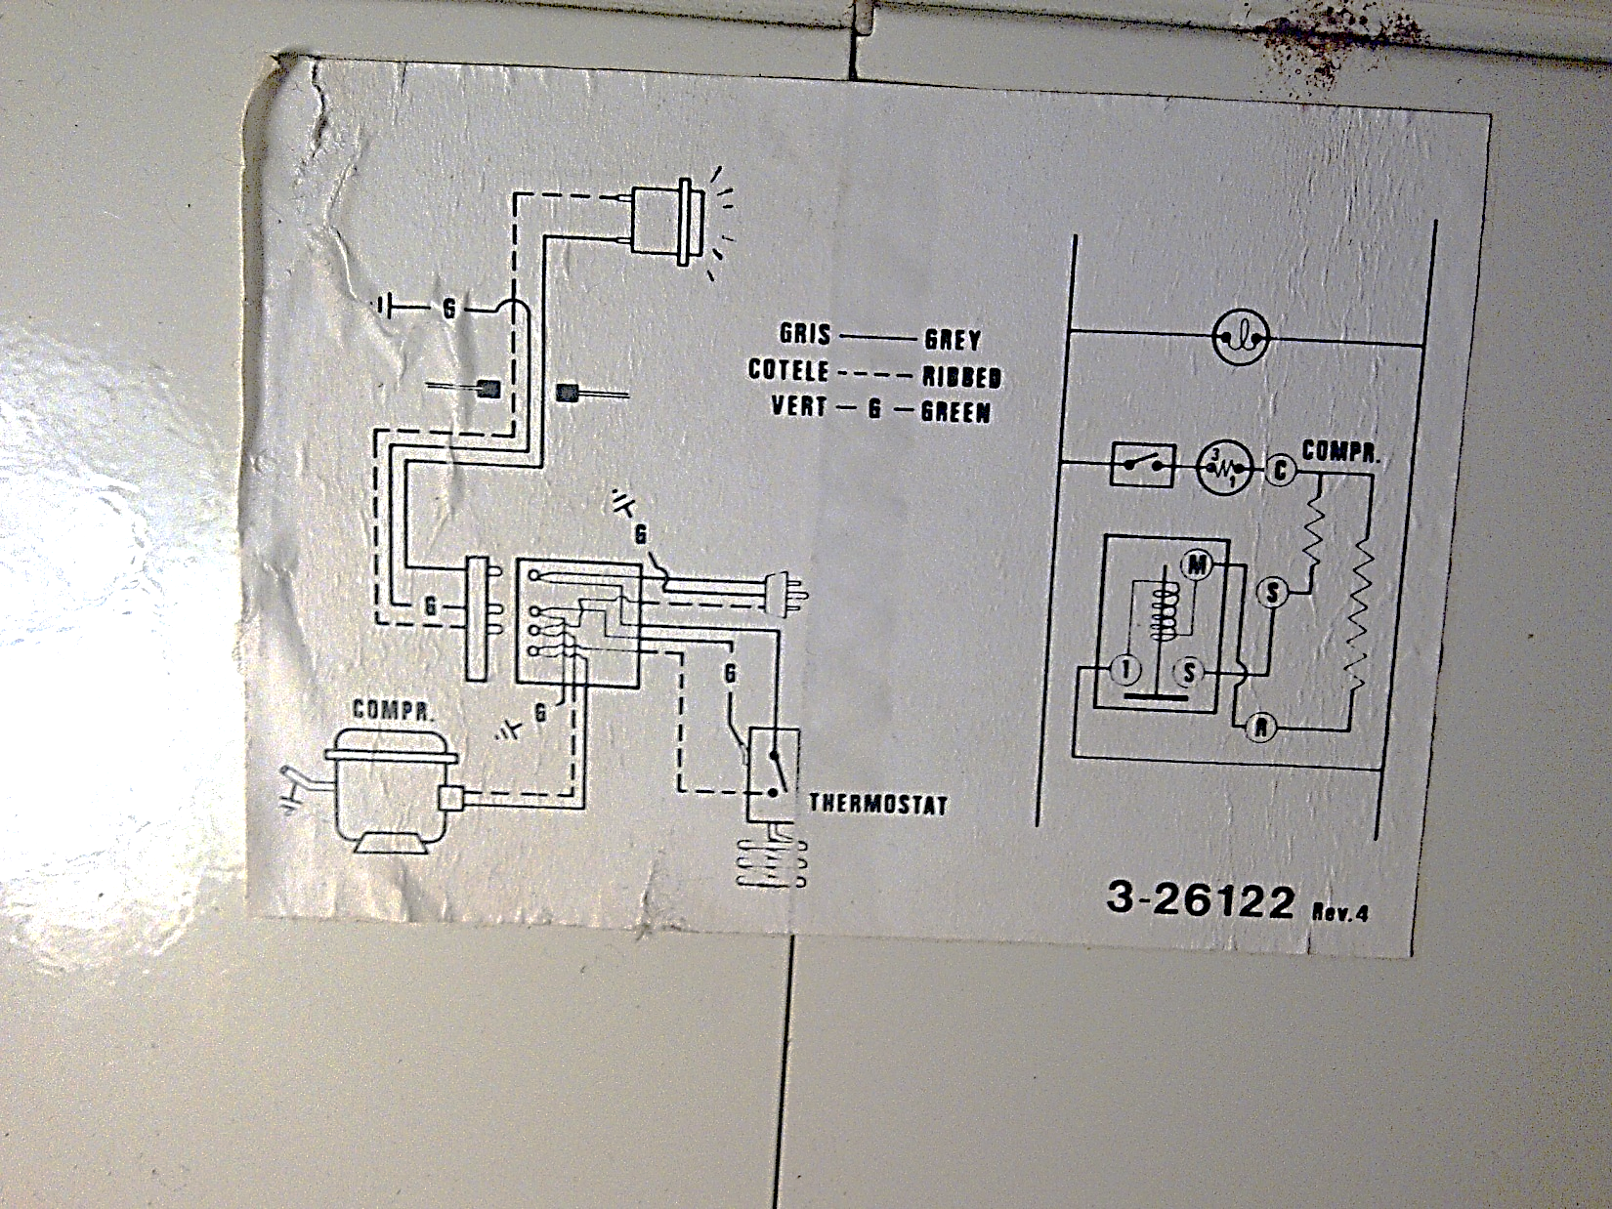

**Cable Chart**

|  |  |  |
| --- | --- | --- |
| **Code** | **No. of Wires** | **Uses** |
| #14-2 | 2 w/gnd | general lighting and receptacles |
| #14-3 | 3 w/gnd | 3-way switches, split receptacles |
| #12-2 | 2 w/gnd | kitchen and bath circuits |
| #12-3 | 3 w/gnd | 3-way switches on 20 amp services |
| #10-3 | 3 w/gnd | Dryers, cook top ovens |
| #4 |  | 70 amp services, 100 amp neutral conductor |
| #2 |  | main conductor for 100 amp services |

Code: Gauge – number of wires. For example, #14-2 means 2 14 gauge wires.

Note: w/gnd means ‘with ground wire’. In these cases, the ground wire is not included in the wire count

# Work Sheet

**Task 1: Circle, underline, or highlight the upper allowable wattage rating on the Hot Water Tank Label. If you are doing this task online, write the answer below.**

Answer:

**______________________________________________________**

**Task 2: On the Electrical Schematic, how many wires are required for the thermostat to function?**

Answer:

**______________________________________________________**

**Task 3: Use the Cable Chart to determine the minimum requirements. Identify the cable by its code.**

1. **The cable to supply a dryer.**

Answer:

1. **The cable to provide 100 amp service to a home.**

Answer:

**c) The 3-wire cable that is required to connect 2 switches (one on main floor and the other on the second) to a light over the stairs.**

Answer:

**______________________________________________________**

# Answers

**Task 1: Circle, underline, or highlight the upper allowable wattage rating on the Hot Water Tank Label. If you are doing this task online, write the answer below.**

Answer: 3000/2225

**Task 2: On the Electrical Schematic, how many wires are required for the thermostat to function?**

Answer: 3

**Task 3: Use the Cable Chart to determine the minimum requirements. Identify the cable by its code.**

**a) The cable to supply a dryer.**Answer: #10-3

**b) The cable to provide 100 amp service to a home.**Answer: #2

**c) The 3-wire cable that is required to connect 2 switches (one on main floor and the other on the second) to a light over the stairs.**

Answer: #14-3

# Performance Descriptors

| Levels | Performance Descriptors | Needs Work | Completes task with support from practitioner | Completes task independently |
| --- | --- | --- | --- | --- |
| A2.2 | performs limited searches using one or two search criteria |  |  |  |
|  | extracts information from tables and forms |  |  |  |
|  | uses layout to locate information |  |  |  |
|  | makes low-level inferences |  |  |  |

This task: Was successfully completed Needs to be tried again

Learner Comments:

Instructor (print): Learner (print):

**__________________ _________________**