

Task Title: Interpret Electrical Measuring Equipment Readings

# OALCF Cover Sheet – Practitioner Copy

**Learner Name: __________________________________________**

**Date Started: ___________________________________________**

**Date Completed: _________________________________________**

|  |  |  |
| --- | --- | --- |
| **Goal Path:** | Employment | Apprenticeship |
| Secondary School | Post Secondary | Independence |

**Successful Completion:**  Yes No

**Task Description:** The learner will find and interpret information about electrical measuring equipment and processes.

**Main Competency/Task Group/Level Indicator:**

* Find and Use Information/Read continuous text/A1.3
* Find and Use Information/Interpret documents/A2.2
* Find and Use Information/Extract info from films, broadcasts and presentations/A3
* Understand and Use Numbers/Use measures/C3.1
* Use Digital Technology/D.1

**Materials Required:**

* Pen/pencil and paper
* Computer or digital device

# Learner Information

Electricians use electrical measuring equipment to test systems and components. They use the readings to determine if a component needs to be replaced, if a system has been safely shut down (lock out and tag out), and to determine the voltage, amperage, and wattage of systems and components.

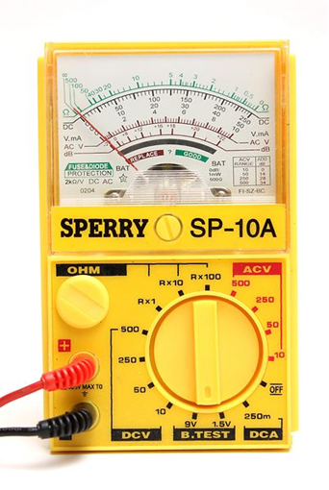Scan the “Multimeter Images”.

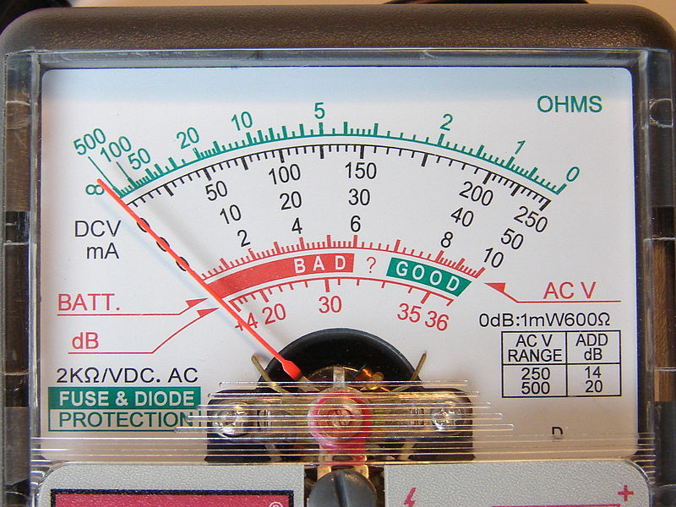

# Work Sheet

**Task 1a: What colour is used to measure the ohms of a circuit?**

Answer:

_____________________________________________________________

**Task 1b: Circle on the picture where the meter setting dial should be set to measure a 9 Volt battery.**

Answer: No written response required here.

Task completed: Yes:

_____________________________________________________________

**Task 1c: Electricians always set the meter slightly higher than the expected voltage being measured. Circle on the picture where the dial should be set to measure a 240 volt AC circuit.**

Answer: No written response required here.

Task completed: Yes:

_____________________________________________________________

**Task 1d: Batteries are considered in working order at 70% voltage or better. A 9 Volt battery reading shows the needle at about 43%. In what range will the needle point?**

Answer:

**______________________________________________________**

Go to the Lockout/Tag out page on the Canadian Centre for Occupational Health and Safety website: <http://www.ccohs.ca/oshanswers/hsprograms/lockout.html>

**Task 2a: List three key pieces of information to be included on a tag?**

Answer:

_____________________________________________________________

**Task 2b: An electrician uses a voltmeter to ensure the power to a circuit is safe to complete the lock out/tag out procedure. Explain what the voltage reading should be and why this is the case.**

Answer:

**______________________________________________________**

Watch this video about using digital and analog ohmmeters: <http://www.youtube.com/watch?v=ocvaqGzvE2I>

**Task 3a: How does an electrician test the ohmmeter to be sure it is working?**

Answer:

_____________________________________________________________

**Task 3b: How does an electrician ‘zero’ out the analog ohmmeter?**

Answer:

_____________________________________________________________

**Task 3c: Using a meter reading at the two terminals, how do you know if a stove element is working?**

Answer:

_____________________________________________________________

**Task 3d: Draw a line to the dial to be used when ‘zeroing’ this analog meter.**

Answer: No written response required here.

Task completed: Yes:

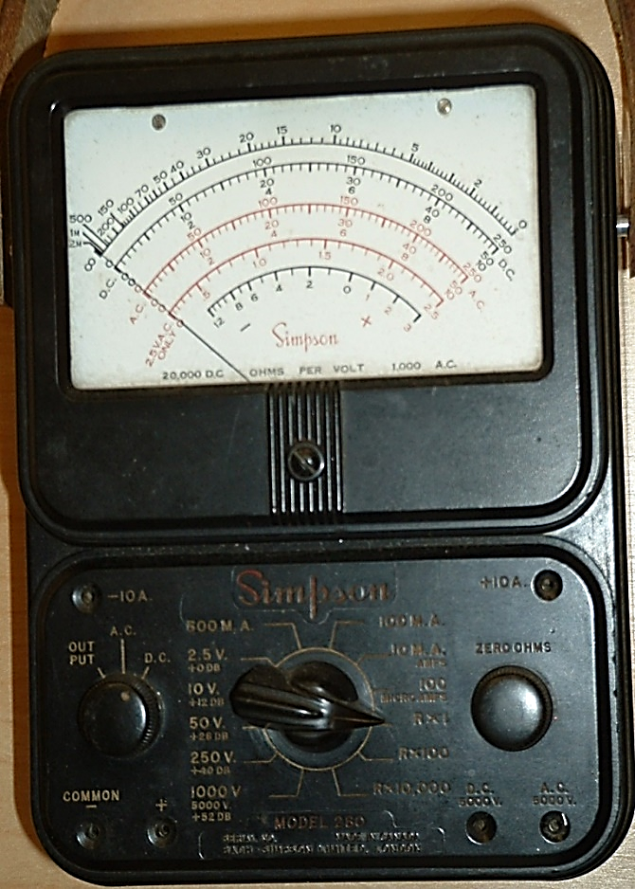

Answers

**Task 1a: What colour is used to measure the ohms of a circuit?**

Answer: Green

**Task 1b: Circle on the picture where the meter setting dial should be set to measure a 9 Volt battery.**



Answer: 9 V (green circle)

**Task 1c: Electricians always set the**

**meter slightly higher than the expected**

**voltage being measured. Circle on the**

**picture where the dial should be set to**

**measure a 240 volt AC circuit.**

Answer: 250 (blue circle)

**Task 1d: Batteries are considered in working order at 70% voltage or better. A 9 Volt battery reading shows the needle at about 43%. In what range will the needle point?**

Answer: Depending on which sensor image the learner views, the needle will either point to “Replace” or “Bad” range. Either answer is acceptable.

_____________________________________________________________

Go to the Lockout/Tag out page on the Canadian Centre for Occupational Health and Safety website: <http://www.ccohs.ca/oshanswers/hsprograms/lockout.html>

**Task 2a: List three key pieces of information to be included on a tag?**

Answer:

* Why the lockout/tag out is required (repair, maintenance, etc.).
* Time of application of the lock/tag.
* The name of the authorized person who attached the tag and lock to the system.

**Task 2b: An electrician uses a voltmeter to ensure the power to a circuit is safe to complete the lock out/tag out procedure. Explain what the voltage reading should be and why this is the case.**

Answers may vary but should be similar to: The reading should show 0 volts. This has to be the reading because there should not be any electrical power at the lock out/tag out site. This is for safety reasons.

_____________________________________________________________

Watch this video about using digital and analog ohmmeters: <http://www.youtube.com/watch?v=ocvaqGzvE2I>

**Task 3a: How does an electrician test the ohmmeter to be sure it is working?**

Answer: Turn the meter to the lowest setting. Place the two leads across the switch. The ohmmeter should go to 0.

**Task 3b: How does an electrician ‘zero’ out the analog ohmmeter?**

Answer: Touch the two leads together and adjust the dial until the ohmmeter reaches 0 ohms. Then take the leads and place them across the thermostat. It should go to zero.

**Task 3c: Using a meter reading at the two terminals, how do you know if a stove element is working?**

Answer: The ohmmeter should display some value if the stove element is working.

**Task 3d: Draw a line to the dial to be used when ‘zeroing’ this analog meter.**

Answer:

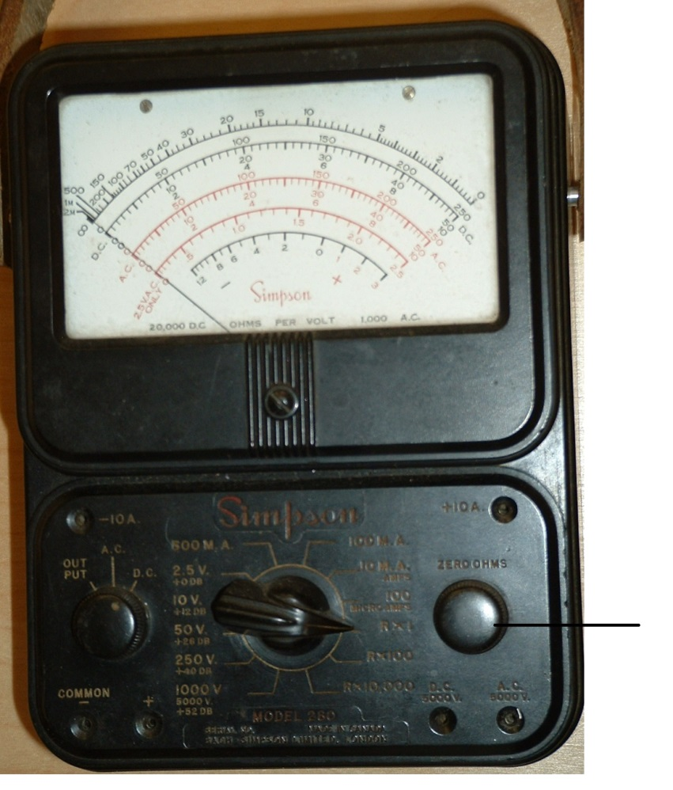

# Performance Descriptors

| Levels | Performance Descriptors | Needs Work | Completes task with support from practitioner | Completes task independently |
| --- | --- | --- | --- | --- |
| A1.3 | integrates several pieces of information from texts |  |  |  |
|  | manages unfamiliar elements (e.g. vocabulary, context, topic) to complete tasks |  |  |  |
|  | skims to get the gist of longer texts |  |  |  |
|  | infers meaning which is not explicit in texts |  |  |  |
|  | uses organizational features, such as headings, to locate information |  |  |  |
|  | follows the main events of descriptive, narrative, informational and persuasive texts |  |  |  |
|  | identifies sources, evaluates and integrates information |  |  |  |
| A2.2 | uses layout to locate information |  |  |  |
|  | makes connections between parts of documents |  |  |  |
|  | makes low-level inferences |  |  |  |
| A3 | extract information from films, broadcasts and presentations |  |  |  |
| C3.1 | recognizes values in number and word format |  |  |  |
|  | understands numerical order |  |  |  |
| D.1 | follows simple prompts |  |  |  |
|  | follow apparent steps to complete tasks |  |  |  |
|  | interprets brief text and icons |  |  |  |
|  | locates specific functions and information |  |  |  |

This task: Was successfully completed Needs to be tried again

Learner Comments:

Instructor (print): Learner (print):

**__________________ _________________**