

Task Title: Kraft Dinner Ingredients

# OALCF Cover Sheet – Practitioner Copy

**Learner Name: __________________________________________**

**Date Started: ___________________________________________**

**Date Completed: _________________________________________**

|  |  |  |
| --- | --- | --- |
| **Goal Path:** | Employment | Apprenticeship |
| Secondary School | Post Secondary | Independence |

**Successful Completion:**  Yes No

**Task Description:** The learner will examine the ingredient list on a Kraft Dinner box to track food groups and nutrients.

**Main Competency/Task Group/Level Indicator:**

* Find and Use Information/Interpret documents/A2.2
* Communicate Ideas and Information/Complete and create documents/B3.2a
* Use Digital Technology/D.2

**Materials Required:**

* Pen/pencil and paper
* Computer or digital device

# Learner Information

Ingredients on food packages may be unfamiliar. It is helpful to know what is in pre-packaged food and which food group each ingredient belongs to.

Scan the “Kraft Dinner” box and the “Ingredient Chart”.

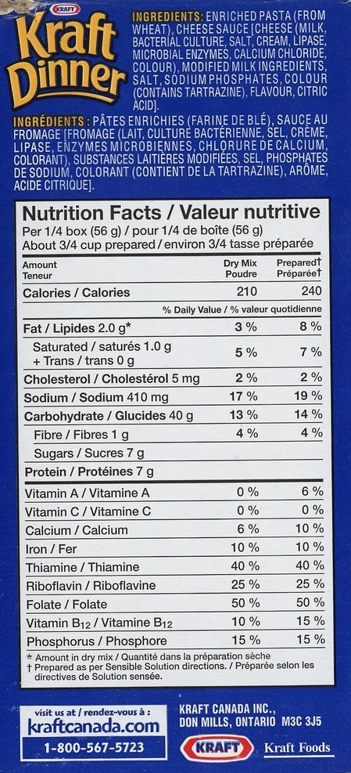

**Ingredient Chart**

| **Ingredient** | **Food Group, Nutrient Group or Purpose** | | | | | | |
| --- | --- | --- | --- | --- | --- | --- | --- |
|  | **Fruits & veg** | **Grains** | **Milk** | **Meat** | **Salt** | **Sugar** | **Other - Give Purpose** |
|  |  |  |  |  |  |  |  |
|  |  |  |  |  |  |  |  |
|  |  |  |  |  |  |  |  |
|  |  |  |  |  |  |  |  |
|  |  |  |  |  |  |  |  |
|  |  |  |  |  |  |  |  |
|  |  |  |  |  |  |  |  |
|  |  |  |  |  |  |  |  |
|  |  |  |  |  |  |  |  |
|  |  |  |  |  |  |  |  |
|  |  |  |  |  |  |  |  |
|  |  |  |  |  |  |  |  |
|  |  |  |  |  |  |  |  |
|  |  |  |  |  |  |  |  |
|  |  |  |  |  |  |  |  |
|  |  |  |  |  |  |  |  |

# Work Sheet

**Task 1: Copy the Kraft Dinner ingredients into the first column of the Ingredient Chart.**

Answer: No written response required here.

Task completed: Yes:

**______________________________________________________**

**Task 2: Beside each ingredient check the food/nutrient group that it belongs to. Put a question mark beside those ingredients you do not know.**

Answer: No written response required here.

Task completed: Yes:

**______________________________________________________**

**Task 3: Open the web browser on the computer. Conduct a search for each of the ingredients you questioned in Task 2. Complete the last column of the chart using the information you find.**

Answer: No written response required here.

Task completed: Yes:

_____________________________________________________________

# Answers

A completed chart should look similar to the following:

| **Ingredient** | **Food Group, Nutrient Group or Purpose** | | | | | | |
| --- | --- | --- | --- | --- | --- | --- | --- |
|  | **Fruits & veg** | **Grains** | **Milk** | **Meat** | **Salt** | **Sugar** | **Other - Give Purpose** |
| Enriched wheat pasta |  | ✓ |  |  |  |  |  |
| Cheese – milk |  |  | ✓ |  |  |  |  |
| Bacterial culture |  |  |  |  |  |  | Provides distinct flavouring and textural characteristics to cheese |
| Salt |  |  |  |  | ✓ |  |  |
| Cream |  |  | ✓ |  |  |  |  |
| Lipase |  |  |  |  |  |  | An enzyme added to milk to release flavour |
| Microbial enzymes |  |  |  |  |  |  | An enzyme used to coagulate milk so it can be separated into solids and liquid |
| Calcium chloride |  |  |  |  |  |  | Salt solution used in cheese making to restore the calcium balance |
| Colour |  |  |  |  |  |  | Provides colouring to the cheese |
| Modified milk ingredients |  |  | ✓ |  |  |  |  |
| Salt |  |  |  |  | ✓ |  |  |
| Sodium phosphate |  |  |  |  |  |  | Leavening agent to help the dough rise |
| Colour - tartrazine |  |  |  |  |  |  | A petroleum by product used to offset colour loss |
| Flavour |  |  |  |  |  |  | Provides flavouring for the cheese sauce |
| Citric acid |  |  |  |  |  |  | A preservative to maintain freshness and prevent food spoilage |

Performance Descriptors

| Levels | Performance Descriptors | Needs Work | Completes task with support from practitioner | Completes task independently |
| --- | --- | --- | --- | --- |
| A2.2 | performs limited searches using one or two search criteria |  |  |  |
|  | extracts information from tables and forms |  |  |  |
|  | uses layout to locate information |  |  |  |
|  | makes low-level inferences |  |  |  |
| B3.2a | uses layout to determine where to make entries |  |  |  |
|  | begins to make some inferences to decide what information is needed, where and how to enter the information |  |  |  |
| D.2 | selects and follows appropriate steps to complete tasks |  |  |  |
|  | locates and recognizes functions and commands |  |  |  |
|  | makes low-level inferences to interpret icons and text |  |  |  |
|  | begins to identify sources and evaluate information |  |  |  |
|  | performs simple searches using keywords (e.g. internet, software help menu) |  |  |  |

This task: Was successfully completed Needs to be tried again

Learner Comments:

Instructor (print): Learner (print):

**__________________ _________________**