

Task Title: Make a Grocery List

OALCF Cover Sheet – Practitioner Copy

Learner Name: __________________________________________
Date Started: ___________________________________________
Date Completed: _________________________________________

Goal Path: | Employment | Apprenticeship
Secondary School | Post Secondary | Independence
Successful Completion: Yes No

Task Description: The learner will look at a grocery store flyer and make a list of items they may need at home in the next week.
Main Competency/Task Group/Level Indicator:
- Find and Use Information/Interpret documents/Interpret documents/A2.1
- Communicate Ideas and Information/Interact with others/B1.1 OR Communicate Ideas and Information/Write continuous text/B2.1
- Communicate Ideas and Information/Complete and create documents/B3.1b
- Understand and Use Numbers/Manage money/C1.1
Materials Required:
- Pen/pencil and paper and/or digital device
- Calculator or digital device with calculator function (optional)

Learner Information
Using a grocery store flyer can help you make a weekly shopping list. You may want to purchase items you use regularly when they are on sale.
Scan the “Food Basics Grocery Flyer”.

Food Basics Grocery Flyer
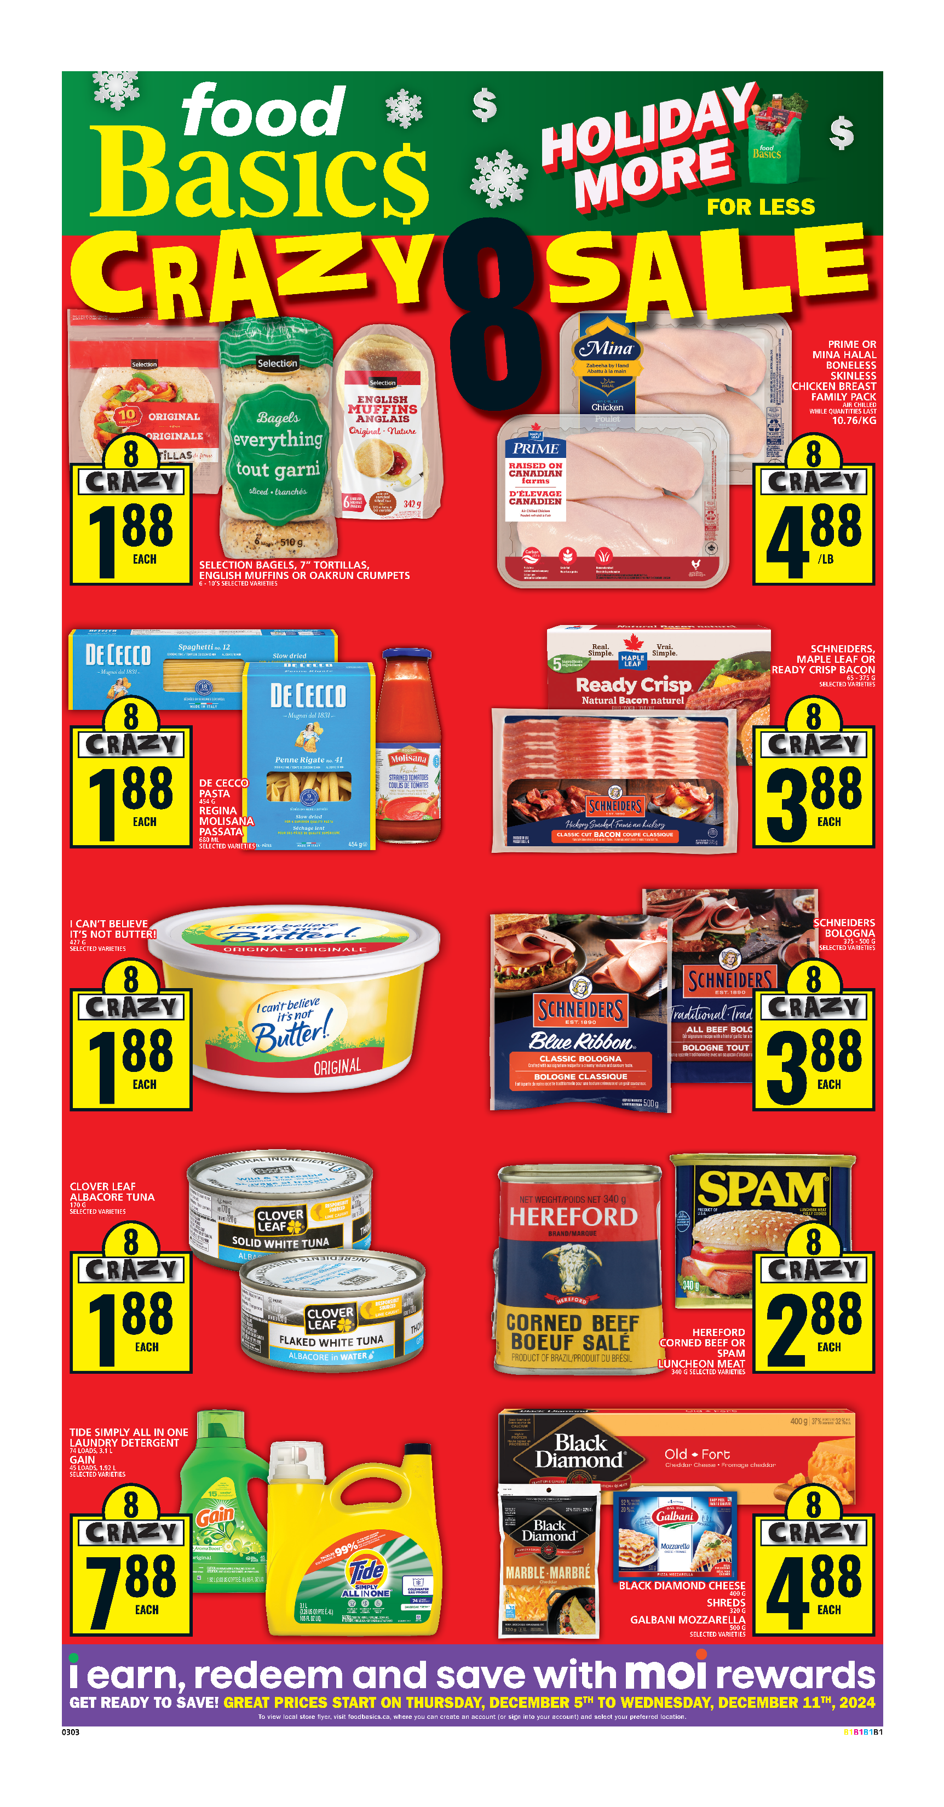
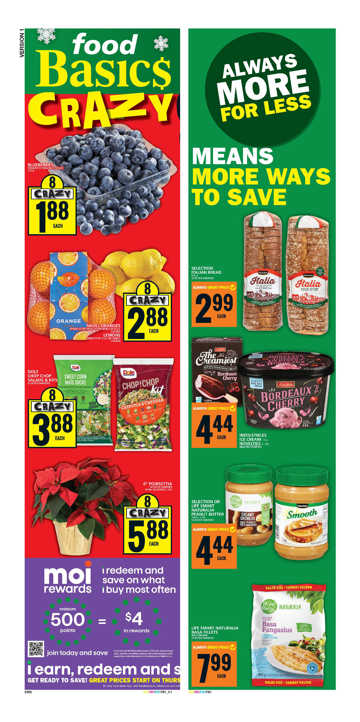

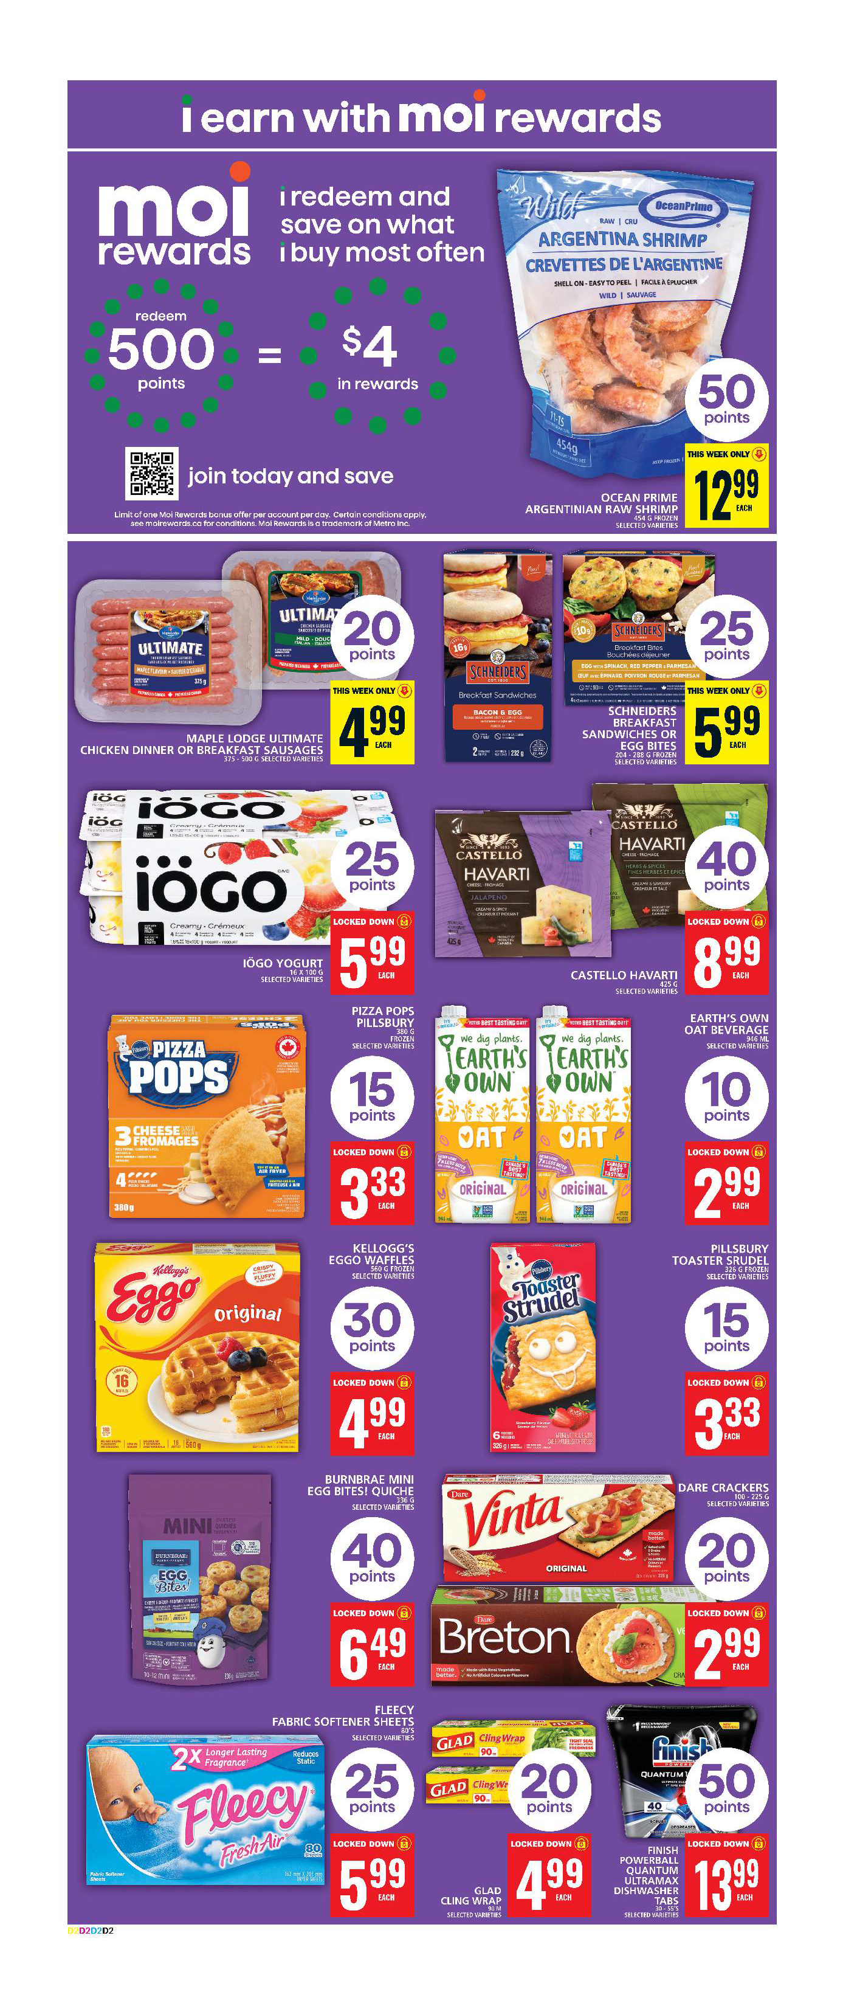
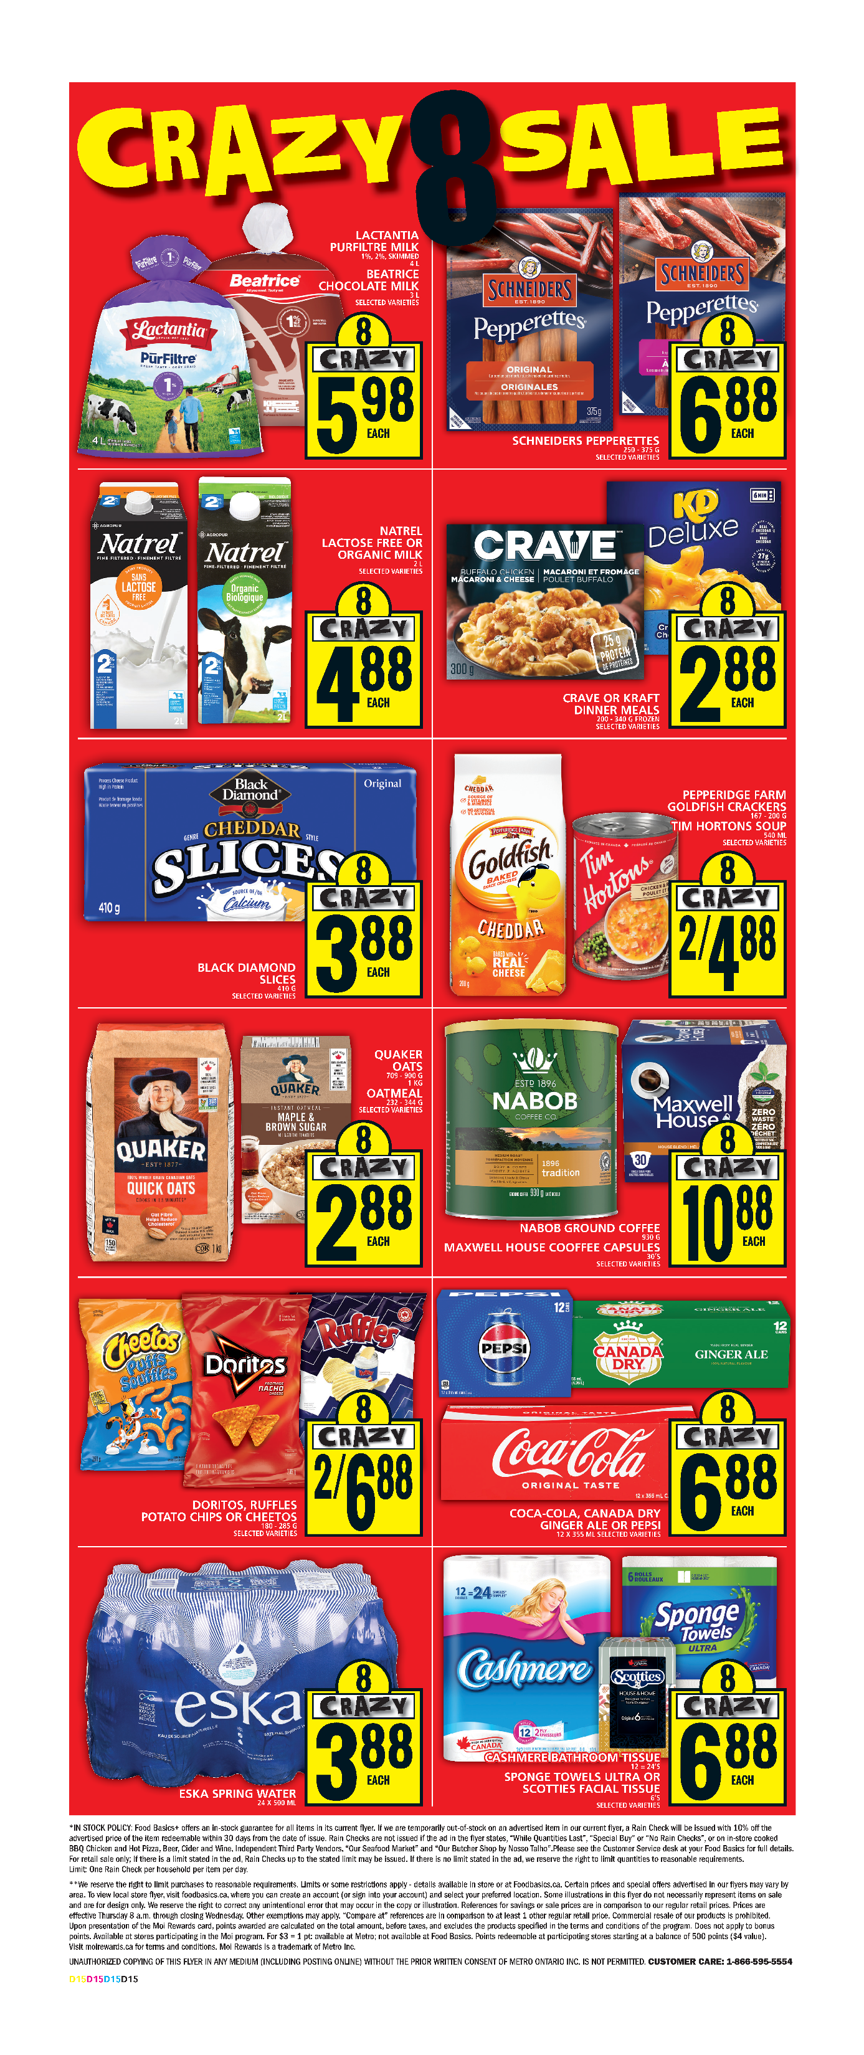

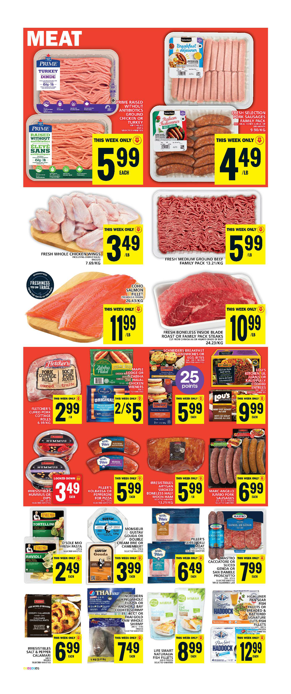
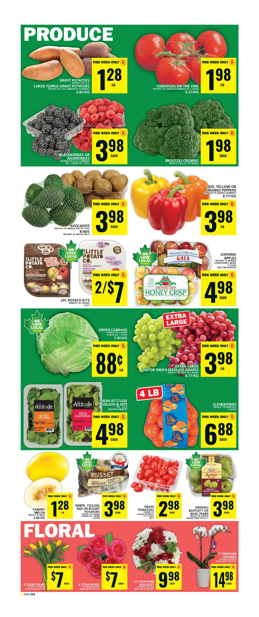

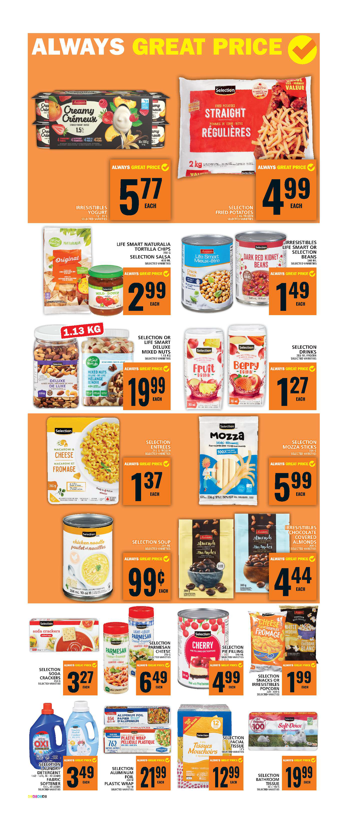
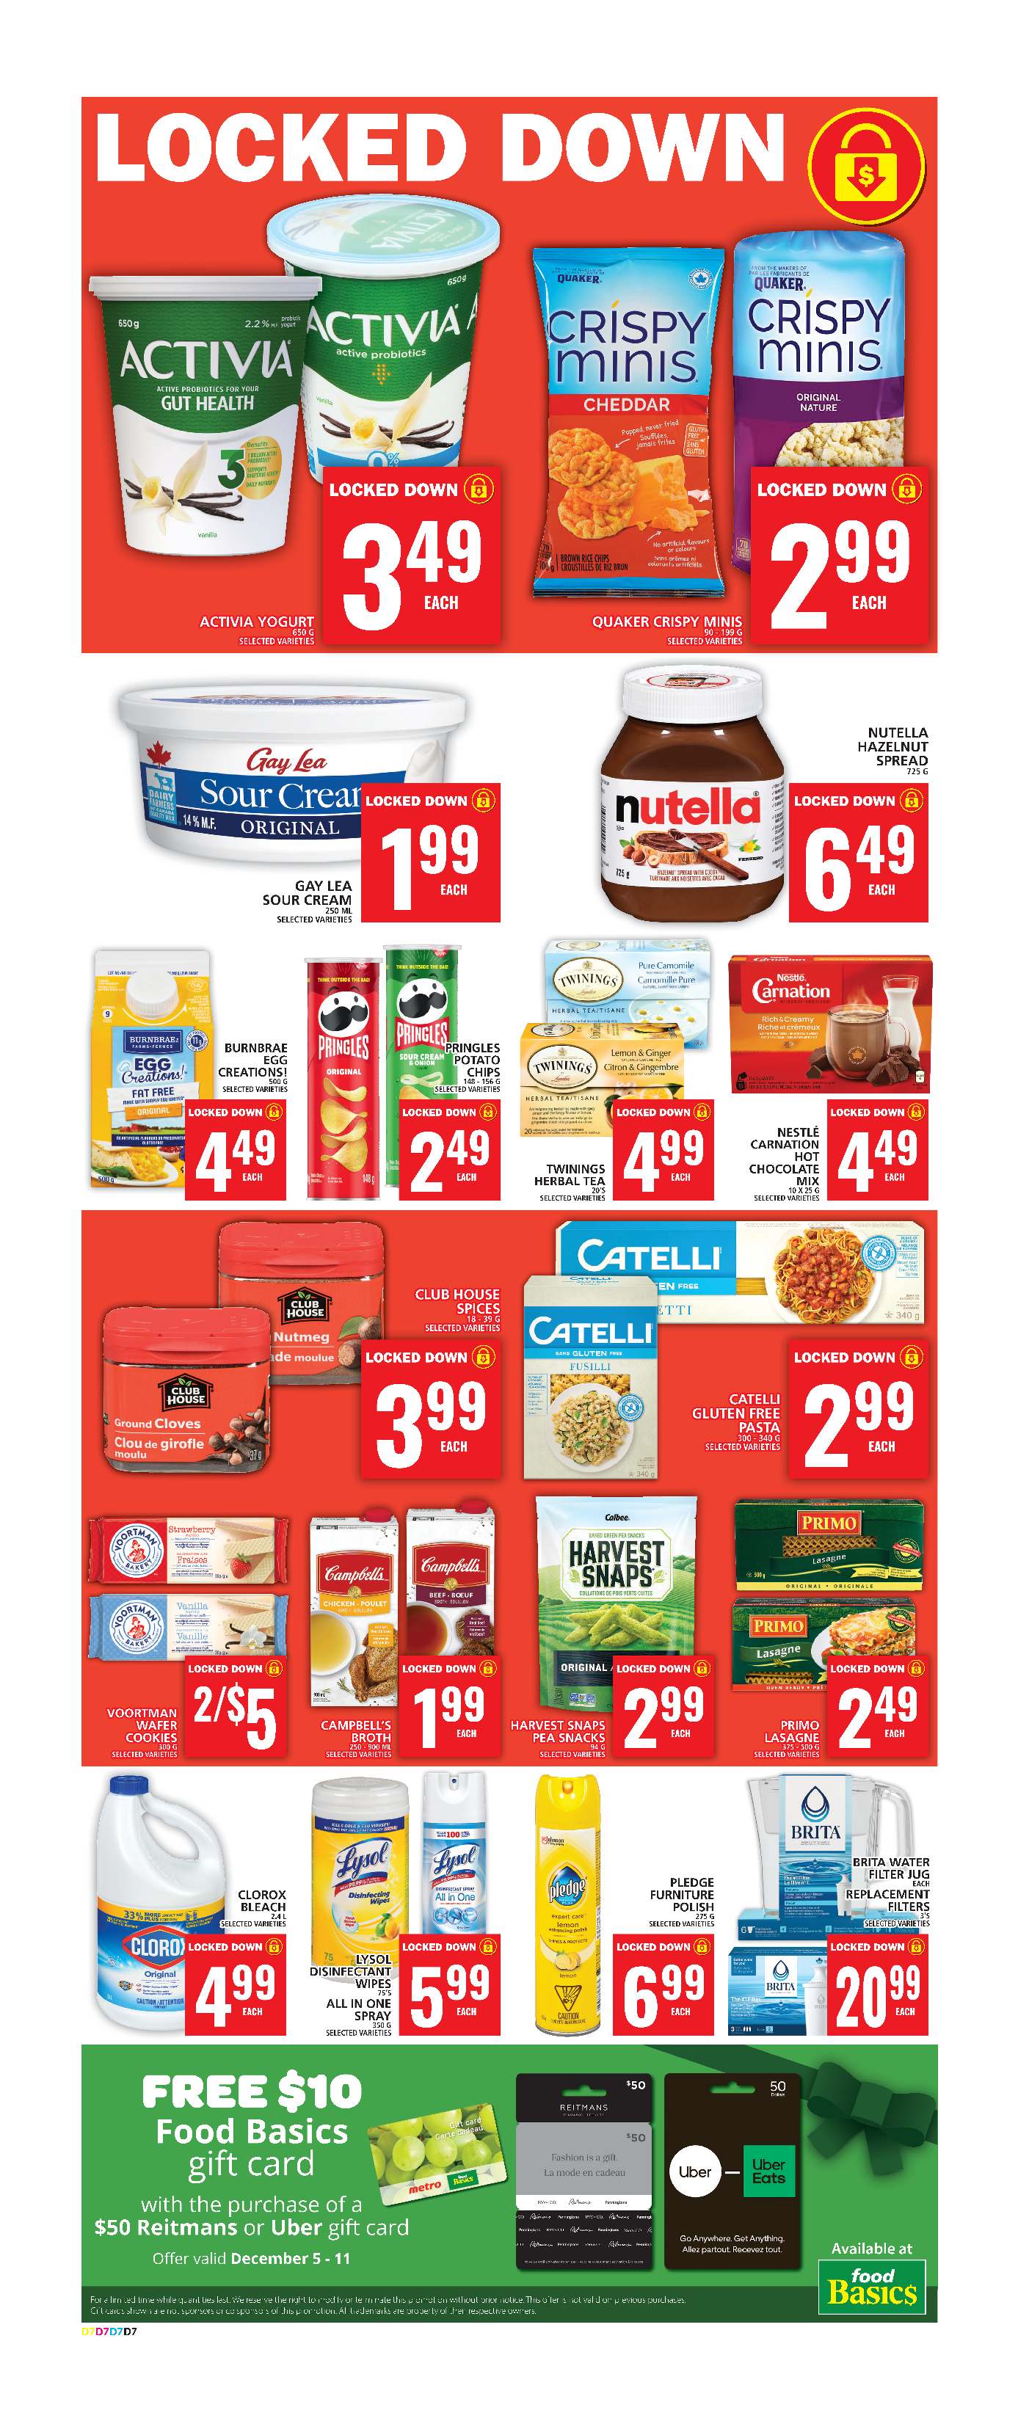

Work Sheet
Task 1: Look over the flyer and think about the grocery items you might need at home over the next week.
- Write a grocery list with at least ten items on it. Try to find some items on sale if you can.
- Add the prices for the items on your list. Some grocery store items have tax added, and some do not. For this task, add the price exactly as it is listed in the flyer. This is the price without tax and your total cost for your grocery items would probably be higher.

Answer:
GROCERY ITEM | PRICE

Task 2: Show your grocery list to your instructor. Explain why using a flyer like this is helpful. Give your instructor at least two reasons. (If you are doing this task online and unable to talk to your instructor, write your answer below.)
Answer:

______________________________________________________

Answers
Answers will vary.

Performance Descriptors
Levels | Performance Descriptors | Needs Work | Completes task with support from practitioner | Completes task independently
A2.1 | scans to locate specific details
 | interprets brief text and common symbols
 | locates specific details in simple documents, such as labels and signs
B1.1 | conveys information on familiar topics
 | participates in short simple exchanges
 | chooses appropriate language in exchanges with clearly defined purposes
 | speaks or signs clearly in a focused or organized way
B2.1 (optional) | conveys simple ideas and factual information
 | uses sentence structure, upper and lower case, and basic punctuation
 | uses highly familiar vocabulary
B3.1b | follows conventions to display information in lists, labels, simple forms, signs
B3.1b cont’d | organizes lists to suit purpose (e.g. chronologically, alphabetically, numerically, sequentially)
 | includes titles where required
C1.1 | recognizes value in number and word format
 | adds, subtracts, multiplies and divides whole numbers and decimals
 | interprets and represents costs using monetary symbols and decimals
 | uses strategies to check accuracy (e.g. estimating, using a calculator, repeating a calculation, using the reverse operation)

This task: Was successfully completed Needs to be tried again

Learner Comments:

Instructor (print): Learner (print):
__________________ _________________

