

Task Title: Plan a Healthy Lunch

# OALCF Cover Sheet – Practitioner Copy

**Learner Name: __________________________________________**

**Date Started: ___________________________________________**

**Date Completed: _________________________________________**

|  |  |  |
| --- | --- | --- |
| **Goal Path:** | Employment | Apprenticeship |
| Secondary School | Post Secondary | Independence |

**Successful Completion:**  Yes No

**Task Description:** The learner will compare their food choices with healthy recommendations from Health Canada.

**Main Competency/Task Group/Level Indicator:**

* Find and Use Information/Read continuous text/A1.2
* Communicate Ideas and Information/Write continuous text/B2.2

**Materials Required:**

* Pen/pencil and paper and/or digital device

# Learner Information

Choosing healthy foods can lead to better health outcomes and decrease your risk of diseases including certain cancers and cardiovascular disease. Learning about how to make healthy choices is a first step towards building healthy habits.

Scan the “Healthy Plate” picture and read “How to Develop a Healthy Eating Pattern” and “How to Limit Highly Processed Foods”.

**Healthy Plate**

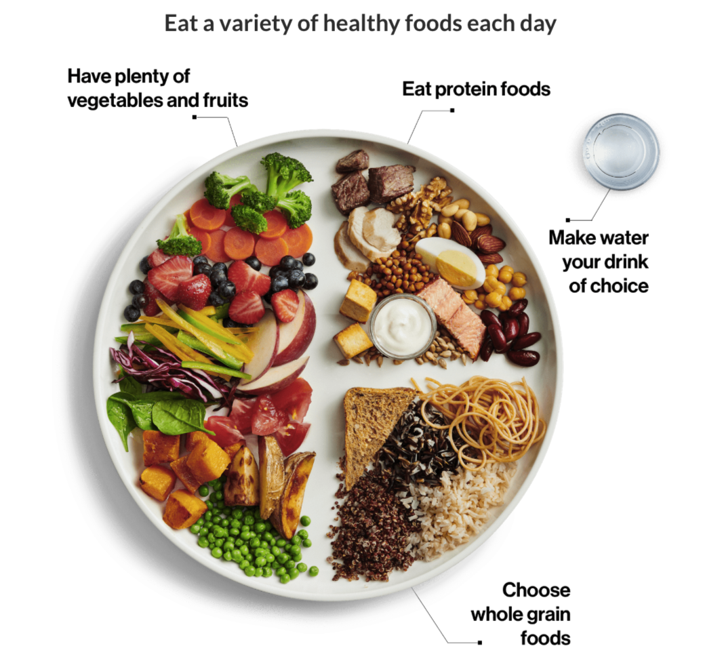

**How To Develop a Healthy Eating Pattern**

1. Eating more vegetables and fruits, especially those that are

* dark green such as broccoli and bok choy
* orange such as carrots and sweet potato

1. Selecting whole grain varieties of grain foods such as

* whole grain pasta
* whole grain bread
* whole oats or oatmeal
* whole grain brown or wild rice

1. Replacing dairy products that are higher in saturated fat, sodium, and sugars with healthier varieties such as

* lower fat unsweetened yogurt
* lower fat and lower sodium cheeses
* lower fat white milk and unsweetened plant-based beverages

1. Replacing meats higher in saturated fat with leaner varieties such as

* eggs
* wild game
* skinless poultry
* fish and shellfish

1. Replacing some of the meat in your meals with plant-based protein foods such as tofu, nuts, seeds, and legumes.
2. Limiting highly processed foods such as

* preserves like jams and jellies
* desserts like ice cream and chocolates
* salty snacks like potato chips and pretzels
* processed meats like bacon and sausages
* sugars and syrups like honey and molasses
* bakery products like cookies and croissants
* sauces, dressings, dips, gravies and condiments
* sugary drinks like juice and sweetened coffee and tea

Adapted from: <https://food-guide.canada.ca/en/healthy-eating-recommendations/make-it-a-habit-to-eat-vegetables-fruit-whole-grains-and-protein-foods/>

**How To Limit Highly Processed Foods**

If you eat highly processed foods, try to eat them less often, eat them in small amounts, or replace them with healthier options.

You can

* replace sugary drinks with water.
* try not to keep highly processed foods at home.
* choose healthier menu options when eating out.
* choose less processed foods like leftover baked chicken instead of deli meats.
* make homemade versions of your favourite highly processed foods. For example, try a healthy muffin recipe to replace store-bought muffins.
* stock your kitchen with healthy snacks like nuts, fruit, carrots, or hard-boiled eggs.
* plan your meals and snacks in advance to include vegetables and fruit, whole grain foods, and protein foods.
* limit the use of highly processed spreads and dressings.

Adapted from: <https://food-guide.canada.ca/en/healthy-eating-recommendations/limit-highly-processed-foods/>

# Work Sheet

**Task 1: Think about what you usually have for lunch. Write down the foods and drinks you would have on a typical day.**

Answer:

**______________________________________________________**

**Task 2: Compare your food choices with the “Healthy Plate” picture. List anything about your food choices that you could change to make healthier choices.**

Answer:

**______________________________________________________**

**Task 3: Refer to “How to Develop a Healthy Eating Pattern” and list two (2) or three (3) things you could change about your lunch to make healthier choices.**

Answer:

**______________________________________________________**

**Task 4: Refer to “How To Limit Highly Processed Foods” and list two (2) or three (3) things you could do to limit highly processed foods in your lunch.**

Answer:

**______________________________________________________**

**Task 5: Based on the changes you have identified, list a new lunch menu you could make that reflects healthier food choices.**

Answer:

**______________________________________________________**

Answers

Answers will vary.

# Performance Descriptors

| Levels | Performance Descriptors | Needs Work | Completes task with support from practitioner | Completes task independently |
| --- | --- | --- | --- | --- |
| A1.2 | scans text to locate information |  |  |  |
|  | locates multiple pieces of information in simple texts |  |  |  |
|  | makes low-level inferences |  |  |  |
|  | makes connections between sentences and between paragraphs in a single text |  |  |  |
|  | reads more complex texts to locate a single piece of information |  |  |  |
|  | follows the main events of descriptive, narrative and informational texts |  |  |  |
|  | obtains information from detailed reading |  |  |  |
|  | begins to identify sources and evaluate information |  |  |  |
| B2.2 | writes texts to explain and describe |  |  |  |
|  | conveys intended meaning on familiar topics for a limited range of purposes and audiences |  |  |  |
|  | uses limited range of vocabulary and punctuation appropriate to the task |  |  |  |
| B2.2 cont’d | begins to select words and tone appropriate to the task |  |  |  |
|  | begins to organize writing to communicate effectively |  |  |  |

This task: Was successfully completed Needs to be tried again

Learner Comments:

Instructor (print): Learner (print):

**__________________ _________________**