

Task Title: Plan a One-Day Bus Trip

# OALCF Cover Sheet – Practitioner Copy

**Learner Name: __________________________________________**

**Date Started: ___________________________________________**

**Date Completed: _________________________________________**

|  |  |  |
| --- | --- | --- |
| **Goal Path:** | Employment | Apprenticeship |
| Secondary School | Post Secondary | Independence |

**Successful Completion:**  Yes No

**Task Description:** The learner will plan a one-day bus trip to visit three locations using a city bus schedule provided.

**Main Competency/Task Group/Level Indicator:**

* Find and Use Information/Interpret documents/A2.2
* Communicate Ideas and Information/Complete and create documents/B3.1a
* Understand and Use Numbers/Manage time/C2.1

**Materials Required:**

* Pen/pencil and paper and/or digital device
* Watch or digital device (e.g. phone) that tells the time

# Learner Information

The city bus is a great way to get around when you need to do errands, visit friends and places, or go shopping.

Scan the City of London bus schedules and maps.

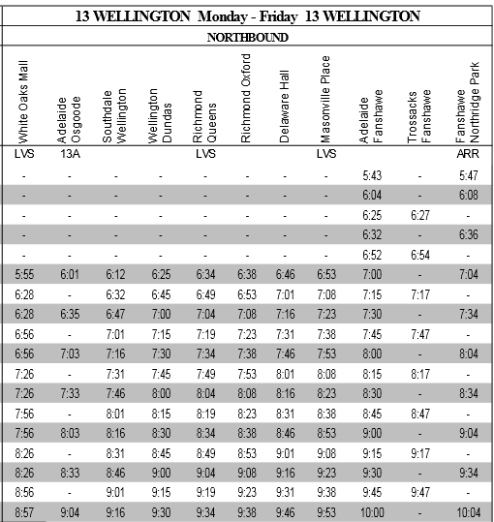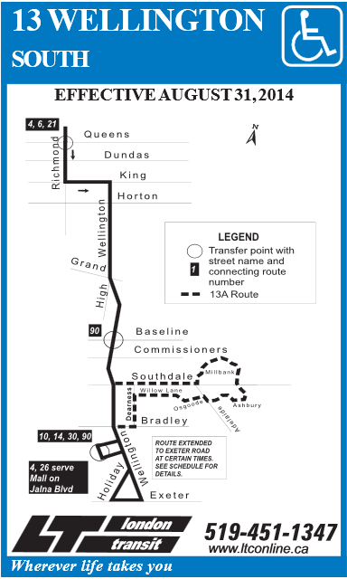

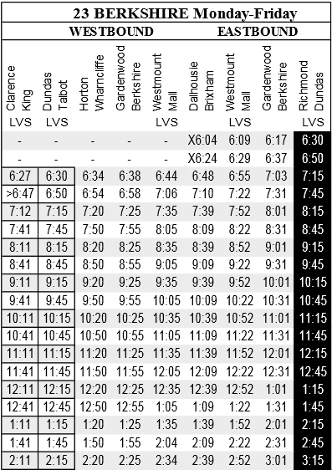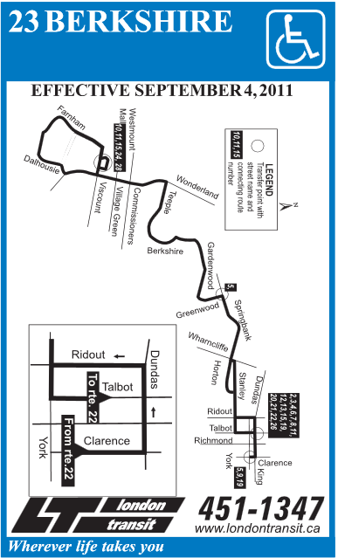

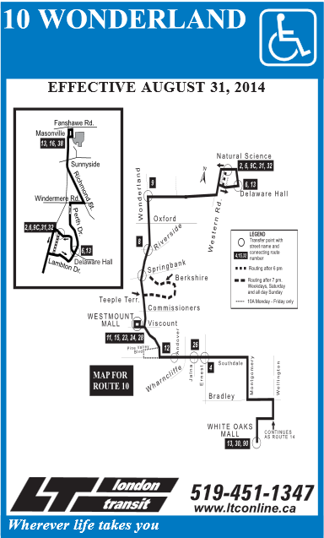

# Work Sheet

Plan a one-day trip using the city bus to visit Central Library downtown and then meet friends for shopping and lunch at Westmount Mall and Shoeless Joe’s Restaurant. You will leave your home around 8:30 am and return home around 5:00 pm. Your trip will start and end at White Oaks Mall.

You will take three separate bus rides. The locations of the places you will travel to and from are:

* White Oaks Mall: on Wellington Street South, near the corner of Bradley Ave
* Central Library: on the corner of Wellington Street and Dundas Street
* Westmount and Shoeless Joe’s Restaurant: on Wonderland Road south, near the corner of Viscount Ave

**Task 1: Fill in the chart for the first bus ride.**

Answer:

|  |  |  |  |
| --- | --- | --- | --- |
| Starting Point: | | Destination: | |
| Bus Route Number: | Bus Route Name: | | |
| Bus Stop Pick-up Location (nearest corner): | | | |
| Pick-up Time: | | | Drop-off Time: |
| Bus Stop Drop-off Location (nearest corner): | | | |

**Task 2: Fill in the chart for the second bus ride.**

Answer:

|  |  |  |  |
| --- | --- | --- | --- |
| Starting Point: | | Destination: | |
| Bus Route Number: | Bus Route Name: | | |
| Bus Stop Pick-up Location (nearest corner): | | | |
| Pick-up Time: | | | Drop-off Time: |
| Bus Stop Drop-off Location (nearest corner): | | | |

**Task 3: Fill in the chart for the third bus ride.**

Answer:

|  |  |  |  |
| --- | --- | --- | --- |
| Starting Point: | | Destination: | |
| Bus Route Number: | Bus Route Name: | | |
| Bus Stop Pick-up Location (nearest corner): | | | |
| Pick-up Time: | | | Drop-off Time: |
| Bus Stop Drop-off Location (nearest corner): | | | |

# Answers

Plan a one-day trip using the city bus to visit Central Library downtown and then meet friends for shopping and lunch at Westmount Mall and Shoeless Joe’s Restaurant. You will leave your home around 8:30 am and return home around 5:00 pm. Your trip will start and end at White Oaks Mall.

You will take three separate bus rides. The locations of the places you will travel to and from are:

* White Oaks Mall: on Wellington Street South, near the corner of Bradley Ave
* Central Library: on the corner of Wellington Street and Dundas Street
* Westmount and Shoeless Joe’s Restaurant: on Wonderland Road south, near the corner of Viscount Ave

**Task 1: Fill in the chart for the first bus ride.**

Answer:

|  |  |  |
| --- | --- | --- |
| 1. **Starting Point: White Oaks Mall** | | **Destination: Central Library** |
| Bus Route Number: 13 | Bus Route Name: Wellington | |
| Bus Stop Pick-up Location (nearest corner): Wellington and Bradley | | |
| Pick-up Time: approx. 8:26 am | | Drop-off Time: approx. 8:45 am |
| Bus Stop Drop-off Location (nearest corner): Wellington and Dundas | | |

**Task 2: Fill in the chart for the second bus ride.**

Answer:

|  |  |  |
| --- | --- | --- |
| 1. **Starting Point: Central Library** | | **Destination: Westmount Mall/ Shoeless Joe’s Restaurant** |
| Bus Route Number: 23 | Bus Route Name: Berkshire | |
| Bus Stop Pick-up Location (nearest corner): Clarence and King | | |
| Pick-up Time: approx. 11:41 am | | Drop-off Time: approx. 12:05 pm |
| Bus Stop Drop-off Location (nearest corner): Wonderland and Viscount | | |

**Task 3: Fill in the chart for the third bus ride.**

Answer:

|  |  |  |
| --- | --- | --- |
| 1. **Starting Point: Westmount Mall** | | **Destination: White Oaks Mall** |
| Bus Route Number: 10 | Bus Route Name: Wonderland | |
| Bus Stop Pick-up Location (nearest corner): Wonderland and Viscount | | |
| Pick-up Time: approx. 4:18 pm | | Drop-off Time: approx. 4:40 pm |
| Bus Stop Drop-off Location (nearest corner): Wellington and Bradley | | |

# Performance Descriptors

| Levels | Performance Descriptors | Needs Work | Completes task with support from practitioner | Completes task independently |
| --- | --- | --- | --- | --- |
| A2.2 | performs limited searches using one or two search criteria |  |  |  |
|  | locates information in simple graphs and maps |  |  |  |
| B3.1a | makes a direct match between what is requested and what is entered |  |  |  |
|  | makes entries using familiar vocabulary |  |  |  |
| C2.1 | understands chronological order |  |  |  |
|  | represents dates and times using standard conventions |  |  |  |
|  | follows apparent steps to reach solutions |  |  |  |

This task: Was successfully completed Needs to be tried again

Learner Comments:

Instructor (print): Learner (print):

**__________________ _________________**

Skill Building Activities (Optional)

**There are many reasons to take the bus even if you have a car and a driver’s licence, you may still take the bus. Some people take the bus because it is better for the environment or because gas and parking may be more expensive.**

**Answer the following questions in complete sentences.**

**Task 1: Do you take the bus or have you ever taken the bus? If so, how often do/did you take the bus and why?**

Answer:

**______________________________________________________**

**Task 2: Which bus comes closest to your home and how often?**

Answer:

**______________________________________________________**

**Task 3: List three places in the city that you frequently visit. Do you take the bus or drive to these places?**

Answer:

**______________________________________________________**

**Task 4: Write a paragraph about a time that you took a bus trip. Your paragraph should be 5-8 sentences in length.**

Answer:

**______________________________________________________**