

Task Title: Pre-Admissions Testing Sample Questions: Fractions, Decimals, Percents

# OALCF Cover Sheet – Practitioner Copy

**Learner Name: __________________________________________**

**Date Started: ___________________________________________**

**Date Completed: _________________________________________**

|  |  |  |
| --- | --- | --- |
| **Goal Path:** | Employment | Apprenticeship |
| Secondary School | Post Secondary | Independence |

**Successful Completion:**  Yes No

**Task Description:** The learner will answer fraction, decimal and percent questions from a sample college mathematics pre-admission test used to prepare students for a post-secondary mature applicant test.

**Main Competency/Task Group/Level Indicator:**

* Understand and Use Numbers/Manage money/C1.2
* Understand and Use Numbers/Use measures/C3.2

**Materials Required:**

* Pen/pencil and paper and/or digital device
* Calculator or digital device with calculator function

# Learner Information

The Secondary School Credit, Post Secondary and Apprenticeship goal paths require learners to complete math question sheets for class and on tests and exams.

Scan the “Mohawk College Pre-Admission Testing Sample Questions – Comprehensive Technical Math” pages.

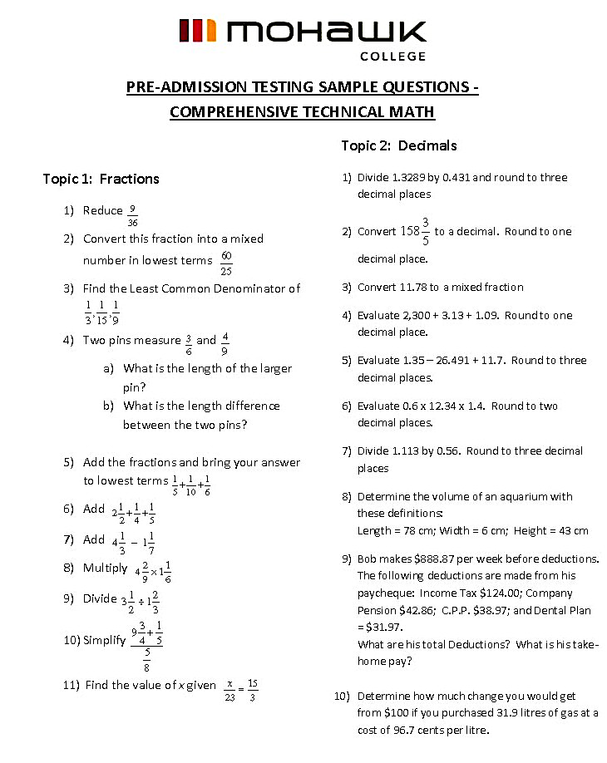

# 

# Work Sheet

**Task 1: On a separate sheet of paper, and showing your calculations, answer all the Mohawk College Pre-Admission Testing Sample Questions.**

Answer: No answers required here.  
 Task Completed: Yes No

# Answers

# Performance Descriptors

| Levels | Performance Descriptors | Needs Work | Completes task with support from practitioner | Completes task independently |
| --- | --- | --- | --- | --- |
| C1.2 | calculates using numbers expressed as whole numbers, fractions, decimals, percentages and integers |  |  |  |
|  | calculates percentages |  |  |  |
|  | interprets and applies rates (e.g. $/kg, $/1) |  |  |  |
|  | chooses and performs required operation(s); may make inferences to identify required operation(s) |  |  |  |
|  | selects appropriate steps to reach solutions |  |  |  |
|  | represents costs and rates using monetary symbols, decimals and percentages |  |  |  |
|  | interprets, represents and converts amounts using whole numbers, decimals, percentages, ratios and simple, common fractions (e.g. ½, ¼) |  |  |  |
|  | uses strategies to check accuracy (e.g. estimating, using a calculator, repeating a calculation, using the reverse operation) |  |  |  |
| C3.2 | selects appropriate steps to solutions |  |  |  |
| C3.2 cont’d | calculates using numbers expressed as whole numbers, fractions, decimals, percentages and integers |  |  |  |
|  | interprets and represents area and volume using symbols and abbreviations (e.g. m3) |  |  |  |
|  | interprets and applies rates (e.g. km/hr) and ratios (e.g. map scales) |  |  |  |
|  | understands and uses formulas for finding the perimeter, area and volume of simple, common shapes |  |  |  |
|  | chooses and performs required operation(s); may make inferences to identify required operation(s) |  |  |  |
|  | interprets, represents and converts measures using whole numbers, decimals, percentages, ratios and simple, common fractions (e.g. ½, ¼) |  |  |  |

This task: Was successfully completed Needs to be tried again

Learner Comments:

Instructor (print): Learner (print):

**__________________ _________________**