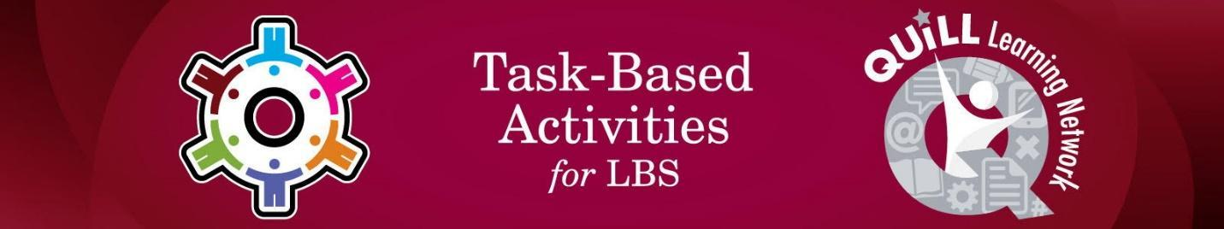

Task Title: Prepare for Certificate of Qualification Exam

# OALCF Cover Sheet – Practitioner Copy

**Learner Name: __________________________________________**

**Date Started: ___________________________________________**

**Date Completed: _________________________________________**

|  |  |  |
| --- | --- | --- |
| **Goal Path:** | Employment | Apprenticeship |
| Secondary School | Post Secondary | Independence |

**Successful Completion:**  Yes No

**Task Description:** The learner will review a short article about the Certificate of Qualification exam, and answer questions.

**Main Competency/Task Group/Level Indicator:**

* Find and Use Information/Read continuous text/A1.1

**Materials Required:**

* Pen/pencil and paper and/or digital device

# Learner Information

Apprentices must eventually take the Certificate of Qualification Exam to get their trade credential or “ticket”.

Read “Preparing for Certificate of Qualification Exams”.

**Preparing for Certificate of Qualification Exams**

After you have completed all your on-the-job training and in-class hours, you still have to write a Certificate of Qualification exam before you become a journeyperson.

Each Certificate of Qualification exam contains 90 to 150 multiple-choice questions. Each question has 4 possible answers and only one answer is correct.

The certification exam is based on the Apprenticeship Training Standard for the trade, and, for Red Seal trades, on the National Occupational Analysis (NOA).

The Apprenticeship Training Standard and the National Occupational Analysis describe what a competent journeyperson is expected to do on the job. The exam questions cover:

* trade terminology and concepts
* why a task is done
* how a task is done

You need to get a score of at least 70% to pass a Certificate of Qualification exam.

# Work Sheet

**Task 1: What type of questions does the Certificate of Qualification exam contain?**

Answer:

**______________________________________________________**

**Task 2: What do Certificate of Qualification exam questions cover?**

Answer:

**______________________________________________________**

**Task 3: What is the minimum score needed to pass the exam?**

Answer:

**______________________________________________________**

# Answers

**Task 1: What type of questions does the Certificate of Qualification exam contain?**

Answer: Multiple Choice

**Task 2: What do Certificate of Qualification exam questions cover?**

Answer: Trade terminology and concepts**,** why a task is done, andhow a task is done.

**Task 3: What is the minimum score needed to pass the exam?**

Answer: 70%

# Performance Descriptors

| Levels | Performance Descriptors | Needs Work | Completes task with support from practitioner | Completes task independently |
| --- | --- | --- | --- | --- |
| A1.1 | reads short texts to locate a single piece of information |  |  |  |
|  | decodes words and makes meaning of sentences in a single text |  |  |  |
|  | identifies the main idea in brief texts |  |  |  |

This task: Was successfully completed Needs to be tried again

Learner Comments:

Instructor (print): Learner (print):

**__________________ _________________**