

Task Title: Properly Using PPE

# OALCF Cover Sheet – Practitioner Copy

**Learner Name: __________________________________________**

**Date Started: ___________________________________________**

**Date Completed: _________________________________________**

|  |  |  |
| --- | --- | --- |
| **Goal Path:** | Employment | Apprenticeship |
| Secondary School | Post Secondary | Independence |

**Successful Completion:**  Yes No

**Task Description:** The learner will interpret PPE guidelines in a Public Health Ontario infographic.

**Main Competency/Task Group/Level Indicator:**

* Find and Use Information/Interpret documents/A2.1

**Materials Required:**

* Pen/pencil and paper and/or digital device

# Learner Information

In many healthcare jobs, employees are required to use Personal Protective Equipment (PPE). Learning how to properly use PPE ensures the safety of both worker and patients.

Scan “Public Health Ontario PPE Guidelines”.

**Public Health Ontario PPE Guidelines**

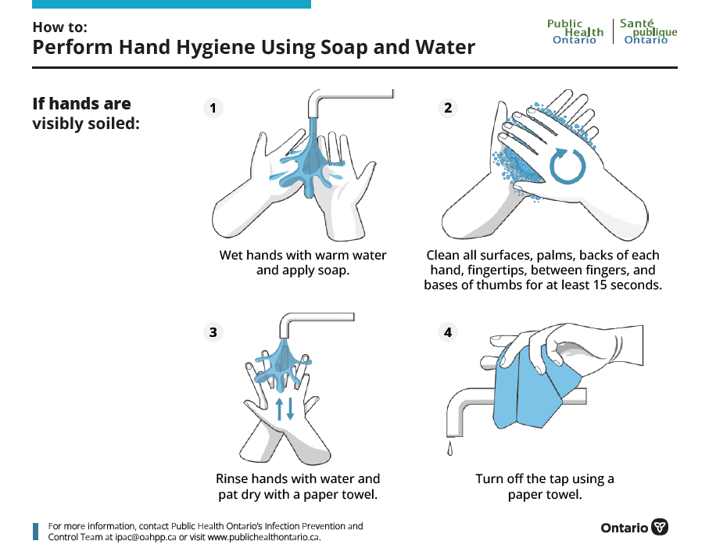

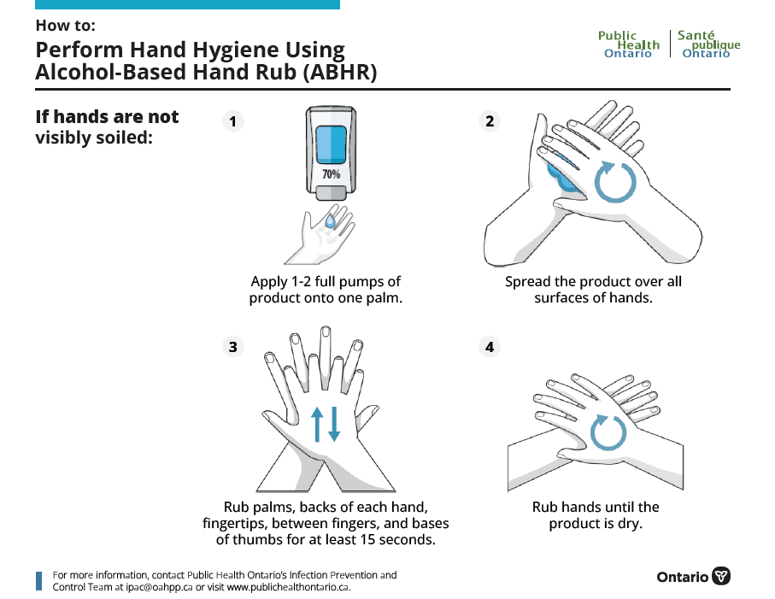

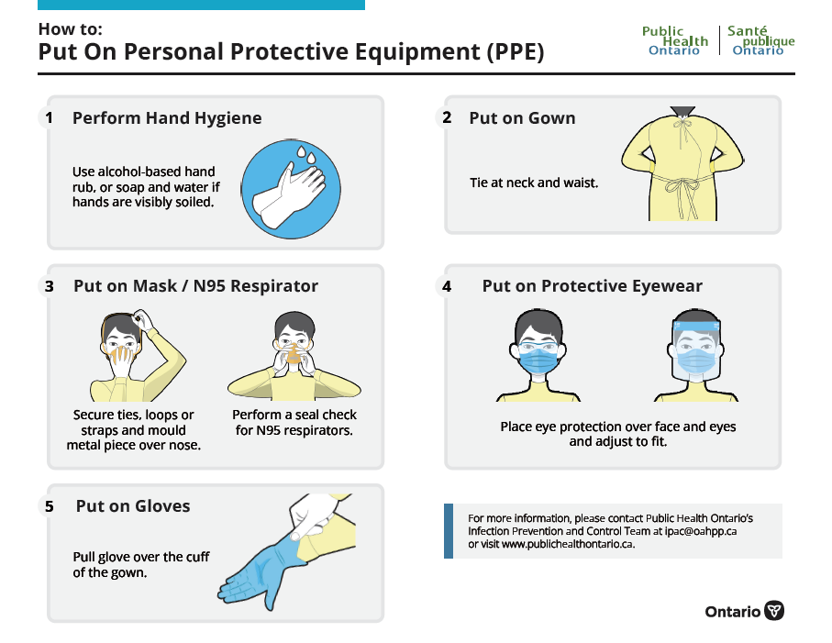

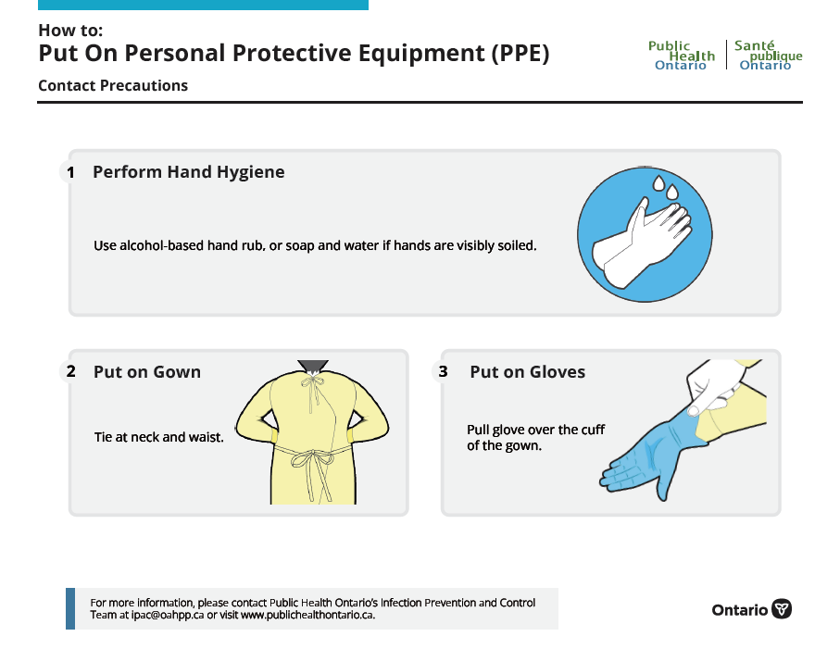

# Work Sheet

**Task 1: When should someone use soap and water instead of alcohol-based hand rub for hand hygiene.**

Answer:

**______________________________________________________**

**Task 2: How long should someone use alcohol-based hand rub if hands are not visibly soiled?**

Answer:

**______________________________________________________**

**Task 3: In what order should the following tasks be completed?**

**Put on Protective Eyewear, Put on Gloves, Perform Hand Hygiene, Put on Mask/N95 Respirator, Put on Gown**

Answer:

**______________________________________________________**

**Task 4: How could you find out more information about PPE and Infection Control?**

Answer:

**______________________________________________________**

Answers

**Task 1: When should someone use soap and water instead of alcohol-based hand rub for hand hygiene.**

Answer: Soap and water should be used when hands are visibly soiled.

**Task 2: How long should someone use alcohol-based hand rub if hands are not visibly soiled?**

Answer: At least 15 seconds.

**Task 3: In what order should the following tasks be completed?**

**Put on Protective Eyewear, Put on Gloves, Perform Hand Hygiene, Put on Mask/N95 Respirator, Put on Gown**

Answer:

1. Perform Hand Hygiene
2. Put on Gown
3. Put on Mask/N95 Respirator
4. Put on Protective Eyewear
5. Put on Gloves

**Task 4: How could you find out more information about PPE and Infection Control?**

Answer: Contact Public Health Ontario’s Infection Prevention and Control Team at ipac@oahpp.ca or visit www.publichealthontario.ca

# Performance Descriptors

| Levels | Performance Descriptors | Needs Work | Completes task with support from practitioner | Completes task independently |
| --- | --- | --- | --- | --- |
| A2.1 | scans to locate specific details |  |  |  |
|  | interprets brief text and common symbols |  |  |  |
|  | locates specific details in simple documents, such as labels and signs |  |  |  |
|  | identifies how lists are organized (e.g. sequential, chronological, alphabetical) |  |  |  |
|  | requires support to identify sources and to evaluate and integrate information |  |  |  |

This task: Was successfully completed Needs to be tried again

Learner Comments:

Instructor (print): Learner (print):

**__________________ _________________**